SUPPLEMENTARY DATA

Geodynamic seawater-sediment porewater evolution of the east central Atlantic Paleogene ocean margin revealed by U-Pb dating of sedimentary phosphates

Jérémie Aubineau¹*, Fleurice Parat¹, Ernest Chi Fru², Radouan El Bamiki³, Olivia Mauguin¹, Fabien Baron⁴, Marc Poujol⁵ & Michel Séranne¹

¹Géosciences Montpellier, Université de Montpellier, CNRS UMR 5243, Montpellier, France
²Center of Geobiology and Geochemistry, School of Earth and Ocean Sciences, College of Physical Sciences and Engineering, Cardiff University, Cardiff CF10 3AT Wales, UK
³Mohammed VI Polytechnic University, Geology and Sustainable Mining, Ben Guerir, Morocco
⁴IC2MP, Université de Poitiers, CNRS UMR 7285, Poitiers, France
⁵Univ Rennes, CNRS, Géosciences Rennes, UMR 6118, 35000 Rennes, France

*corresponding author: jeremie.aubineau@umontpellier.fr

SUPPLEMENTARY METHOD

X-Ray Diffraction (XRD). The <2 µm clay fraction was extracted from gently hand-crushed samples with an ultrasonic agitation device and centrifugal machine in deionized water without any chemical pre-treatment (Moore and Reynolds Jr, 1997), at IC2MP, University of Poitiers. Oriented preparations were then prepared by sedimentation from ~1 mL of suspension on glass slides at room temperature. Analysis of whole-rock powders was done over an angular range of 4–65° 2θ and a step size of 0.02° 2θ per 2 s, while that of oriented slides was performed over an angular range of 2–30° 2θ and a step size of 0.02° 2θ per 3 s after successive air-dried (AD) and ethylene glycol (EG) treatment.
Electron probe microanalyses (EPMA). Major (Na, Mg, Al, Si, P, K, Ca, Ti, Mn and Fe) and volatile (F, S, and Cl) element concentrations were measured. The counting time was fixed at 10 s for Ca, P, F, Cl, S, 30 s for Na, Mg, Al, Si, K, Mn, Fe, and 60 s for Ti. Elemental quantitative maps (F, Na, Si, P, K, Ca, and Fe) were acquired with a focused electron beam, step size of 1 µm and dwell time of 0.1 s. EPMA analyses for each element were calibrated using reference material standards, including albite for Na, forsterite for Mg, aluminum oxide for Al, wollastonite for Si, fluorapatite for P and Ca, orthose for K, titanium oxide for Ti, native metal for Mn, hematite for Fe, lithium fluoride for F, baryte for S, and chlorapatite for Cl.
Laser ablation ICP-MS (LA-ICP-MS) analysis. LA-ICP-MS measurements consisted of 1 s preablation pulse with a spot size of 65 µm. Signals were then acquired, devoting 70 s for the blank and 40 s for elemental measurement. We were not able to use CaO concentrations from EPMA analyses as results yielded lower values than theoretical values for CFA minerals. This likely results from highly porous CFA material and the presence of other mineral phases in the Amizmiz phosphorites (see sections 5.1 and 5.3.1). Consequently, a uniform CaO concentration of 54 wt.% was chosen as internal standard value, which is thought to best represent the composition of porous CFA peloids in the Moroccan phosphorites (Aubineau et al., 2022). For clay analysis, we used SiO₂ concentration of 60.34 wt.% as internal standard value to best represent SiO₂ chemical compositions of palygorskite and sepiolite. This chosen SiO₂ value corresponds to the mean value of n°2 palygorskite (58.85 wt.%) and n°3 sepiolite (61.83 wt.%) from (Wilson, 2013). Compared to the Geo-REM database (http://georem.mpch-mainz.gwdg.de), trace element concentrations of measured NIST SRM 612 standards show a mean relative error of <2.5 %. Data reduction were carried out using Glitter software (Griffin, 2008) during which time-resolved spectra have been screened for heterogeneities in the analyzed volume. Also, LA-ICP-MS values were removed if elemental concentrations were lower than the sum of detection limit and standard deviation (1σ).
Rare Earth Element + Y (REEY) geochemistry. Post Archean Australian Shale (PAAS) values were used for REEY normalization (Taylor and McLennan, 1985), hereafter referred to as REEY_{SN}. In this study, numerous REEY-based proxies were calculated. The bell-shaped index (BSI) allows to estimate the degree of middle REE enrichment relative to light REE and heavy REE and is calculated using the following equation: (2*(Sm_{SN} + Gd_{SN} + Dy_{SN})/3) / ((La_{SN} + Pr_{SN} + Nd_{SN})/3 + (Ho_{SN} + Er_{SN} + Tm_{SN} + Yb_{SN} + Lu_{SN})/5) (Tostevin et al., 2016). To assess the REEY behavior, REEY anomalies were calculated as follows: Ce anomaly (Ce/Ce*) = Ce_{SN} / (0.5*(La_{SN} + Pr_{SN})), Pr anomaly (Pr/Pr*) = Pr_{SN} / 0.5*(Ce_{SN} + Nd_{SN}), Eu anomaly (Eu/Eu*) = Eu_{SN} / (0.66*Sm_{SN} + 0.33*Tb_{SN}), Gd anomaly (Gd/Gd*) = Gd_{SN} / (0.33*Sm_{SN} + 0.67*Tb_{SN}), and Y anomaly (Y/Y*) = 2*Y_{SN} / (Dy_{SN} + Ho_{SN}) (Bau and Dulski, 1996; Shields and Stille, 2001; Planavsky et al., 2010).
SUPPLEMENTARY FIGURES

Figure S1. Weighted average ²⁰⁷Pb-corrected ages for apatite standards analyzed during this study. (a) Durango apatite and (b) McClure apatite.

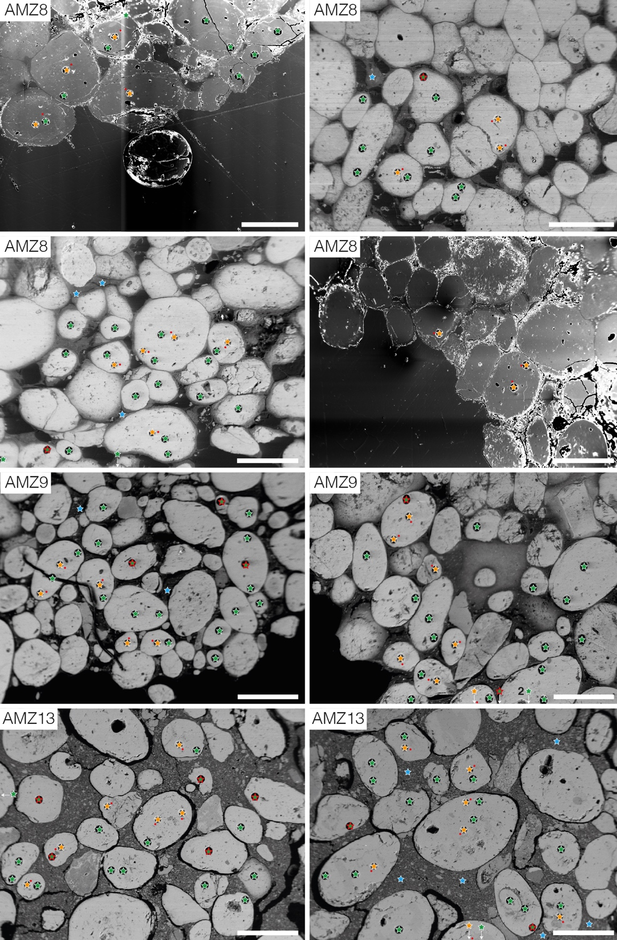
Figure S2. SEM-BSE images of Amizmiz phosphorites from the Moroccan High Atlas with spatial positions of in situ geochemical measurements. Red dots: EPMA; orange and blue stars: LA-ICP-MS analyses on CFA grains and clay matrix, respectively; green stars: U-Pb LA-ICP-MS dating. Data omitted from age calculation in Figure 2 correspond to green stars with a red outline. Scale bars are 500 µm.

Figure S3. Elemental points analysis of clay minerals presented in Figures 3d (a) and 4e (b). EDX analyses indicate the presence of Si and Mg and to a lesser extent Al, which confirms the presence of sepiolite/palygorskite. The occurrence of phosphate minerals is related to Ca, F, Na, and P elements. Ir and Sc elements are absent; their presence resulted from a misinterpretation of the software.

Figure S4. XRD patterns of randomly oriented bulk powders of Amizmiz phosphorites. (a) Analyses over a large °2θ angular range showing the main mineralogical phases. (b) Close-up of (410) and (004) apatite peaks that are diagnostic for estimating the CO₃²⁻ contents in phosphate grains.
Calcite (Ca); carbonate fluorapatite (CFA); dolomite (Do); palygorskite (Paly); quartz (Q); sepiolite (Sep).

Figure S5. FTIR spectra of Amizmiz phosphorites from the Moroccan High Atlas. (a) OH-bending vibration region. (b) OH-stretching vibration zone. The presence of trioctahedral Mg clays like sepiolite is attributed to δMg₃–OH and νMg₃–OH, while that of dioctahedral Al clays like palygorskite is attributed to νAl₂–OH. The structural interpretation has been written only for clay features.

Figure S6. CFA peloid compositions from the Amizmiz phosphorites. (a) Ternary 6P-Mg-Si+Al diagram where 6P = P content (wt.%)/6, Mg = Mg content (wt.%), and Si + Al (wt.%) = Si + Al contents. The 6P-Mg-Si+Al system shows mixing trends between phosphate minerals and clay minerals. (b) Cross-plot of SiO₂ vs. MgO displaying strong correlations between Si and Mg from the three studied samples, suggesting the presence of Si- and Mg-rich clay minerals like sepiolite and palygorskite. Empty diamond is excluded from the calculation of coefficient determination.

Figure S7. SEM-BSE image and electron probe element mapping (dashed square) of a representative section from the AMZ13 phosphorite. We used a viridis color map to avoid a misinterpretation of data, as recommended by (Stoelzle and Stein, 2021). In Ca panel, white and red arrows indicate calcite and dolomite, respectively, in a matrix dominantly composed of clay minerals. Quartz and K-feldspar are occasionally observed. Scale bars are 100 µm.

Figure S8. PAAS-normalized REEY patterns of Amizmiz phosphorites from the Moroccan High Atlas. PAAS values are from Taylor and McLennan (1985).

References:
Aubineau, J., Parat, F., Elghali, A., Raji, O., Addou, A., Bonnet, C., et al. (2022). Highly variable content of fluorapatite-hosted CO₃²⁻ in the Upper Cretaceous/Paleogene phosphorites (Morocco) and implications for paleodepositional conditions. Chemical Geology 597, 120818. doi: 10.1016/j.chemgeo.2022.120818.
Bau, M., and Dulski, P. (1996). Distribution of yttrium and rare-earth elements in the Penge and Kuruman iron-formations, Transvaal Supergroup, South Africa. Precambrian Research 79, 37–55. doi: 10.1016/0301-9268(95)00087-9.
Griffin, W. L. (2008). GLITTER: Data reduction software for laser ablation ICP-MS. Laser Ablation ICP-MS in the Earth Sciences : Current practices and outstanding issues, 308–311.
Moore, D. M., and Reynolds Jr, R. C. (1997). X-ray diffraction and the identification and analysis of clay minerals. New York: Oxford University Press.
Planavsky, N. J., Bekker, A., Rouxel, O. J., Kamber, B., Hofmann, A., Knudsen, A., et al. (2010). Rare earth element and yttrium compositions of Archean and Paleoproterozoic Fe formations revisited: New perspectives on the significance and mechanisms of deposition. Geochimica et Cosmochimica Acta 74, 6387–6405. doi: 10.1016/j.gca.2010.07.021.
Shields, G., and Stille, P. (2001). Diagenetic constraints on the use of cerium anomalies as palaeoseawater redox proxies: an isotopic and REE study of Cambrian phosphorites. Chemical Geology 175, 29–48. doi: 10.1016/S0009-2541(00)00362-4.
Stoelzle, M., and Stein, L. (2021). Rainbow color map distorts and misleads research in hydrology – guidance for better visualizations and science communication. Hydrol. Earth Syst. Sci. 25, 4549–4565. doi: 10.5194/hess-25-4549-2021.
Taylor, S. R., and McLennan, S. M. (1985). The continental crust: Its composition and evolution. Oxford: Blackwell Scientific Puplications.
Tostevin, R., Shields, G. A., Tarbuck, G. M., He, T., Clarkson, M. O., and Wood, R. A. (2016). Effective use of cerium anomalies as a redox proxy in carbonate-dominated marine settings. Chemical Geology 438, 146–162. doi: 10.1016/j.chemgeo.2016.06.027.
Wilson, M. J. (2013). Rock-Forming Minerals Volume 3C (second ed.) - Sheet Silicates: Clay Minerals. London: The Geological Society of London.

