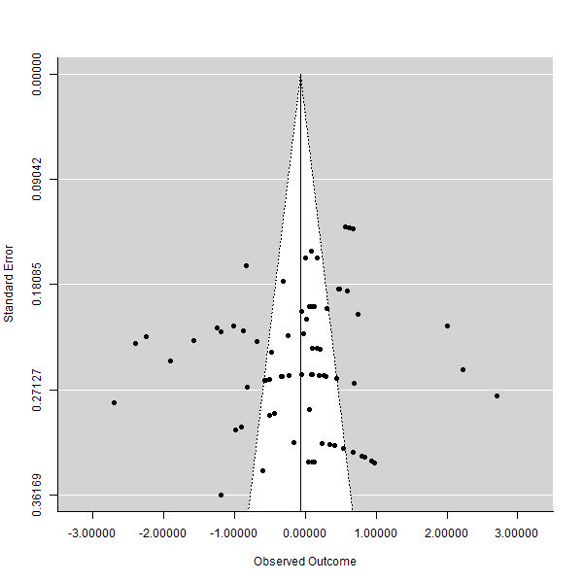
Supplementary Figure 1 Funnel graph of the impact of cassava on feed intake in broilers.

