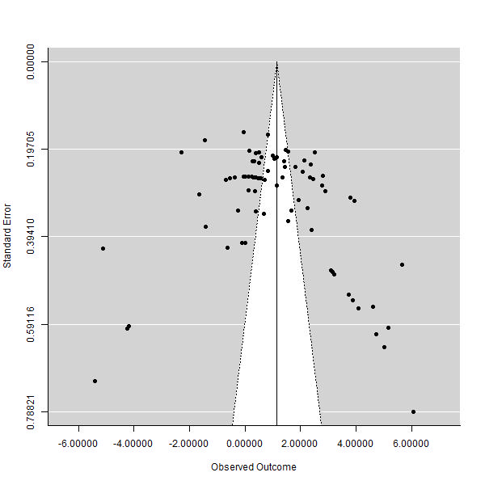
Supplementary Figure 2 Funnel plots of the influence of cassava on FCR in broiler chickens.

