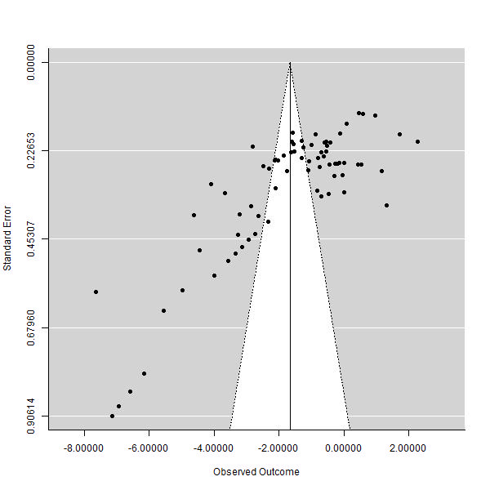
Supplementary Figure 3 Funnel plots of the impact of cassava intervention on ADG in broiler chickens.

