# **Supplementary Materials**

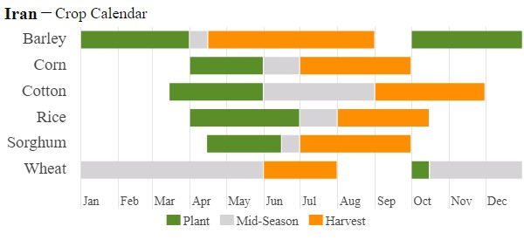

**Figure S1. Crop Calendar in Iran from USDA Foreign Agricultural Service (Source:** [**https://ipad.fas.usda.gov/**](https://ipad.fas.usda.gov/countrysummary/Default.aspx?id=IR&crop=Wheat)**)**

**Table S1. Crop productions with areas and yields for wheat, barley and rice**

|  |  |  |  |  |  |  |  |  |  |
| --- | --- | --- | --- | --- | --- | --- | --- | --- | --- |
| **Market Year** | **Wheat area**  **(1000 Ha)** | **Wheat production (1000 Tons)** | **Wheat yield (T/Ha)** | **Barley area**  **(1000 Ha)** | **Barley production (1000 Tons)** | **Barley yield (T/Ha)** | **Rice**  **area**  **(1000 Ha)** | **Rice production (1000 Tons)** | **Rice**  **yield (T/Ha)** |
| 2010/2011 | 7000 | 13500 | 1.93 | 1580 | 3290 | 2.08 | 563 | 1643 | 4.42 |
| 2011/2012 | 6400 | 12400 | 1.94 | 1580 | 2530 | 1.60 | 530 | 1249 | 3.57 |
| 2012/2013 | 6400 | 13800 | 2.16 | 1625 | 2770 | 1.70 | 570 | 1558 | 4.14 |
| 2013/2014 | 6400 | 14000 | 2.19 | 1635 | 3000 | 1.83 | 565 | 1617 | 4.34 |
| 2014/2015 | 6061 | 13000 | 2.14 | 1713 | 3200 | 1.7 | 529 | 1518 | 4.35 |
| 2015/2016 | 6700 | 14500 | 2.16 | 1763 | 3200 | 1.82 | 530 | 1550 | 4.43 |
| 2016/2017 | 6700 | 14500 | 2.16 | 1760 | 3724 | 2.12 | 596 | 1928 | 4.90 |
| 2017/2018 | 6500 | 12700 | 1.95 | 1600 | 3100 | 1.94 | 572 | 2013 | 5.33 |
| 2018/2019 | 6700 | 14500 | 2.16 | 1550 | 2800 | 1.81 | 575 | 1993 | 5.25 |
| 2019/2020 | 6200 | 15500 | 2.51 | 1700 | 3600 | 2.12 | 575 | 1993 | 5.25 |
| 2020/2021 | 6000 | 15000 | 2.50 | 1600 | 3600 | 2.25 | 575 | 2000 | 5.27 |

**Source:** [**https://ipad.fas.usda.gov/**](https://ipad.fas.usda.gov/countrysummary/Default.aspx?id=IR&crop=Wheat)

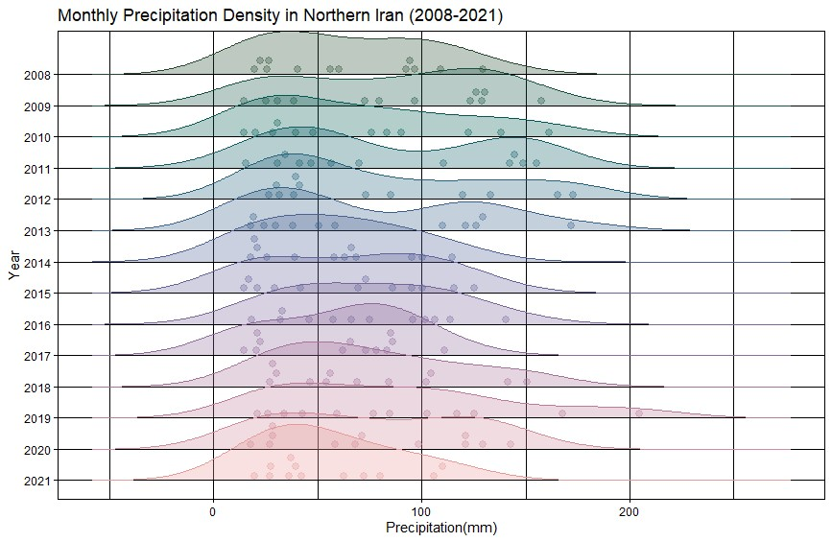

**Figure S2. Precipitation density 2008-2021 (**[**https://data.chc.ucsb.edu/products/CHIRPS-2.0/**](https://data.chc.ucsb.edu/products/CHIRPS-2.0/) **)**

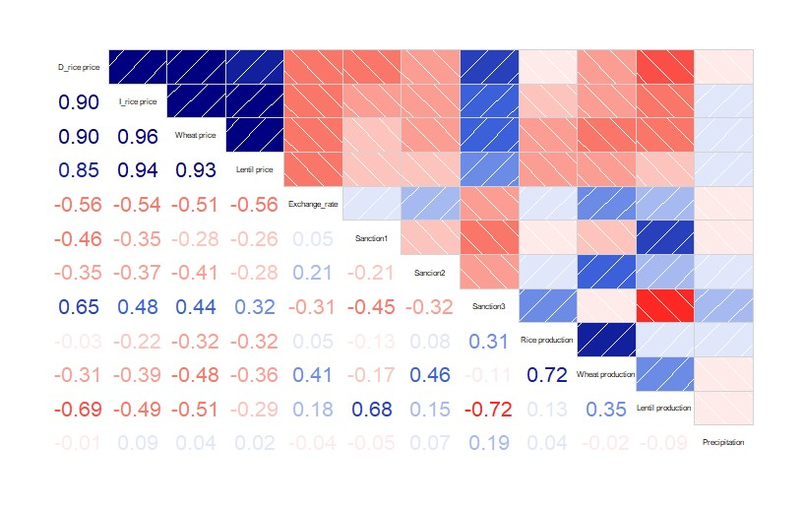

**Figure S3. Correlation matrix for detrended predictors**

**Imported Crops statistics for rice, wheat, barley and lentils in Iran at 2020 :**

The Statistical Center of Iran estimates that Iranians consume approximately 35 kilograms of rice per person each year. That would mean a domestic demand of nearly three million tons for a country of 84 million people (Statistical Center of Iran 2021). The Ministry of Agriculture Jihad in in Iran’s yearbook declares that rice self-sufficiency would save Iran more than $1.1 billion in imports, adding that it would also be a major success amid efforts to minimize the impacts of the sanctions on food security in the country. Furthermore, the Iranian government buys wheat from domestic farmers at a guaranteed price to build its strategic reserves and regulate the market and the harvest statistics of wheat production in Iran suggest that imports of as much as 8 million Ton (wheat imports tripled in 2021 in comparison to that of in 2019) may be required to ensure domestic requirements are met, and the government has enough stock to regulate domestic prices. And, barley output was also adversely impacted by the drought and needed to be imported to meet domestic needs (Ministry of Agriculture Jihad in Iran Yearbook 2021). Table 1 shows the last statistics of imported crops.

**Table S2. Imported crops in 2020**

|  |  |  |  |  |
| --- | --- | --- | --- | --- |
| **Imported Crops** | **Year** | **Countries in order** | **Dollar amount** | **Weight (kg)** |
| Rice | 2020 | Thailand, India and Pakistan | 932 Million Dollar | 1000000000 kg |
| Wheat | 2020 | Russia, Turkey, Germany and UK | 915 Million Dollar | 32000000000 kg |
| Barley | 2020 | Kazakhstan, Russia, Germany, Turkey and UK | 464 Million Dollar | 18000000000 kg |
| Lentils | 2020 | United Arab Emirates, Russia, Canada, Turkey and Kyrgyzstan | 82.13 Million Dollar | 39133562 kg |

**Multiple Linear Regression results:**

**General formula:**

$Y=β_{0} +β_{1}(Domestic rice production) +β_{2} ( Domestic wheat production) + β_{3} ( Domestic Lentils production) +β_{4} (Sanction1) + β_{5} (Sanction2) + β_{6} (Sanction3) +$ $β_{7} (Sanction3)+β_{8} (Precipitation)$

Domestic rice:

**Table S3. Domestic rice summary table**

|  |  |  |  |  |
| --- | --- | --- | --- | --- |
| **Coefficients** | **Estimate** | **Std. Error** | **Statistic** | **P.value** |
| Intercept | 12156. | 21061. | 0.577 | 0.565 |
| Exchange rate | -0.310 | 0.0640 | -4.85 | 0.000 |
| sanction1 | -26177. | 9798. | -2.67 | 0.000 |
| sanction2 | -21155. | 8142. | -2.60 | 0.01 |
| sanction3 | 55530. | 10464. | 5.31 | 0.000 |
| Domestic rice production | -0.0109 | 0.00373 | -2.91 | 0.000 |
| Wheat production | 0.00224 | 0.00186 | 1.20 | 0.232 |
| Lentil production | -0.151 | 0.369 | -0.410 | 0.683 |

**Significant: p-value < 0.05; +2 < t-value < -2**

Imported rice:

**Table S4. Imported rice summary table**

|  |  |  |  |  |
| --- | --- | --- | --- | --- |
| **Coefficients** | **Estimate** | **Std. Error** | **Statistic** | **P.value** |
| Intercept | -29798. | 22697. | -1.31 | 0.192 |
| Exchange rate | -0.270 | 0.0690 | -3.91 | 0.000 |
| sanction1 | -35283. | 10559. | -3.34 | 0.000 |
| sanction2 | -27387. | 8774. | -3.12 | 0.000 |
| sanction3 | 51849. | 11277. | 4.60 | 0.000 |
| Domestic rice production | -0.0174 | 0.00402 | -4.34 | 0.000 |
| Wheat production | 0.00186 | 0.00201 | 0.927 | 0.356 |
| Lentil production | 0.766 | 0.397 | 1.93 | 0.056 |

**Significant: p-value < 0.05; +2 < t-value < -2**

Domestic wheat:

**Table S5. Wheat summary table**

|  |  |  |  |  |
| --- | --- | --- | --- | --- |
| **Coefficients** | **Estimate** | **Std. Error** | **Statistic** | **P.value** |
| Intercept | 2048. | 3935. | 0.520 | 0.604 |
| Exchange rate | -0.0391 | 0.0120 | -3.27 | 0.000 |
| sanction1 | -2172. | 1831. | -1.19 | 0.238 |
| sanction2 | -5392. | 1521. | -3.54 | 0.000 |
| sanction3 | 7319. | 1955. | 3.74 | 0.000 |
| Domestic rice production | -0.00340 | 0.000697 | -4.88 | 0.000 |
| Wheat production | 0.000538 | 0.000348 | 1.54 | 0.125 |
| Lentil production | 0.00793 | 0.0689 | 0.115 | 0.909 |

**Significant: p-value < 0.05; +2 < t-value < -2**

Domestic lentils:

**Table S6. Lentils summary table**

|  |  |  |  |  |
| --- | --- | --- | --- | --- |
| **Coefficients** | **Estimate** | **Std. Error** | **Statistic** | **P.value** |
| Intercept | -66835. | 31167. | -2.14 | 0.0340 |
| Exchange rate | -0.474 | 0.0947 | -5.00 | 0.000 |
| sanction1 | -41434. | 14500. | -2.86 | 0.000 |
| sanction2 | -22713. | 12049. | -1.89 | 0.06 |
| sanction3 | 56855. | 15485. | 3.67 | 0.000 |
| Domestic rice production | -0.0286 | 0.00552 | -5.19 | 0.000 |
| Wheat production | 0.00415 | 0.00276 | 1.50 | 0.135 |
| Lentil production | 1.35 | 0.546 | 2.47 | 0.015 |

**Significant: p-value < 0.05; +2 < t-value < -2**

**Including Precipitation:**

Domestic rice:

**Table S7. Domestic rice summary table**

|  |  |  |  |  |
| --- | --- | --- | --- | --- |
| **Coefficients** | **Estimate** | **Std. Error** | **Statistic** | **P.value** |
| Intercept | 71694. | 20968. | 3.42 | 0.000 |
| Exchange rate | -0.175 | 0.0581 | -3.01 | 0.003 |
| sanction1 | -3214. | 9492. | -0.339 | 0.736 |
| sanction2 | -1305. | 7547. | -0.173 | 0.863 |
| sanction3 | 54516. | 9356. | 5.83 | 0.000 |
| Domestic rice production | -0.0186 | 0.00361 | -5.16 | 0.000 |
| Wheat production | 0.00227 | 0.00162 | 1.41 | 0.163 |
| Lentil production | -0.662 | 0.347 | -1.91 | 0.059 |
| Precipitation | -0.0288 | 0.0116 | -2.49 | 0.014 |

**Significant: p-value < 0.05; +2 < t-value < -2**

Imported rice:

**Table S8. Imported rice summary table**

|  |  |  |  |  |
| --- | --- | --- | --- | --- |
| **Coefficients** | **Estimate** | **Std. Error** | **Statistic** | **P.value** |
| Intercept | 55698. | 11648. | 4.78 | 0.000 |
| Exchange rate | -0.0611 | 0.0323 | -1.89 | 0.061 |
| sanction1 | 1445. | 5273. | 0.274 | 0.785 |
| sanction2 | -760. | 4192. | -0.181 | 0.857 |
| sanction3 | 44832. | 5197. | 8.63 | 0.000 |
| Domestic rice production | -0.0264 | 0.00201 | -13.2 | 0.000 |
| Wheat production | 0.00209 | 0.000898 | 2.33 | 0.021 |
| Lentil production | -0.188 | 0.193 | -0.975 | 0.332 |
| Precipitation | -0.000228 | 0.00642 | -0.0355 | 0.972 |

**Significant: p-value < 0.05; +2 < t-value < -2**

Domestic Wheat:

**Table S9. Wheat summary table**

|  |  |  |  |  |
| --- | --- | --- | --- | --- |
| **Coefficients** | **Estimate** | **Std. Error** | **Statistic** | **P.value** |
| Intercept | 15150. | 2222. | 6.82 | 0.000 |
| Exchange rate | -0.00754 | 0.00616 | -1.22 | 0.224 |
| sanction1 | 3419. | 1006. | 3.40 | 0.000 |
| sanction2 | -1303. | 800. | -1.63 | 0.1 |
| sanction3 | 6344. | 992. | 6.40 | 0.000 |
| Domestic rice production | -0.00475 | 0.000383 | -12.4 | 0.000 |
| Wheat production | 0.000571 | 0.000171 | 3.33 | 0.001 |
| Lentil production | -0.137 | 0.0368 | -3.71 | 0.000 |
| Precipitation | -0.000790 | 0.00122 | -0.645 | 0.52 |

**Significant: p-value < 0.05; +2 < t-value < -2**

Domestic Lentils:

**Table S10. Lentil summary table**

|  |  |  |  |  |
| --- | --- | --- | --- | --- |
| **Coefficients** | **Estimate** | **Std. Error** | **Statistic** | **P.value** |
| Intercept | 74777. | 18451. | 4.05 | 0.000 |
| Exchange rate | -0.171 | 0.0511 | -3.34 | 0.001 |
| sanction1 | 18353. | 8353. | 2.20 | 0.03 |
| sanction2 | 17959. | 6641. | 2.70 | 0.007 |
| sanction3 | 41725. | 8233. | 5.07 | 0.000 |
| Domestic rice production | -0.0449 | 0.00318 | -14.1 | 0.000 |
| Wheat production | 0.00525 | 0.00142 | 3.69 | 0.000 |
| Lentil production | -0.279 | 0.305 | -0.915 | 0.362 |
| Precipitation | -0.00630 | 0.0102 | -0.620 | 0.537 |

**Significant: p-value < 0.05; +2 < t-value < -2**

**Domestic barley (Without precipitation):**

**Table S11. Summary table**

|  |  |  |  |  |
| --- | --- | --- | --- | --- |
| **Coefficients** | **Estimate** | **Std. Error** | **Statistic** | **P.value** |
| Intercept | 2133. | 3214. | 0.664 | 0.508 |
| Exchange rate | -0.00252 | 0.00980 | -0.257 | 0.798 |
| sanction1 | -3230. | 1459. | -2.21 | 0.028 |
| sanction2 | -3613. | 1200. | -3.01 | 0.003 |
| sanction3 | 4811. | 1673. | 2.87 | 0.004 |
| Domestic rice production | -0.00192 | 0.000547 | -3.50 | 0.000 |
| Wheat production | -0.00161 | 0.000458 | -3.52 | 0.000 |
| Barley production | 0.00712 | 0.00159 | 4.47 | 0.000 |
| Lentil production | -0.0192 | 0.0529 | -0.363 | 0.717 |

**Significant: p-value < 0.05; +2 < t-value < -2**

**Barley (With precipitation):**

**Table S12.Summary table**

|  |  |  |  |  |
| --- | --- | --- | --- | --- |
| **Coefficients** | **Estimate** | **Std. Error** | **Statistic** | **P.value** |
| Intercept | 6807. | 2800. | 2.43 | 0.016 |
| Exchange rate | 0.00884 | 0.00444 | 1.99 | 0.048 |
| sanction1 | -1170. | 1150. | -1.02 | 0.311 |
| sanction2 | -2283. | 570. | -4.01 | 0.000 |
| sanction3 | 5986. | 818. | 7.32 | 0.000 |
| Domestic rice production | -0.00221 | 0.000394 | -5.61 | 0.000 |
| Wheat production | -0.00129 | 0.000371 | -3.48 | 0.000 |
| Barley production | 0.00528 | 0.00140 | 3.78 | 0.000 |
| Lentil production | -0.0486 | 0.0313 | -1.55 | 0.123 |
| Precipitation | 0.000782 | 0.000868 | 0.902 | 0.369 |

**Significant: p-value < 0.05; +2 < t-value < -2**

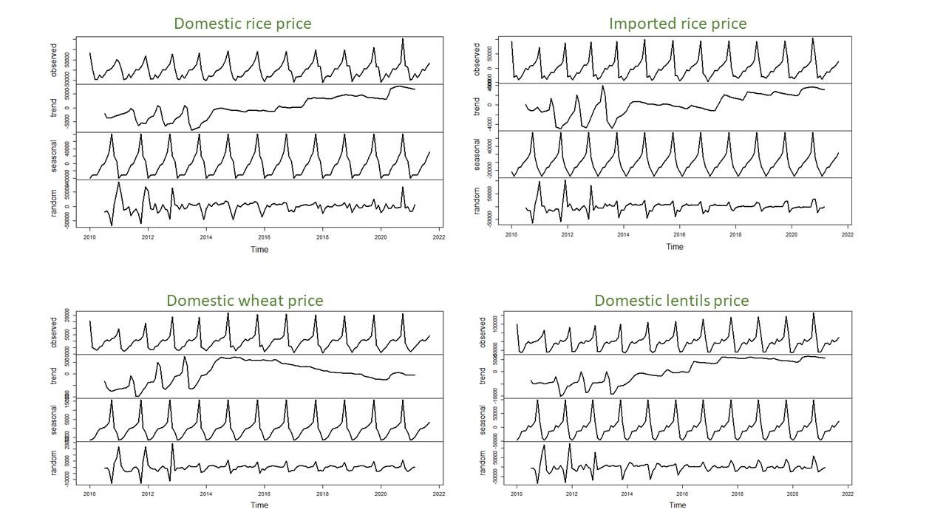

**Figure S4. Decomposition of additive time series for domestic and imported rices prices, domestic wheat prices and domestic lentils prices**