Effects of water hyacinth biochar on lettuce growth in cadmium contaminated soil
Yin Xin^{a,b} Wang yaliª Wei li’eª Huang Huajunª Yu Chenglongª Zhou chunhuo^{a,b}*
a. College of Land Resources and Environment, Jiangxi Agricultural University, Nanchang, Jiangxi, 330045, China
b. Key Innovation Center of Agricultural Waste Resource Utilization and Non-point Source Pollution Prevention and Control of Jiangxi Province, Nanchang, Jiangxi, 330045, China
Fig.S1 Comparison of the lettuce yield after water hyacinth biochar application with different preparation condition
Fig.S2 Comparison of catalase activities before and after application of water hyacinth biochar.

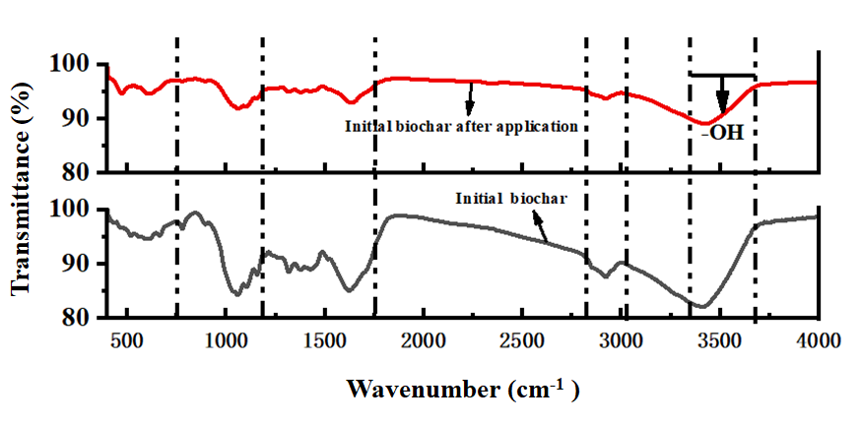
Fig.S3 FTIR analysis of biochar before and after application

