Supplementary Material

# Supplementary Table

Supplementary Table 1. Organic volatile compounds of *S. cerevisiae* identified by SPME-GC-MS on a DB-WAX column.

|  |  |  |  |  |  |
| --- | --- | --- | --- | --- | --- |
| **Compounds** | **CAS** | **RT** | **RIcalc** | **RIpub** | **References** |
| ethyl acetate | 141-78-6 | 4.881 | 879.77 | 880 | 1 |
| unknown-1 | unknown-1 | 4.496 | 901.72 |  |  |
| 3-methylbutanal | 590-86-3 | 5.24 | 921.14 | 921 | 2 |
| unknown-2 | unknown-2 | 5.428 | 936.84 |  |  |
| ethanol | 64-17-5 | 5.555 | 947.45 | 947 | 3 |
| butane-2,3-dione | 431-03-8 | 5.858 | 972.77 | 971 | 4 |
| propan-1-ol | 71-23-8 | 6.735 | 1041.65 | 1942 | 5 |
| 2-methylpropan-1-ol | 78-83-1 | 7.611 | 1106.61 | 1107 | 6 |
| 3-methylbutyl acetate | 123-92-2 | 7.95 | 1128.14 | 1128 | 7 |
| butan-1-ol | 71-36-3 | 8.35 | 1153.56 | 1152 | 8 |
| pentyl acetate | 628-63-7 | 8.651 | 1172.68 | 1172 | 9 |
| 3-methylbutan-1-ol | 123-51-3 | 9.245 | 1211.24 | 1211 | 10 |
| hexan-2-ol | 626-93-7 | 9.305 | 1215.35 | 1216 | 11 |
| ethyl hexanoate | 123-66-0 | 9.561 | 1232.9 | 1233 | 12 |
| unknown-3 | unknown-3 | 10.086 | 1268.88 |  |  |
| 3-hydroxybutan-2-one | 513-86-0 | 10.333 | 1285.81 | 1285 | 1 |
| unknown-4 | unknown-4 | 10.547 | 1300.48 |  |  |
| 3-methylpentan-1-ol | 589-35-5 | 10.732 | 1313.72 | 1313 | 13 |
| 1-hydroxypropan-2-one | 116-09-6 | 10.762 | 1315.87 | 1317 | 14 |
| ethyl 2-hydroxypropanoate | 97-64-3 | 11.232 | 1349.46 | 1349 | 15 |
| unknown-5 | unknown-5 | 11.376 | 1359.76 |  |  |
| ethyl heptanoate | 106-30-9 | 11.431 | 1363.76 | 1342 | 15 |
| unknown-6 | unknown-6 | 11.432 | 1363.76 |  |  |
| ethyl (*E*)-hex-2-enoate | 27829-72-7 | 11.495 | 1368.26 | 1367 | 16 |
| unknown-7 | unknown-7 | 12.312 | 1428.07 |  |  |
| ethyl octanoate | 106-32-1 | 12.472 | 1440.11 | 1441 | 1 |
| heptan-1-ol | 111-70-06 | 12.518 | 1443.57 | 1444 | 17 |
| acetic acid | 64-19-17 | 12.63 | 1451.99 | 1452 | 18 |
| 2-ethylhexan-1-ol | 104-76-7 | 13.098 | 1487.21 | 1488 | 8 |
| 2-ethyl-3,5,6-trimethylpyrazine | 17398-16-2 | 13.163 | 1492.1 | 1491 | 15 |
| 1,1-diethoxynonane | 54815-13-3 | 13.247 | 1498.42 | 1498 | 15 |
| furan-2-ylmethyl acetate | 623-17-6 | 13.581 | 1518.5 | 1518 | 19 |
| benzaldehyde | 100-52-7 | 13.7 | 1525.53 | 1525 | 13 |
| ethyl nonanoate | 123-29-5 | 13.839 | 1533.75 | 1533 | 15 |
| butane-2,3-diol | 513-85-9 | 13.899 | 1537.29 | 1539 | 20 |
| propanoic acid | 79-09-4 | 14.274 | 1559.46 | 1561 | 15 |
| octan-1-ol | 111-87-5 | 14.505 | 1573.11 | 1573 | 21 |
| 2-methylpropanoic acid | 79-31-2 | 14.528 | 1574.47 | 1575 | 22 |
| ethyl decanoate | 110-38-3 | 15.265 | 1639.56 | 1638 | 8 |
| phenyl acetate | 122-79-2 | 15.291 | 1661.54 | 1660 | 23 |
| nonan-1-ol | 143-08-8 | 15.336 | 1665.47 | 1665 | 24 |
| (*E*)-non-2-en-1-ol | 31502-14-4 | 16.002 | 1723.69 | 1722 | 25 |
| ethyl 2-phenylacetate | 101-97-3 | 16.582 | 1774.39 | 1775 | 15 |
| 1-phenylethanol | 98-85-1 | 17.108 | 1819.08 | 1820 | 26 |
| 4-methylpentanoic acid | 646-07-1 | 17.176 | 1824.65 | 1824 | 15 |
| hexanoic acid | 142-62-1 | 17.919 | 1885.5 | 1884.5 | 27 |
| 2-phenylethanol | 60-12-8 | 18.352 | 1922.7 | 1922 | 10 |
| heptanoic acid | 111-14-8 | 18.923 | 1973.32 | 1971 | 28 |
| octanoic acid | 124-07-2 | 19.923 | 2061.97 | 2061 | 29 |
| oxecan-2-one | 6008-27-1 | 20.048 | 2064.18 | 2063 | 30 |
| nonanoic acid | 112-05-0 | 21.085 | 2164.98 | 2164 | 27 |
| CAS = Cas number of compounds, RT = Retention time, RIcalc = Retention index calculated, RIpub = Retention index reported in the literature. | | | | | |

# Supplementary Figures

**Supplementary Figure 1**. Representative GC-EAD trace showing antennal response of female *B. dorsalis* to 1-day old yeast volatiles.

**Supplementary Figure 2.** Nonmetric multidimensional scaling (NMDS) analysis of volatile compounds emanated from the three developmental ages (1-day, 8-days, & 15-days) of the yeast *S. cerevisiae*. Stress value = 0.124.

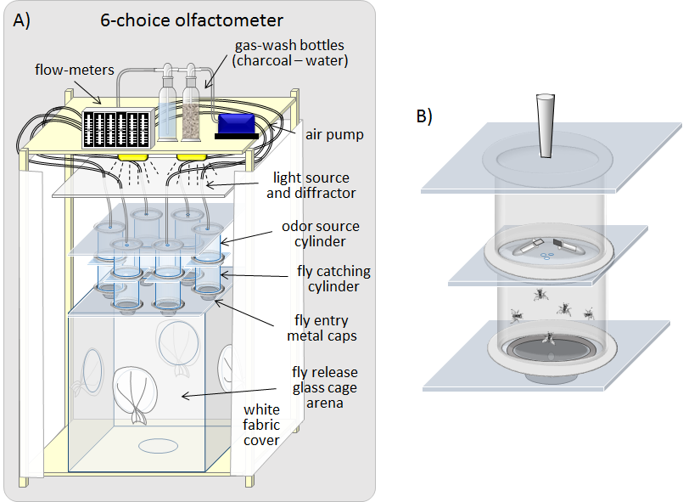

**Supplementary Figure 3.** Schematic drawing of the six-choice olfactometer setup (A), with a close-up view of the odor source cylinder and the fly catching cylinder (B). The apparatus is made up of a 40 x 40 x 40 cm cubic glass cage with 6 circular holes on the top, and large circular holes on the lateral sides and bottom providing access for release and collecting flies. Charcoal filtered and humidified air passes through the odor source cylinders containing each of the six treatments.

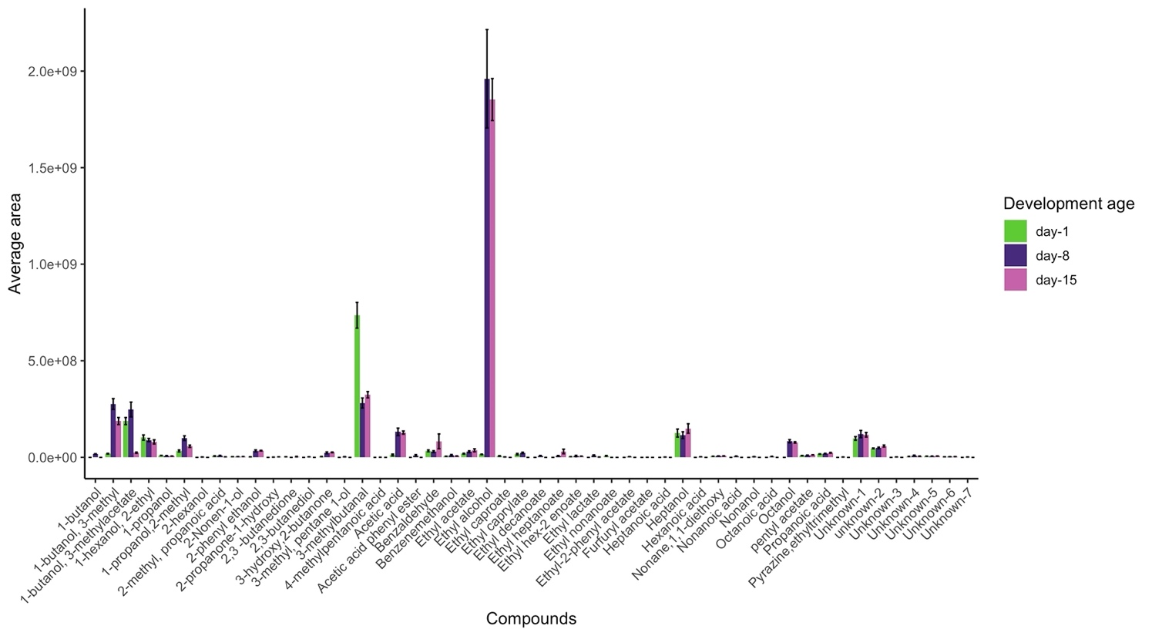

**Supplementary Figure 4.** A bar plot with error bars showing the average peak area of organic volatile compounds emanated from 16 SPME injections of 1-day, 8-days and 15-days old yeast culture.

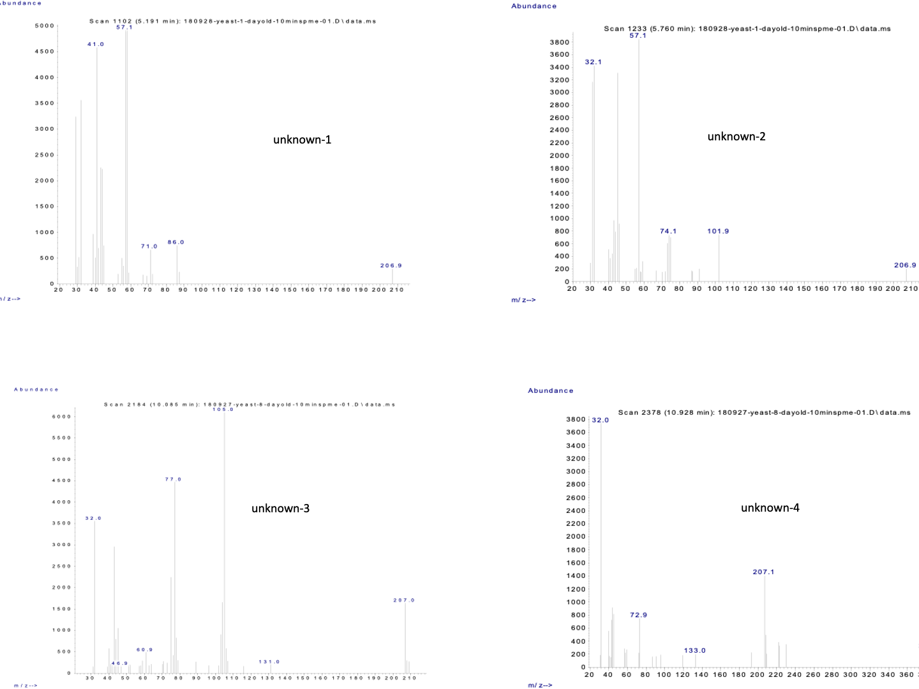

**Supplementary Figure 5.** Mass spectra of compounds for which a spectrum query in the MS library did not return reliable candidate compounds.

.

# References

1. Umano, K., Shoji, A., Hagi, Y., and Shibamoto, T. (1986). Volatile constituents of peel of quince fruit, Cydonia oblonga Miller. *Journal of Agricultural and Food Chemistry* 34, 593–596. doi:10.1021/jf00070a003.
2. Klesk, K., and Qian, M. (2003). Aroma Extract Dilution Analysis of Cv. Marion (Rubus spp. hyb) and Cv. Evergreen (R. laciniatus L.) Blackberries. *Journal of Agricultural and Food Chemistry* 51, 3436–3441. doi:10.1021/jf0262209.
3. Mallia, S., Fernández-García, E., and Olivier Bosset, J. (2005). Comparison of purge and trap and solid phase microextraction techniques for studying the volatile aroma compounds of three European PDO hard cheeses. *International Dairy Journal* 15, 741–758. doi:10.1016/j.idairyj.2004.11.007.
4. Shimoda, M., and Shibamoto, T. (1990). Isolation and identification of headspace volatiles from brewed coffee with an on-column GC/MS method. *Journal of Agricultural and Food Chemistry* 38, 802–804. doi:10.1021/jf00093a045.
5. Kobayashi, A., Tsuda, Y., Hirata, N., Kubota, K., and Kitamura, K. (1995). Aroma Constituents of Soybean [Glycine max (L.) Merril] Milk Lacking Lipoxygenase Isoenzymes. *Journal of Agricultural and Food Chemistry* 43, 2449–2452. doi:10.1021/jf00057a025.
6. Escudero, A., and Etiévant, P. (1999). Effect of antioxidants on the flavor characteristics and the gas chromatography/olfactometry profiles of champagne extracts. *Journal of Agricultural and Food Chemistry* 47, 3303–3308. doi:10.1021/jf9813790.
7. Fan, W., and Qian, M. C. (2005). Headspace solid phase microextraction and gas chromatography−olfactometry dilution analysis of young and aged Chinese “yanghe daqu” liquors. *Journal of Agricultural and Food Chemistry* 53, 7931–7938. doi:10.1021/jf051011k.
8. Zhao, Y., Xu, Y., Li, J., Fan, W., and Jiang, W. (2009). Profile of volatile compounds in 11 brandies by headspace solid-phase microextraction followed by gas chromatography-mass spectrometry. *Journal of Food Science* 74, C90–C99. doi:10.1111/j.1750-3841.2008.01029.x.
9. Hayata, Y., Sakamoto, T., Kozuka, H., Sakamoto, K., and Osajima, Y. (2002). Analysis of Aromatic Volatile Compounds in “Miyabi” Melon (Cucumis melo L.) using the Porapak Q Column. *Engei Gakkai zasshi* 71, 517–525. doi:10.2503/jjshs.71.517.
10. Tatsuka, K., Suekane, S., Sakai, Y., and Sumitani, H. (1990). Volatile constituents of kiwi fruit flowers: Simultaneous distillation and extraction versus headspace sampling. *Journal of Agricultural and Food Chemistry* 38, 2176–2180. doi:10.1021/jf00102a015.
11. Ledauphin, J., Saint-Clair, J.-F., Lablanquie, O., Guichard, H., Founier, N., Guichard, E., et al. (2004). Identification of trace volatile compounds in freshly distilled calvados and cognac using preparative separations coupled with gas chromatography−mass spectrometry. *Journal of Agricultural and Food Chemistry* 52, 5124–5134. doi:10.1021/jf040052y.
12. Hayata, Y., Sakamoto, T., Maneerat, C., Li, X., Kozuka, H., and Sakamoto, K. (2003). Evaluation of aroma compounds contributing to muskmelon flavor in porapak Q extracts by aroma extract dilution analysis. *Journal of Agricultural and Food Chemistry* 51, 3415–3418. doi:10.1021/jf0209950.
13. Selli, S., Canbas, A., Cabaroglu, T., Erten, H., and Günata, Z. (2006). Aroma components of cv. Muscat of Bornova wines and influence of skin contact treatment. *Food Chemistry* 94, 319–326. doi:10.1016/j.foodchem.2004.11.019.
14. Shimoda, M., Shiratsuchi, H., Nakada, Y., Wu, Y., and Osajima, Y. (1996). Identification and sensory characterization of volatile flavor compounds in sesame seed oil. *Journal of Agricultural and Food Chemistry* 44, 3909–3912. doi:10.1021/jf960115f.
15. Fan, W., and Qian, M. C. (2006). Characterization of aroma compounds of Chinese “wuliangye” and “jiannanchun” liquors by aroma extract dilution analysis. *Journal of Agricultural and Food Chemistry* 54, 2695–2704. doi:10.1021/jf052635t.
16. Qian, M. C., and Wang, Y. (2005). Seasonal Variation of Volatile Composition and Odor Activity Value of‘Marion’(Rubus spp. hyb) and‘Thornless Evergreen’(R. laciniatus L.) Blackberries. *Journal of Food Science* 70, C13–C20. doi:10.1111/j.1365-2621.2005.tb09013.x.
17. Ferrari, G., Lablanquie, O., Cantagrel, R., Ledauphin, J., Payot, T., Fournier, N., et al. (2004). Determination of key odorant compounds in freshly distilled cognac using GC-O, GC-MS, and sensory evaluation. *Journal of Agricultural and Food Chemistry* 52, 5670–5676. doi:10.1021/jf049512d.
18. Aznar, M., López, R., Cacho, J. F., and Ferreira, V. (2001). Identification and quantification of impact odorants of aged red wines from Rioja. GC−Olfactometry, quantitative GC-MS, and odor evaluation of HPLC fractions. *Journal of Agricultural and Food Chemistry* 49, 2924–2929. doi:10.1021/jf001372u.
19. Werkhoff, P., Güntert, M., Krammer, G., Sommer, H., and Kaulen, J. (1998). Vacuum headspace method in aroma research:  Flavor chemistry of yellow passion fruits. *Journal of Agricultural and Food Chemistry* 46, 1076–1093. doi:10.1021/jf970655s.
20. Kim, T. H., Shin, J. H., Baek, H. H., and Lee, H. J. (2001). Volatile flavour compounds in suspension culture ofAgastache rugosa Kuntze (Korean mint). *Journal of the Science of Food and Agriculture* 81, 569–575. doi:10.1002/jsfa.845.
21. Mahattanatawee, K., Perez-Cacho, P. R., Davenport, T., and Rouseff, R. (2007). Comparison of three lychee cultivar odor profiles using gas chromatography−olfactometry and gas chromatography−sulfur detection. *Journal of Agricultural and Food Chemistry* 55, 1939–1944. doi:10.1021/jf062925p.
22. Moio, L., Piombino, P., and Addeo, F. (2000). Odour-impact compounds of Gorgonzola cheese. *Journal of Dairy Research* 67, 273–285. doi:10.1017/s0022029900004106.
23. Peng, C. T., Ding, S. F., Hua, R. L., and Yang, Z. C. (1988). Prediction of retention indexes. *Journal of Chromatography A* 436, 137–172. doi:10.1016/s0021-9673(00)94575-8.
24. Parada, F., Duque, C., and Fujimoto, Y. (2000). Free and Bound Volatile Composition and Characterization of Some Glucoconjugates as Aroma Precursors in Melón de Olor Fruit Pulp (Sicana odorifera). *Journal of Agricultural and Food Chemistry* 48, 6200–6204. doi:10.1021/jf0007232.
25. Weckerle, B., Bastl-Borrmann, R., Richling, E., Hör, K., Ruff, C., and Schreier, P. (2001). Cactus pear (Opuntia ficus indica) flavour constituents-chiral evaluation (MDGC-MS) and isotope ratio (HRGC-IRMS) analysis. *Flavour and Fragrance Journal* 16, 360–363. doi:10.1002/ffj.1012.
26. Cho, I. H., Choi, H.-K., and Kim, Y.-S. (2006). Difference in the Volatile Composition of Pine-Mushrooms (Tricholoma matsutake Sing.) According to Their Grades. *Journal of Agricultural and Food Chemistry* 54, 4820–4825. doi:10.1021/jf0601416.
27. Ott, A., Fay, L. B., and Chaintreau, A. (1997). Determination and origin of the aroma impact compounds of yogurt flavor. *Journal of Agricultural and Food Chemistry* 45, 850–858. doi:10.1021/jf960508e.
28. Mahajan, S. S., Goddik, L., and Qian, M. C. (2004). Aroma compounds in sweet whey powder. *Journal of Dairy Science* 87, 4057–4063. doi:10.3168/jds.s0022-0302(04)73547-x.
29. Cha, Y. J., Kim, H., and Cadwallader, K. R. (1998). Aroma-Active compounds in kimchi during fermentation. *Journal of Agricultural and Food Chemistry* 46, 1944–1953. doi:10.1021/jf9706991.
30. López, R., Ortín, N., Pérez-Trujillo, J. P., Cacho, J., and Ferreira, V. (2003). Impact odorants of different young white wines from the Canary Islands. *Journal of Agricultural and Food Chemistry* 51, 3419–3425. doi:10.1021/jf026045w.