# Supporting Information

# For

# Inorganic Nanoparticle Empowered Biomaterial Hybrids: Engineered Payload Release

Lucía Morillas-Becerril, Luisa De Cola, Jonathan M. Zuidema

# Experimental Details

**Preparation of organosilica nanocages (ssOSC).** ssOSCs were fabricated as previously reported [1]. In a 100 mL round-bottom flask equipped with a magnetic stirrer, Hexadecyltrimethylammonium bromide (CTAB) (99+%, ACROS ORGANICS) was dissolved in freshly deionized water (408 mg, 1.12 mmol in 50 mL) at 50 °C while the solution was stirred for 30 min at 250 rpm. Aqueous ammonia (NH3) (28 wt %, Sigma-Aldrich) (12.5 μL of 28% NH3 in H2O) was then added and the stirring speed was increased to 750 rpm. Subsequently, a mixture of tetraethyl orthosilicate (TEOS) (≥99.0%, GC, Sigma-Aldrich) (448.1 μL, 2 mmol), and Bis(triethoxysilylpropyl)disulfide (BTDS) (95%, Fluorochem) (102.8 μL, 0.223 mmol) was added, and the reaction mixture was allowed to stir at 750 rpm overnight at 50 °C. Then Methoxy(polyethyleneoxy)propyltrimethoxysilane (PEG-silane) (6–9 units, 90%, ABCR) (818 μL) was added to the stirring solution, and the reaction mixture was allowed to react under stirring at 750 rpm for 14 h at 50 °C. For surfactant removal and purification, the particle dispersion was purified by dialysis using SnakeSkin dialysis tubing (MWCO 10.000, 22 mm, ThermoScientific) (the dialysis solution was replaced every 5h) against EtOH/H2O/ acetic acid (glacial, extra pure, Sigma-Aldrich) (1/1/0.007 v/v/v) mixture for 48 h, against an EtOH/H2O (1/1 v/v) mixture for 24 h and finally against deionized water for 24 h. The final solution of nanoparticles was transferred to a conical tube and stored in deionized water at 4ºC until needed. 1 mL of the particle solution was lyophilized and subsequently weighed to determine the particle concentration of the final solution.

**Rhodamine 6G loading into ssOSC.** To load OSCs with Rhodamine6G (suitable for fluorescence, BioReagent, Sigma-Aldrich) PEGylated particles (5 mg) were suspended in a solution of the dye (2.5 mg) in water (1 mL). The suspension was vigorously stirred overnight in the dark. Subsequently, the solvent was evaporated, and the particles were then recovered through centrifugation of the dispersion at 14.1 krpm for 30 min. The recovered particles were washed three times in 1 mL cold water. The loading of Rhodamine 6G was evaluated via absorbance spectroscopy following particle breaking via incubation at room temperature in PBS at pH 7 containing 10 mM L-glutathione reduced (GSH) (≥98.0%, Sigma-Aldrich) [2], which indicated a mass loading % ((mass of drug)/(mass of particle +mass of drug) *100) of 2.45% of Rhodamine 6G into ssOSCs.

**Materials Characterization.** The hydrodynamic particle size (Dynamic Light Scattering, DLS) and Z-potential were measured with aMalvern Zetasizer Ultra equipped with a HeNe laser (633nm) and a Peltier thermostatic system in water at 25 ºC. UV-Vis absorption spectra were measured in water on a Shimadzu UV-3600 spectrophotometer double-beam UV–VIS–NIR spectrometer. Infrared spectra were recorded on a FTIR Perkin-Elmer SPECTRUM ONE equipped with RAIR PIKE, Microscope MULTISCOPE Perkin-Elmer and Universal ATR sampling accessory. The spectra (42 scans) were acquired in reflection mode, in the 4000-600 cm-1 range. Transmission electron microscopy was conducted using a Talos L120C (Thermo Fisher Scientific). Images were acquired using a CETA CMOS Camers (4k x 4k) (Thermo Fisher Scientific).

**Incorporation of rhodamine 6G loaded ssOSCs into polyacrylamide hydrogels.** Polyacrylamide hydrogels were made by first dissolving 1090 mg Acrylamide (suitable for electrophoresis, ≥99.0%, Sigma-Aldrich), 10 mg *N,N’*-Methylenebis(acrylamide) (99%, Sigma-Aldrich), and 20 mg lithium phenyl-2,4,6-trimethylbenzoylphosphinate (LAP) (≥95%, Sigma-Aldrich) in 10 mL of phosphate buffered saline (PBS) (0.01M, Sigma-Aldrich) (1.53 M acrylamide, 6.5 mM *N,N’*-Methylenebis(acrylamide), and 6.8 mM LAP). This solution was used to form hydrogel molds by crosslinking via 365 nm UV light (6 watt, analytikjena) for 5 minutes. 800 μL of hydrogel precursor solution was then combined with 200 μL of 5 mg/mL Rhodamine6G-OSC in DIH2O, and this solution was added to the center of the hydrogel molds. Rhodamine6G-OSC were incorporated into the acrylate hydrogel network via UV light crosslinking for 5 minutes. Control hydrogels were made by combining 800 μL of hydrogel precursor solution with 200 μL of a 256 μM solution of rhodamine 6G (final concentration 51.2 μM to match calculated amount of Rhodamine6G loaded into OSCs). Once crosslinked, the hydrogels were soaked in PBS, and PBS solutions were changed at 3 h and 24 h timepoints.

# Supporting Figure

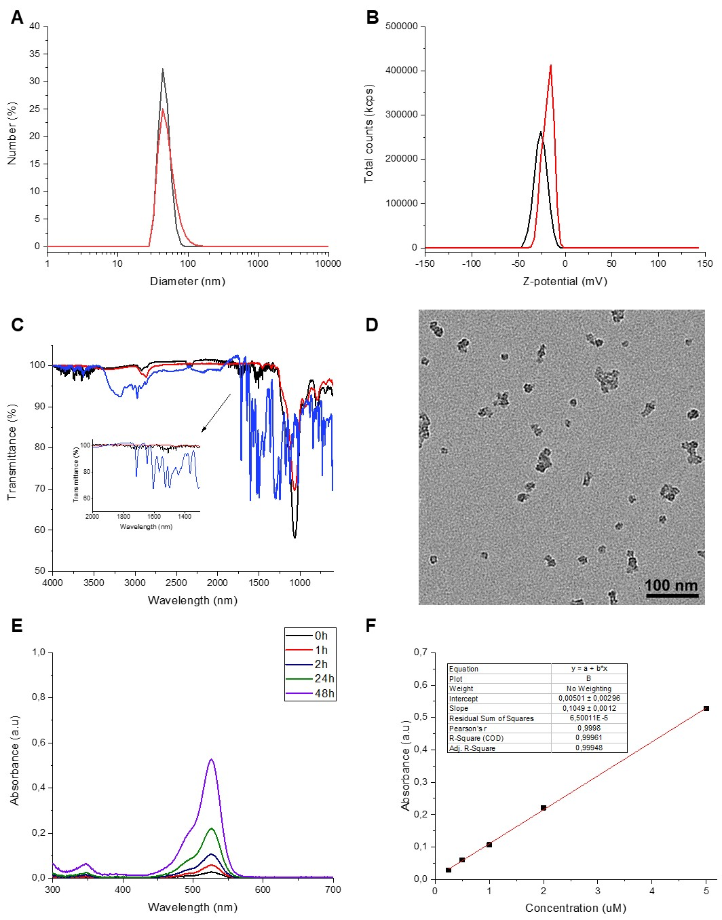

**Figure S1**: Characterization of ssOSCs (red) and Rhodamine 6G loaded ssOSCs (black). **A)** Hydrodynamic size distribution by DLS of ssOSC (44 ± 4 nm) and Rhodamine 6G loaded ssOSC (43 ± 4 nm). **B)** Z-potential of ssOSC (-16 mV) and Rhodamine 6G loaded ssOSC (-20 mV). **C)** FTIR analysis of ssOSC (red), Rhodamine 6G (blue) and Rhodamine 6G loaded ssOSC (black). Characteristic vibrations of the organosilica framework are observed at 3445, 1077, 947 and 805 cm-1, the characteristic vibrations of rhodamine 6G are observed at 3234, 1716, 1646, 1607, 1501, 1360, 1312 and 1181 cm-1. **D)** TEM micrograph of Rhodamine 6G loaded ssOSC. **E)** Absorption spectroscopy over 48h after incubation of Rhodamine 6G loaded ssOSCs with 10 mM GSH in PBS pH 7 at room temperature. Rhodamine 6G encapsulation efficiency was 4.9% (final mass Rhodamine 6G/initial mass Rhodamine 6G). **F)** Calibration curve of Rhodamine 6G in water.

# Supporting References

[1] L. Talamini, P. Picchetti, L. M. Ferreira, G. Sitia, L. Russo, M. B. Violatto, L. Travaglini, J. F. Alarcon, L. Righelli, P. Bigini, L. De Cola, *Acs Nano* **2021**, 15, 9701.

[2] E. A. Prasetyanto, A. Bertucci, D. Septiadi, R. Corradini, P. Castro-Hartmann, L. De Cola, *Angew Chem Int Ed Engl* **2016**, 55, 3323.