Supplementary Material
Emotion has no impact on attention in a change detection flicker task

Robert C. A. Bendall*, and Catherine Thompson
* Correspondence: Robert Bendall: r.c.a.bendall@salford.ac.uk

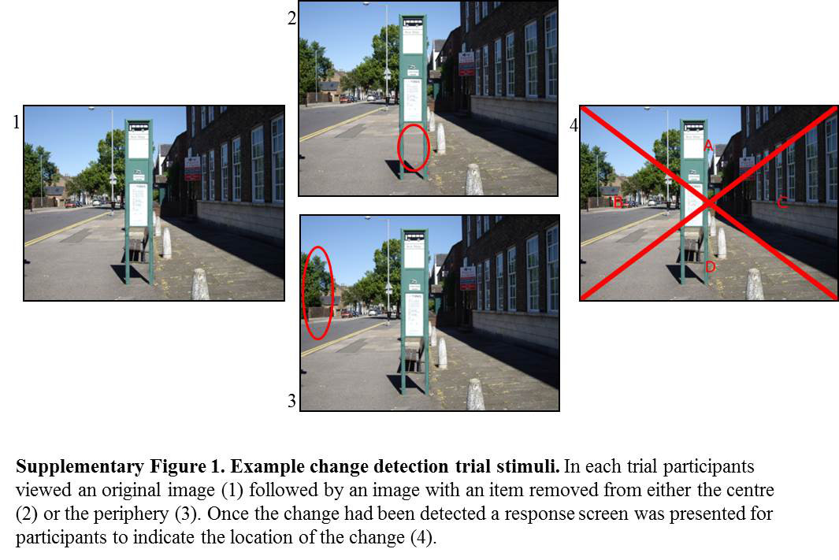

Supplementary Table 1. Emotional valence and arousal ratings of images used during emotion induction procedure taken from the International Affective Picture System (Lang et al., 2008).

Positive images |  |  | Neutral images |  |  | Negative images
IAPS number | Valence | Arousal | IAPS number | Valence | Arousal | IAPS number | Valence | Arousal
1610 | 7.82 | 3.98 | 2101 | 4.49 | 3.46 | 2141 | 2.44 | 5.00
2058 | 7.91 | 5.09 | 2210 | 4.54 | 3.32 | 2205 | 1.95 | 4.53
2150 | 7.92 | 5.00 | 2215 | 4.63 | 3.38 | 2375 | 2.20 | 4.88
2314 | 7.55 | 4.00 | 2221 | 4.39 | 3.07 | 2900 | 2.56 | 4.61
2360 | 7.70 | 3.66 | 2383 | 4.72 | 3.41 | 3215 | 2.51 | 5.44
2398 | 7.48 | 4.74 | 5130 | 4.45 | 2.51 | 3220 | 2.49 | 5.52
2530 | 7.80 | 3.99 | 7025 | 4.63 | 2.71 | 9000 | 2.55 | 4.06
4622 | 7.46 | 4.11 | 7030 | 4.69 | 2.99 | 9007 | 2.49 | 5.03
5480 | 7.53 | 5.48 | 7031 | 4.52 | 2.03 | 9140 | 2.19 | 5.38
5700 | 7.61 | 5.68 | 7040 | 4.69 | 2.69 | 9332 | 2.25 | 5.34
5780 | 7.52 | 3.75 | 7044 | 4.69 | 3.94 | 9340 | 2.41 | 5.16
5829 | 7.65 | 4.68 | 7110 | 4.55 | 2.27 | 9419 | 2.55 | 5.19
7270 | 7.53 | 5.76 | 7130 | 4.77 | 3.35 | 9420 | 2.31 | 5.69
7502 | 7.75 | 5.91 | 7150 | 4.72 | 2.61 | 9421 | 2.21 | 5.04
7580 | 7.71 | 4.59 | 7180 | 4.73 | 3.43 | 9435 | 2.27 | 5.00
8200 | 7.54 | 6.35 | 7186 | 4.63 | 3.60 | 9560 | 2.12 | 5.50
8370 | 7.77 | 6.73 | 7224 | 4.45 | 2.81 | 9561 | 2.68 | 4.79
8380 | 7.56 | 5.74 | 7590 | 4.77 | 3.80 | 9810 | 2.09 | 6.62
8499 | 7.63 | 6.07 | 7705 | 4.77 | 2.65 | 9830 | 2.54 | 4.86
8502 | 7.51 | 5.78 | 8121 | 4.63 | 4.14 | 9901 | 2.27 | 5.70
 | M = 7.65 | M = 5.05 |  | M = 4.62 | M = 3.11 |  | M = 2.35 | M = 5.17

Supplementary Table 2. Emotional valence and arousal ratings of positive images presented at the end of the experimental session taken from the International Affective Picture System (Lang et al., 2008).

IAPS number | Valence | Arousal
1460 | 8.21 | 4.31
1710 | 8.34 | 5.41
1750 | 8.28 | 4.10
1920 | 7.90 | 4.27
2154 | 8.03 | 4.48
2332 | 7.64 | 4.30
2340 | 8.03 | 4.90
4626 | 7.60 | 5.78
5621 | 7.57 | 5.19
5760 | 8.05 | 3.22
5825 | 8.03 | 5.46
5830 | 8.00 | 4.92
5833 | 8.22 | 5.71
5910 | 7.80 | 5.59
7330 | 7.69 | 5.14
7405 | 7.38 | 6.28
8470 | 7.74 | 6.14
8496 | 7.58 | 5.79
8501 | 7.91 | 6.44
8540 | 7.48 | 5.16
 | M = 7.87 | M = 5.13

