Supplementary Material
A novel multivariate approach to phenotyping and association mapping of multi-locus gametophytic self-incompatibility reveals S, Z and other loci in a perennial ryegrass (Poaceae) population
Daniel Thorogood^{1*}, Steven Yates², Chloé Manzanares², Leif Skot¹, Matthew Hegarty¹, Tina Blackmore^{1,4}, Susanne Barth³, Bruno Studer²
Correspondence: Corresponding author: dnt@aber.ac.uk

Supplementary Data

Supplementary Figures and Tables
Supplementary Table 1. Correlation coefficients (R) of within and between half-sib family pollinations made in 2013 and 2015.
 |  | ♂
 |  | h-sib 1 | h-sib 2 | h-sib 3 | h-sib 4
♀ | h-sib 1 | 0.60 | 0.42 | 0.74 | 0.52 | 0.67
 | h-sib 2 | 0.43 | 0.64 | 0.54 | 0.63 | 0.69
 | h-sib 3 | 0.63 | 0.65 | 0.83 | 0.63 | 0.73
 | h-sib 4 | 0.55 | 0.55 | 0.61 | 0.71 | 0.64
 |  | 0.63 | 0.70 | 0.72 | 0.61 | 0.68

All correlations P < 0.001 (degrees of freedom ranging between 98 and 223)

Supplementary Table 2. Correlation coefficients (R) pollinations made of each genotype as female or male parent with other members of the population.
Genotype | ♀ | df | P | ♂ | df | P |  | Genotype | ♀ | df | P | ♂ | df | P
5 | 0.80 | 40 | <.001 | 0.53 | 48 | <.001 |  | 222 | 0.82 | 41 | <.001 | 0.68 | 36 | <.001
12 | 0.66 | 37 | <.001 | 0.96 | 48 | <.001 |  | 223 | 0.74 | 35 | <.001 | 0.56 | 49 | <.001
27 | 0.57 | 33 | <.001 | 0.58 | 34 | <.001 |  | 228 | 0.92 | 40 | <.001 | 0.66 | 44 | <.001
33 | 0.45 | 41 | <.01 | 0.69 | 22 | <.001 |  | 231 | 0.67 | 36 | <.001 | 0.71 | 14 | <.01
39 | 0.62 | 36 | <.001 | 0.67 | 47 | <.001 |  | 233 | 0.67 | 31 | <.001 | 0.89 | 24 | <.001
42 | 0.74 | 41 | <.001 | 0.41 | 38 | <.05 |  | 235 | 0.95 | 36 | <.001 | 0.89 | 46 | <.001
43 | 0.72 | 33 | <.001 | 0.30 | 43 | <.05 |  | 238 | 0.58 | 32 | <.001 | 0.50 | 45 | <.001
45 | 0.70 | 35 | <.001 | 0.86 | 32 | <.001 |  | 294 | 0.60 | 27 | <.001 | 0.79 | 13 | <.01
46 | 0.78 | 45 | <.001 | 0.67 | 34 | <.001 |  | 295 | 0.48 | 35 | <.01 | 0.72 | 44 | <.001
47 | 0.46 | 38 | <.01 | 0.62 | 12 | <.05 |  | 298 | 0.81 | 34 | <.001 | 0.48 | 46 | <.001
115 | 0.85 | 41 | <.001 | 0.79 | 42 | <.001 |  | 301 | 0.63 | 38 | <.001 | 0.88 | 33 | <.001
123 | 0.65 | 36 | <.001 | 0.57 | 38 | <.001 |  | 307 | 0.67 | 41 | <.001 | 0.75 | 33 | <.001
131 | 0.89 | 30 | <.001 | 0.63 | 34 | <.001 |  | 314 | 0.60 | 42 | <.001 | 0.63 | 30 | <.001
132 | 0.79 | 43 | <.001 | 0.89 | 48 | <.001 |  | 318 | 0.69 | 37 | <.001 | 0.58 | 18 | <.05
133 | 0.67 | 40 | <.001 | 0.61 | 49 | <.001 |  | 320 | 0.37 | 40 | <.05 | 0.56 | 45 | <.001
134 | 0.84 | 36 | <.001 | 0.42 | 33 | <.01 |  | 323 | 0.00 | 27 | NS | 0.91 | 41 | <.001
136 | 0.50 | 35 | <.01 | 0.76 | 34 | <.001 |  | 329 | 0.83 | 40 | <.001 | 0.71 | 47 | <.001
138 | 0.69 | 45 | <.001 | 0.90 | 46 | <.001 |  | 331 | 0.90 | 39 | <.001 | 0.69 | 42 | <.001
143 | 0.64 | 27 | <.001 | 0.70 | 48 | <.001 |  | 332 | 0.80 | 37 | <.001 | 0.69 | 46 | <.001
145 | 0.53 | 42 | <.001 | 0.83 | 27 | <.001 |  | 334 | 0.45 | 26 | <.05 | 0.15 | 15 | NS
148 | 0.56 | 46 | <.001 | 0.51 | 46 | <.001 |  | 337 | 0.53 | 34 | <.001 | 0.62 | 34 | <.001
204 | 0.96 | 35 | <.001 | 0.79 | 31 | <.001 |  | 342 | 0.66 | 31 | <.001 | 0.70 | 18 | <.01
213 | 0.78 | 38 | <.001 | 0.82 | 45 | <.001 |  | 345 | 0.82 | 31 | <.001 | 0.58 | 39 | <.001
216 | 0.69 | 43 | <.001 | 0.93 | 34 | <.001 |  | 347 | 0.82 | 40 | <.001 | 0.68 | 41 | <.001
218 | 0.66 | 34 | <.001 | 0.84 | 32 | <.001 |  | 348 | 0.74 | 30 | <.001 | 0.73 | 40 | <.001

Supplementary Table 3 Summary statistics for numbers and density of SNP markers mapped using the integrated map of Blackmore et al. 2015).
Linkage group | Length (cM) | Number of markers | Mapped marker density (n/cM) | Number of markers | Mapped marker density (n/cM)
 |  | 2013 |  | 2015
1 | 87.6 | 236 | 2.69 | 237 | 2.71
2 | 127.0 | 251 | 1.98 | 251 | 1.98
3 | 99.2 | 257 | 2.59 | 257 | 2.59
4 | 131.2 | 330 | 2.52 | 331 | 2.52
5 | 89.2 | 153 | 1.72 | 153 | 1.72
6 | 114.0 | 267 | 2.34 | 267 | 2.34
7 | 106.0 | 278 | 2.62 | 278 | 2.62
Total mapped | 754.2 | 1772 | 2.35 | 1774 | 2.35
Unmapped |  | 689 |  | 690
Total mapped and unmapped |  | 2461 |  | 2464

Supplementary Figures
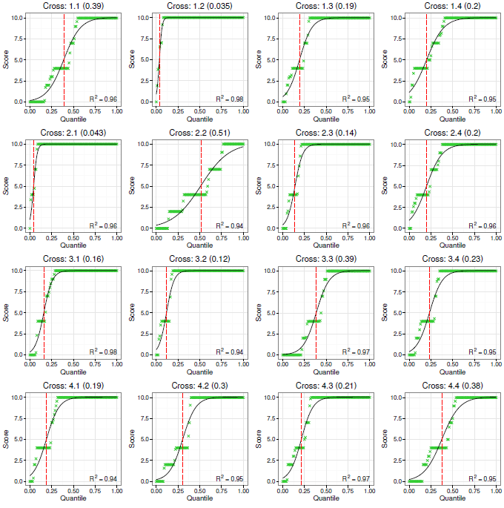

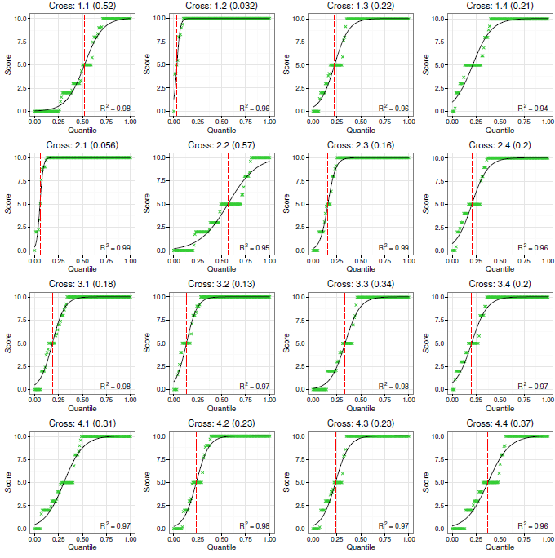

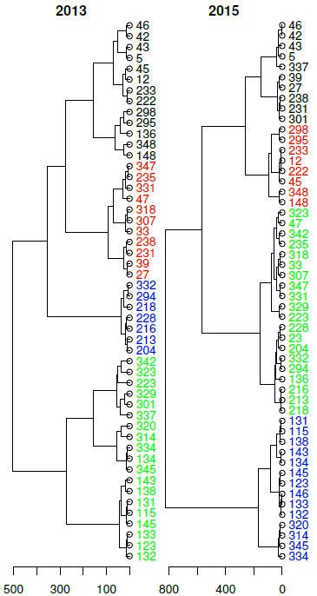

Supplementary Figure 1. 2013 cross-compatibility quantiles within and between half-sib families. Compatibility score (1-10, y-axis) is plotted against quantile (every 0.01, x-axis). Cross numbers in each graph title are given as two numbers (x.y), the first designating the maternal half-sib family and the second, the paternal half-sib family and is then followed by the SI₅₀ score in brackets. The quantiles are shown as green crosses and the predictions of the modelling as a solid black line. The SI₅₀ is shown as a vertical red dashed line. R² for the model is shown in the lower right corner of each graph.

Supplementary Figure 2. 2015 cross-compatibility quantiles within and between half-sib families. Compatibility score (1-10, y-axis) is plotted against quantile (every 0.01, x-axis). Cross numbers in each graph title are given as two numbers (x.y), the first designating the maternal half-sib family and the second, the paternal half-sib family and is then followed by the SI₅₀ score in brackets. The quantiles are shown as green crosses and the predictions of the modelling as a solid black line. The SI₅₀ is shown as a vertical red dashed line. R² for the model is shown in the lower right corner of each graph.

Supplementary Figure 3. Dendrograms showing principal components for 2013 and 2015 of cross-compatibility scores. The genotype numbers (5-47 = half-sib family 1; 115-148 = half-sib family 2; 204-298 = half-sib family 3; 301-348 = half-sib family 4) are coloured based on hierarchical clustering into four groups using the Ward method.

