Supplementary Material
New Alpiniamides from Streptomycetes sp. 11-12 assembled by an unusual hybrid-nonribosomal peptide synthetase-transAT-polyketidesynthase enzyme

Constanze Paulus ¹, Yuriy Rebets ², Josef Zapp², Christian Rückert³, Jörn Kalinowski³, Andriy Luzhetskyy ^{1, 2,}*
¹ Helmholtz-Institute for Pharmaceutical Research, Saarbrücken, Germany
² Department for pharmaceutical Biotechnology, University of Saarland, Saarbrücken, Germany
³ Center for Biotechnology (CeBiTec), Bielefeld University, Bielefeld, Germany

Supplementary Data
Supplementary Material should be uploaded separately on submission. Please include any supplementary data, figures and/or tables.

Supplementary Figures and Tables

Supplementary tables
Table S1. Primer used in this work.
Name | sequence
11-12_12720ChF | TCGACAGACAGCTGCCCTG
11-12_12720ChR | GCACACAGTAGAACGTGTTG
11-12_12715ChF | ACCCGAAGTTCGTGGTCCTG
11-12_12715ChR | CGGACCGTTGCGTGTTCACA
11-12_12695ChF | CACGCTGGTGTTCGACTACC
11-12_12695ChR | AGAGCTCTTCGATGGGGTAG
11-12_12720DF | TGGGGCGCCCCCGGTTCCTCGGTTAGCCTGAGTGACATATGAAACTACGCCCCCAACTGAGAG
11-12_12720DR | GGAAGGGCCGGGAACCCTGATCTCCGCCGTCAGCGCTTGACTCGACCCGGTACCGGAGTA
11-12_12715DF | CACGGGCGACGCAGACGCGAGACTCTGGAGGGGCCGTGCAACTACGCCCCCAACTGAGAG
11-12_12715DR | GACGCGTCGCGCCACCGCGAGCCAGCGCCTCACCGCCGCACTCGACCCGGTACCGGAGTA
11-12_12695DF | TGAGAGGGAACGAGAAGTGAAGACAGAGGCCCTGTTCATCGACTACGCCCCCAACTGAGAG
11-12_12695DR | CCCTGTCCCGGGAACACGTAGCAGCGCATCAGAGCCGCCCGCTCGACCCGGTACCGGAGTA
C9-2REcV | atGATATCATCCAGGAGATGATCTCGCG
C9-2FEcI | atGAATTCAATCTGGACCGCAACGGCCT
C9-1FEcV | atGATATCG CCTGAAGGACCAACTCGT
C9-1RXba | atTCTAGAACTTCGATGGGAT CGCCGA
11-12DelCheckF | AAGTGCTGGTCGAGGACGTA
11-12DelCheckR | TACGCCTGGCTGATGG AGAT
11-12C9TarF1Not | ATGCGGCCGCAACGGCGTGAAGCCGAAGAT
11-12C9TarR1Nhe | ATGCTAGCGAATGCTGCTCATGGGGTGT
11-12C9TarF2NheI | ATGCTAGCCTGCACACGATCATCAGCGA
11-12C9TarR2HindIII | ATAAGCTTGATTGGACGGAATGTCCGTG
11-12C9CheckHind | GACGAC ACGTACTACCAGGA
pCLYCheckHind | CTCTTCGGTGAACTTCGGG
Sequence highlighted in yellow anneal with the priming sites of hygromycin resistance cassette from patt-shyg-oriT.

Table S2. Secondary metabolism gene clusters identified within the genome of Streptomyces sp. IB2014/011-12 with the use of the antiSMASH software.
BGC | Type | Most similar known cluster.
1 | Lantipeptide | AmfS antibiotic (Ueda et al., 2002)
2 | Terpene | -
3 | Lassopeptide | Lassopetide similar to SRO15-2005 (Kersten et al., 2011)
4 | Lantipeptide | -
5 | Siderophore | Desferrioxamine B (Barona-Gómez et al., 2004)
6 | Bacteriocin | -
7 | Butyrolactone | -
8 | Terpene | -
9 | NRPS-Trans-at-type 1-PKS | -
10 | Melanin-NRPS | Peptide similar to Coelichelin (Challis and Ravel, 2000)
11 | Type 3 PKS | -
12 | NRPS | -
13 | type 1 PKS-NRPS | Similar to polycyclic tetramate macrolactams (Luo et al., 2013)
14 | Terpene | Squalene antibiotic similar to Hopene (Pan et al., 2015)
16 | Type 1 PKS | -
17 | Other | Riboflavin antibiotic similar to Roseoflavin (Schwarz et al., 2016)
18 | Terpene | -
19 | thiopeptide | -
20 | Melanin | Phenoxazinone antibiotic Grixazone (Suzuki et al., 2007)
21 | Ectoine | Ectoine (Zhu et al., 2014)
22 | NRPS | -
23 | Type 3 PKS | Alkylresorcinol (Cook et al., 2010)
24 | Melanin | Dihydroxynaphthalene Melanin (Woo et al., 2010)
25 | NRPS | -
26 | Siderophore | -
27 | Type 2 PKS | -
28 | Terpene | -
29 | NRPS | -

Table S3. NMR spectroscopic data (MeOD₄) for alpiniamides 1-5.
Position | (1) |  | (1)¹ |  | (2) |  | (3) |  | (4) |  | (5)
 | δ_{C} ª | δ_{H} ^{b} | δ_{C} ª | δ_{H} ^{b} | δ_{C} ª | δ_{H} ^{b} | δ_{C} ª | δ_{H} ^{b} | δ_{C} ª | δ_{H} ^{b} | δ_{C} ª | δ_{H} ^{b}
1 | 178.3, C |  | 176.75, C |  | 178.0, C |  | 177.2, C |  | 178.2, C |  | 172.2, C
2 | 45.1, CH | 2.54, dq (9.5, 7.0) | 44.28, CH | 2.52, dq (9.5, 7.0) | 40.4, CH | 3.36, dq (9.5, 7.0) | 40.5, CH | 3.36, dq (9.5, 7.0) | 45.5, CH | 2.56, dq (9.5, 7.1) | 130.7, C
3 | 81.0, CH | 3.98, d (9.5) | 80.40, CH | 4.03, d (9.5) | 126.6, CH | 5.43, br d (9.3) | 127.2, CH | 5.43, br d (9.3) | 81.0, CH | 3.98, d (9.5) | 139.4, CH | 6.39, tq (7.2, 1.5)
4 | 135.1, C |  | 133.13, C |  | 140.6, C |  | 139.8, C |  | 135.0, C |  | 22.3, C | 2.20, quint (7.5, 1.0)
5 | 131.8, CH | 5.41, t (7.2) | 131.94, CH | 5.40, t (7.2) | 79.3, CH | 3.85, t (6.7) | 79.8, CH | 3.85, t (6.8) | 132.0, CH | 5.42, t (7.3) | 13.2, CH₃ | 1.05, t (7.5)
6 | 21.5, CH₂ | 2.06, quint (7.5) | 20.85, CH₂ | 2.02, quint (7.5) | 28.5, CH₂ | 1.54, m | 28.1, CH₂ | 1.55, m | 21.5, CH₂ | 2.06, quint (7.5) | 12.2, CH₃ | 1.85, br s
7 | 14.1, CH₃ | 0.97, t (7.5) | 13.88, CH₃ | 0.94, t (7.5) | 10.1, CH₃ | 0.85, t (7.5) | 10.3, CH₃ | 0.85, t (7.5) | 14.2, CH₃ | 0.97, t (7.5)
8 | 14.8, CH₃ | 0.93, d (7.0) | 14.38, CH₃ | 0.95, d (7.0) | 18.5, CH₃ | 1.22, d (7.0) | 18.6, CH₃ | 1.20, d (7.0) | 14.7, CH₃ | 0.94, d (7.0)
9 | 10.3, CH₃ | 1.60, s | 10.41, CH₃ | 1.57, s | 11.6, CH₃ | 1.66, d (1.5) | 11.1, CH₃ | 1.66, d (1.5) | 10.5, CH₃ | 1.61, s
1’ | 178.4, C |  | 179.03, C |  | 178.7, C |  | 178.3, C |  | 180.8, C |  | 178.1, C
2’ | 44.6, CH | 2.50, quint (7.0) | 42.71, CH | 2.54, quint (7.0) | 44.60, CH | 2.48, quint (7.0) | 44.7, CH | 2.47, quint (7.0) | 44.3, CH | 3.41, dq (9.5, 7.1) | 44.4, CH | 2.55, quint (7.1)
3’ | 74.2, CH | 4.01, ddd (7.0, 5.3, 1.5) | 73.54; CH | 4.02, m | 74.4, CH | 3.96, ddd (7.0, 5.3, 1.5) | 74.4, CH | 3.95, ddd (7.0, 5.3, 1.5) | 146.7, CH | 6.87, dq (9.5, 1.5) | 74.1, CH | 4.03, dd (7.1, 5.3)
4’ | 47.7, CH | 2.92, qd (7.0, 5.3) | 47.23, CH | 2.79, d (7.0, 4.5) | 47.9, CH | 2.87, qd (7.0, 5.5) | 48.1, CH | 2.88, qd (7.0, 5.5) | 135.0, CH |  | 47.7, CH | 2.93, qd (7.1, 5.3)
5’ | 209.9, C |  | 209.27, C |  | 209.5, C |  | 209.1, C |  | 197.4, C |  | 209.9, C
6’ | 49.0, CH₂ | 4.13, d (18.5)  4.25, d (18.5) | 48.81, CH₂ | 4.19, dd (19.0, 5.0)  4.29, dd (19.0, 5.5) | 48.8 CH₂ | 4.12, d (18.5)  4.16, d (18.5) | 48.8, CH₂ | 4.13, d (18.5)  4.17, d (18.5) | 46.0, CH₂ | 4.44, d (18.5)  4.48, d (18.5) | 49.0, CH₂ | 4.18, d (18.5)  4.22, d (18.5)
7’ | 15.0, CH₃ | 1.16, d (7.0) | 14.49, CH₃ | 1.17, d (7.0) | 14.9, CH₃ | 1.15, d (7.0) | 15.0, CH₃ | 1.15, d (7.0) | 18.4, CH₃ | 1.30, d (7.0) | 14.8, CH₃ | 1.15, d (7.0)
8’ | 10.5, CH₃ | 1.13, d (7.0) | 9.79, CH₃ | 1.14, d (7.0) | 10.8, CH₃ | 1.12, d (7.0) | 10.8, CH₃ | 1.12, d (7.0) | 11.2, CH₃ | 1.82, d (1.5) | 10.6, CH₃ | 1.14, d (7.0)
NH |  |  |  | 7.09, t (5.3)

¹ = NMR data aquired in CDCl₃; ª = followed by multiplicity; ^{b} = followed by coupling constant J in Hz; all ¹³C chemical shifts were taken from 2D spectra HSQC/HMBC except for (1) in CDCl₃.
Table S4. ¹H chemical shifts (in ppm, recorded in CDCl₃) and ∆δ_{(S-R)} values for Mosher derivatives 6R and 6S of alpiniamide A (1), 7R and 7S of alpiniamide B₁ (2) and 8R and 8S of alpiniamide B₂ (3).
Position | (1) |  |  | (2) |  |  | (3)
 | 6S δ_{H} | 6R δ_{H} | ∆δ_{(S-R)} | 7S δ_{H} | 7R δ_{H} | ∆δ_{(S-R)} | 8S δ_{H} |  | 8R δ_{H} | ∆δ_{(S-R)}
1 | - | - | - | - | - | - | - | - |  | -
2 | 2.69 | 2.72 | -0.03 | 3.32 | 3.36 | -0.04 | 3.40 | 3.36 |  | +0.04
3 | 5.53 | 5.48 | +0.05 | 5.60 | 5.67 | -0.07 | 5.64 | 5.57 |  | +0.07
4 | - | - | - | - | - | - | - | - |  | -
5 | 5.75 | 5.69 | +0.06 | 5.17 | 5.20 | -0.03 | 5.31 | 5.26 |  | +0.04
6 | 2.04 | 2.00 | +0.04 | 1.68 | 1.64 | +0.04 | 1.70 | 1.74 |  | -0.04
7 | 0.95 | 0.93 | +0.02 | 0.90 | 0.82 | +0.08 | 0.83 | 0.89 |  | -0.06
8 | 1.01 | 1.02 | -0.01 | 1.25 | 1.30 | -0.05 | 1.26 | 1.25 |  | +0.01
9 | 1.58 | 1.41 | +0.17 | 1.54 | 1.69 | -0.15 | 1.70 | 1.53 |  | +0.17
1’ | - | - | - | - | - | - | - | - |  | -
2’ | 2.96 | 3.00 | -0.04 | 3.42 | 3.46 | -0.04 | 3.46 | 3.45 |  | +0.01
3’ | 4.21 | 4.20 | +0.01 | 4.29 | 4.28 | +0.01 | 4.39 | 4.38 |  | +0.01
4’ | 3.46 | 3.42 | +0.04 | 3.02 | 3.00 | +0.02 | 3.07 | 3.05 |  | +0.02
5’ | - | - | - | - | - | - | - | - |  | -
6’ | 4.11  3.78 | 4.26  4.01 | -0.15  -0.23 | n.d.  n.d. | n.d.  n.d. | -  - | n.d.  n.d. | n.d.  n.d. |  | -  -
7’ | 1.27 | 1.22 | +0.05 | 1.37 | 1.36 | +0.01 | 1.38 | 1.37 |  | +0.01
8’ | 1.37 | 1.35 | +0.02 | 1.29 | 1.27 | +0.02 | 1.30 | 1.30 |  | 0

n.d.: not detected due to overlap with MTPA signals.

Supplementary Figures
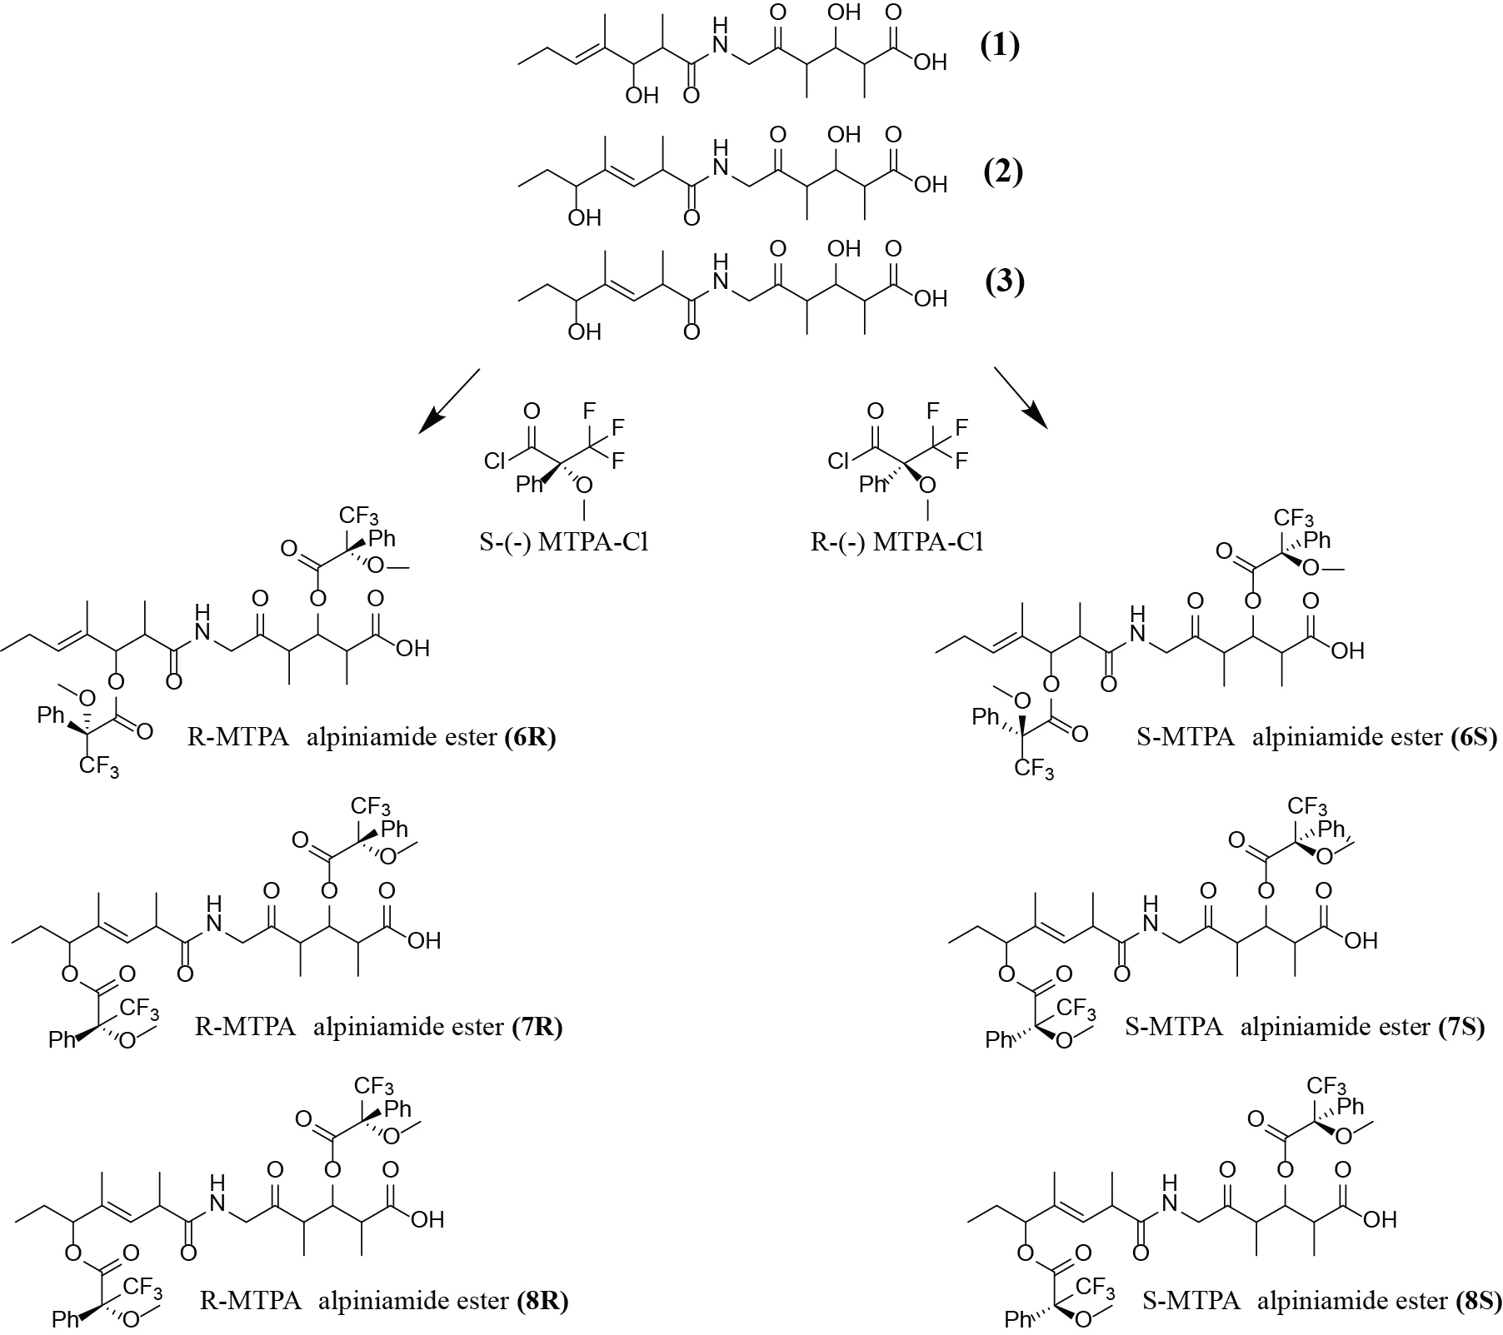

Supplementary figure S1. Reaction of alpiniamides with R-MTPA-Cl and S-MTPA-Cl in order to determine the absolute configuration.

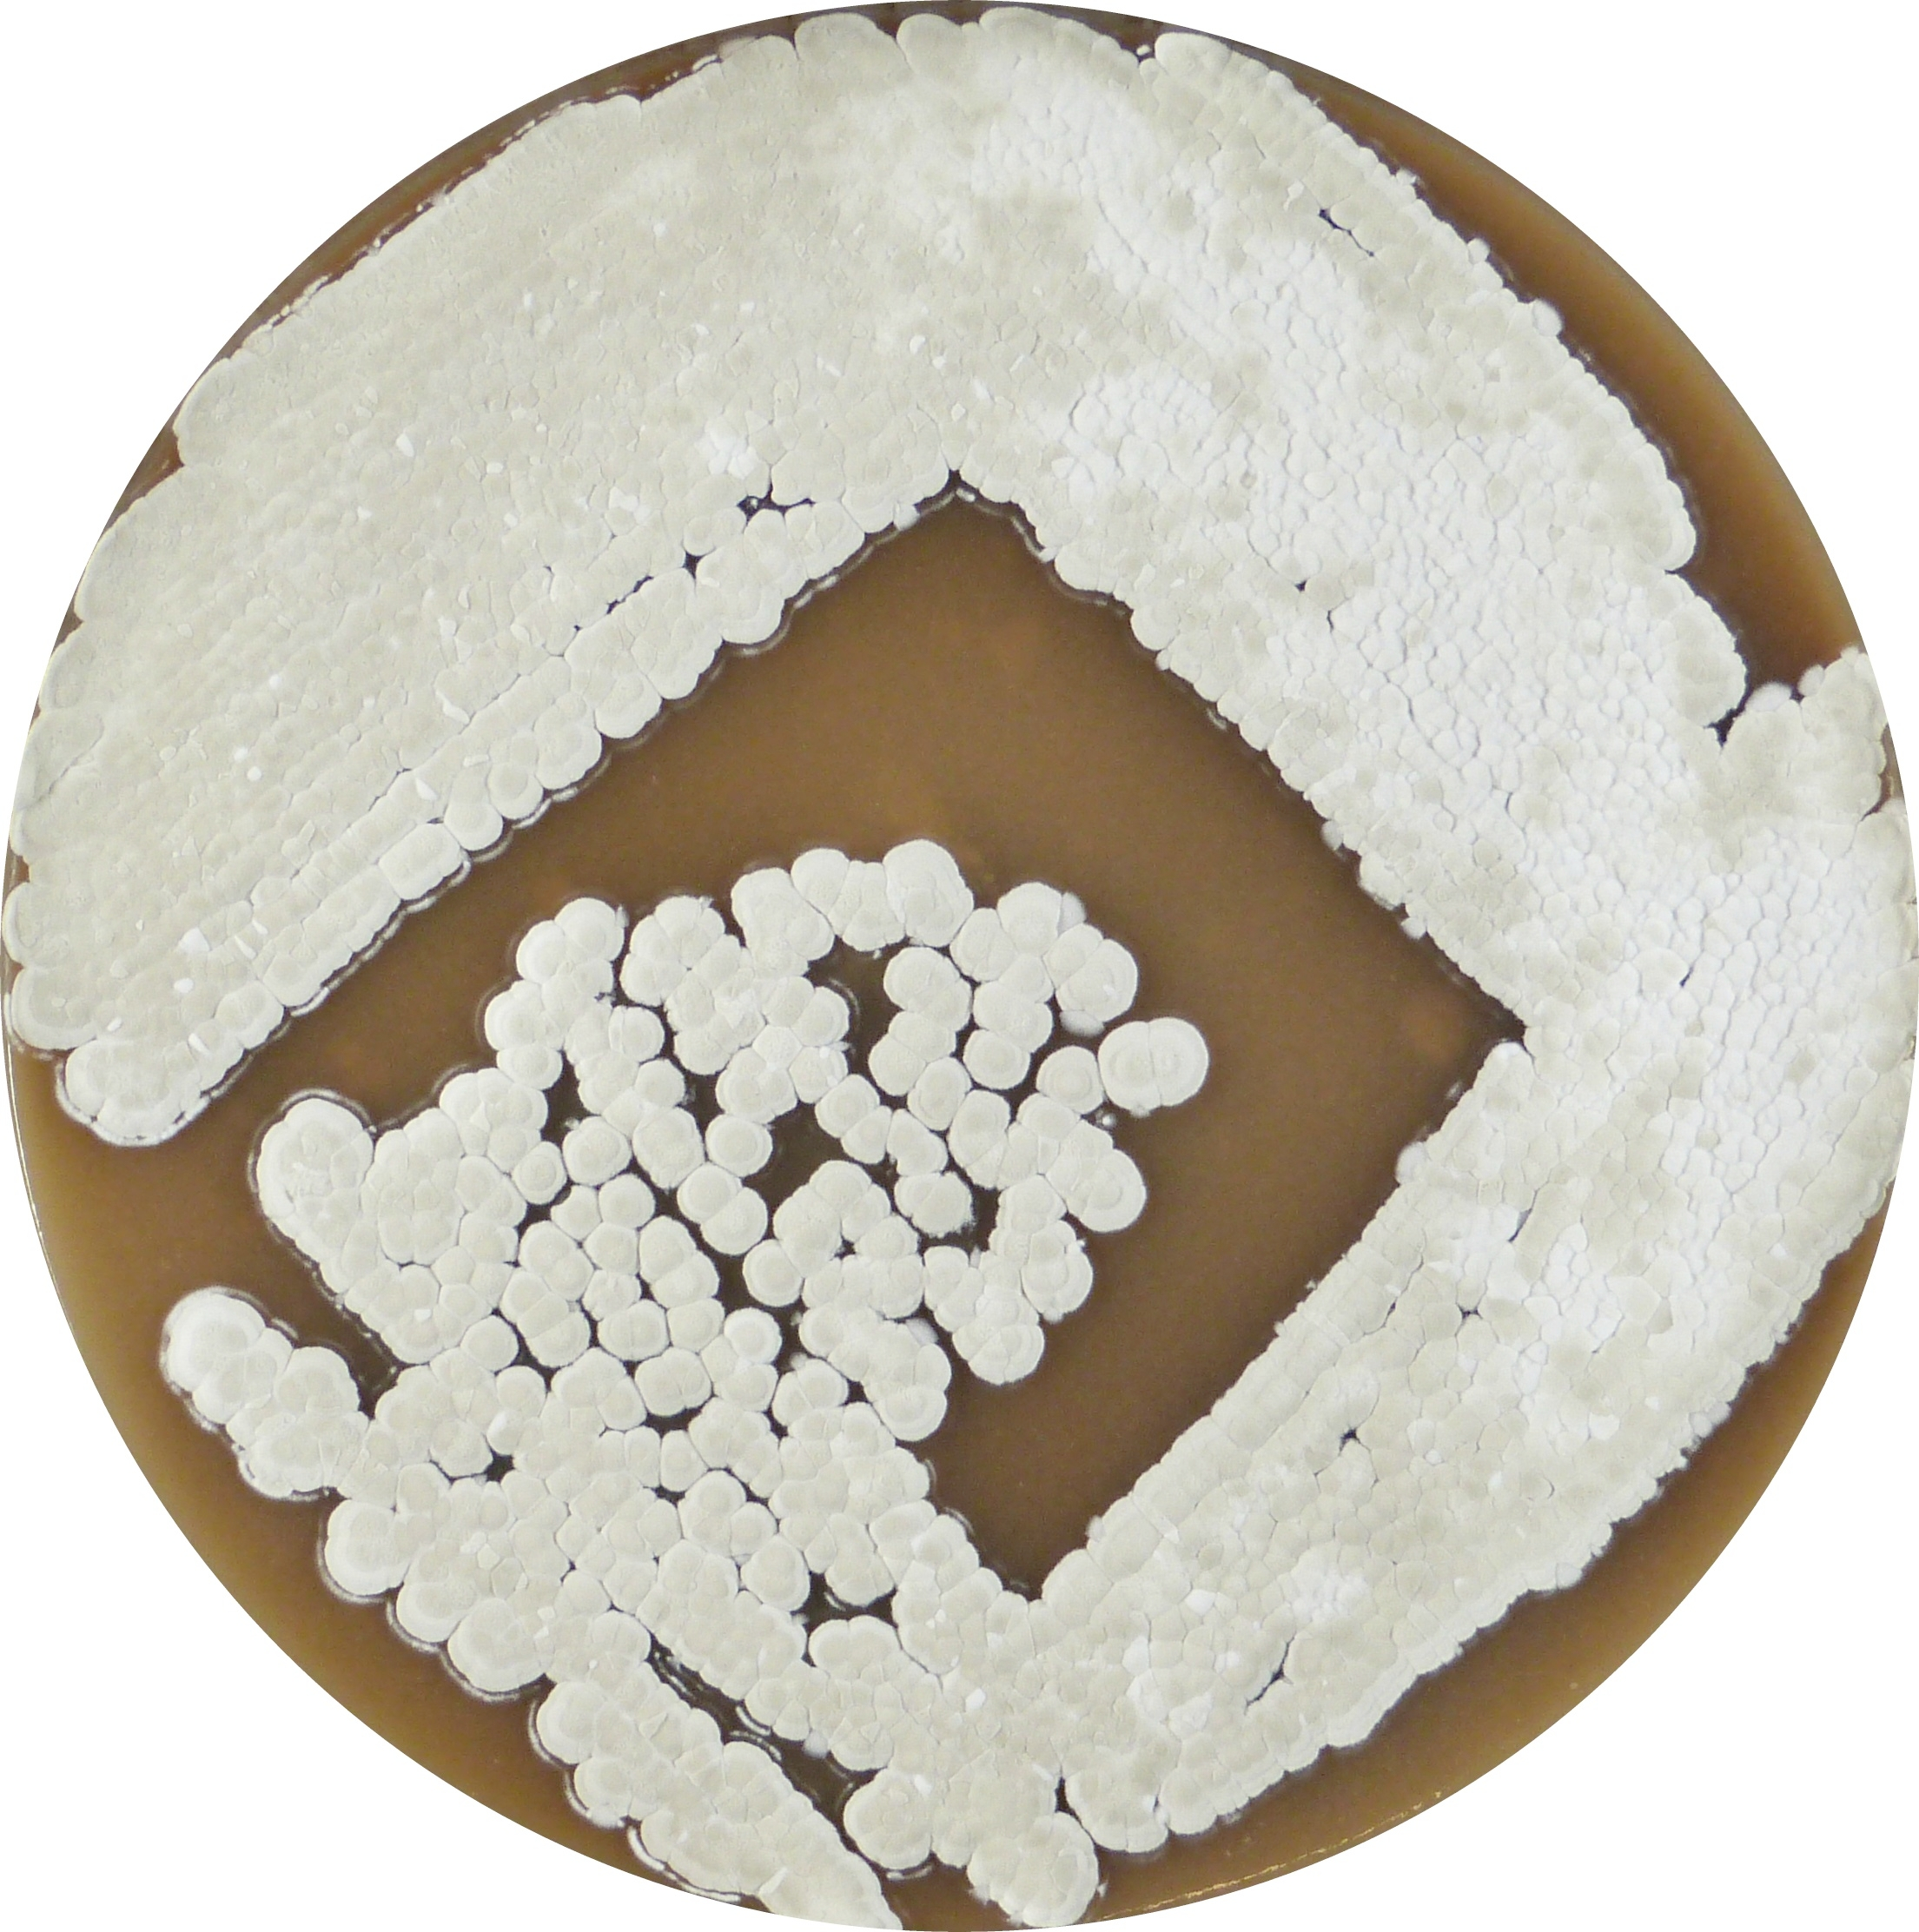
Supplementary figure S2. Streptomycetes sp. IB2014/011-12 grown on MS medium for 7 days.

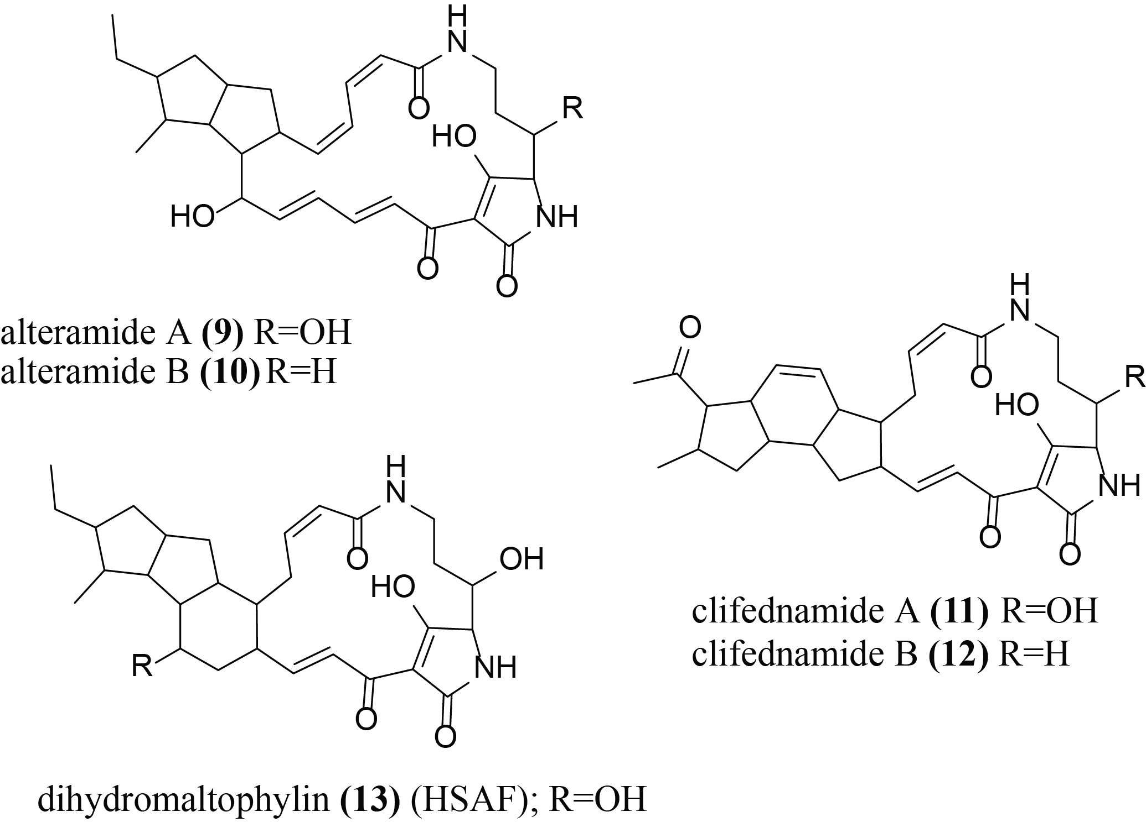

Supplementary figure S3. Structures of polycyclic tetramate macrolactams (9-13) identified in the extract of Streptomyces sp. IB2014/011-12.

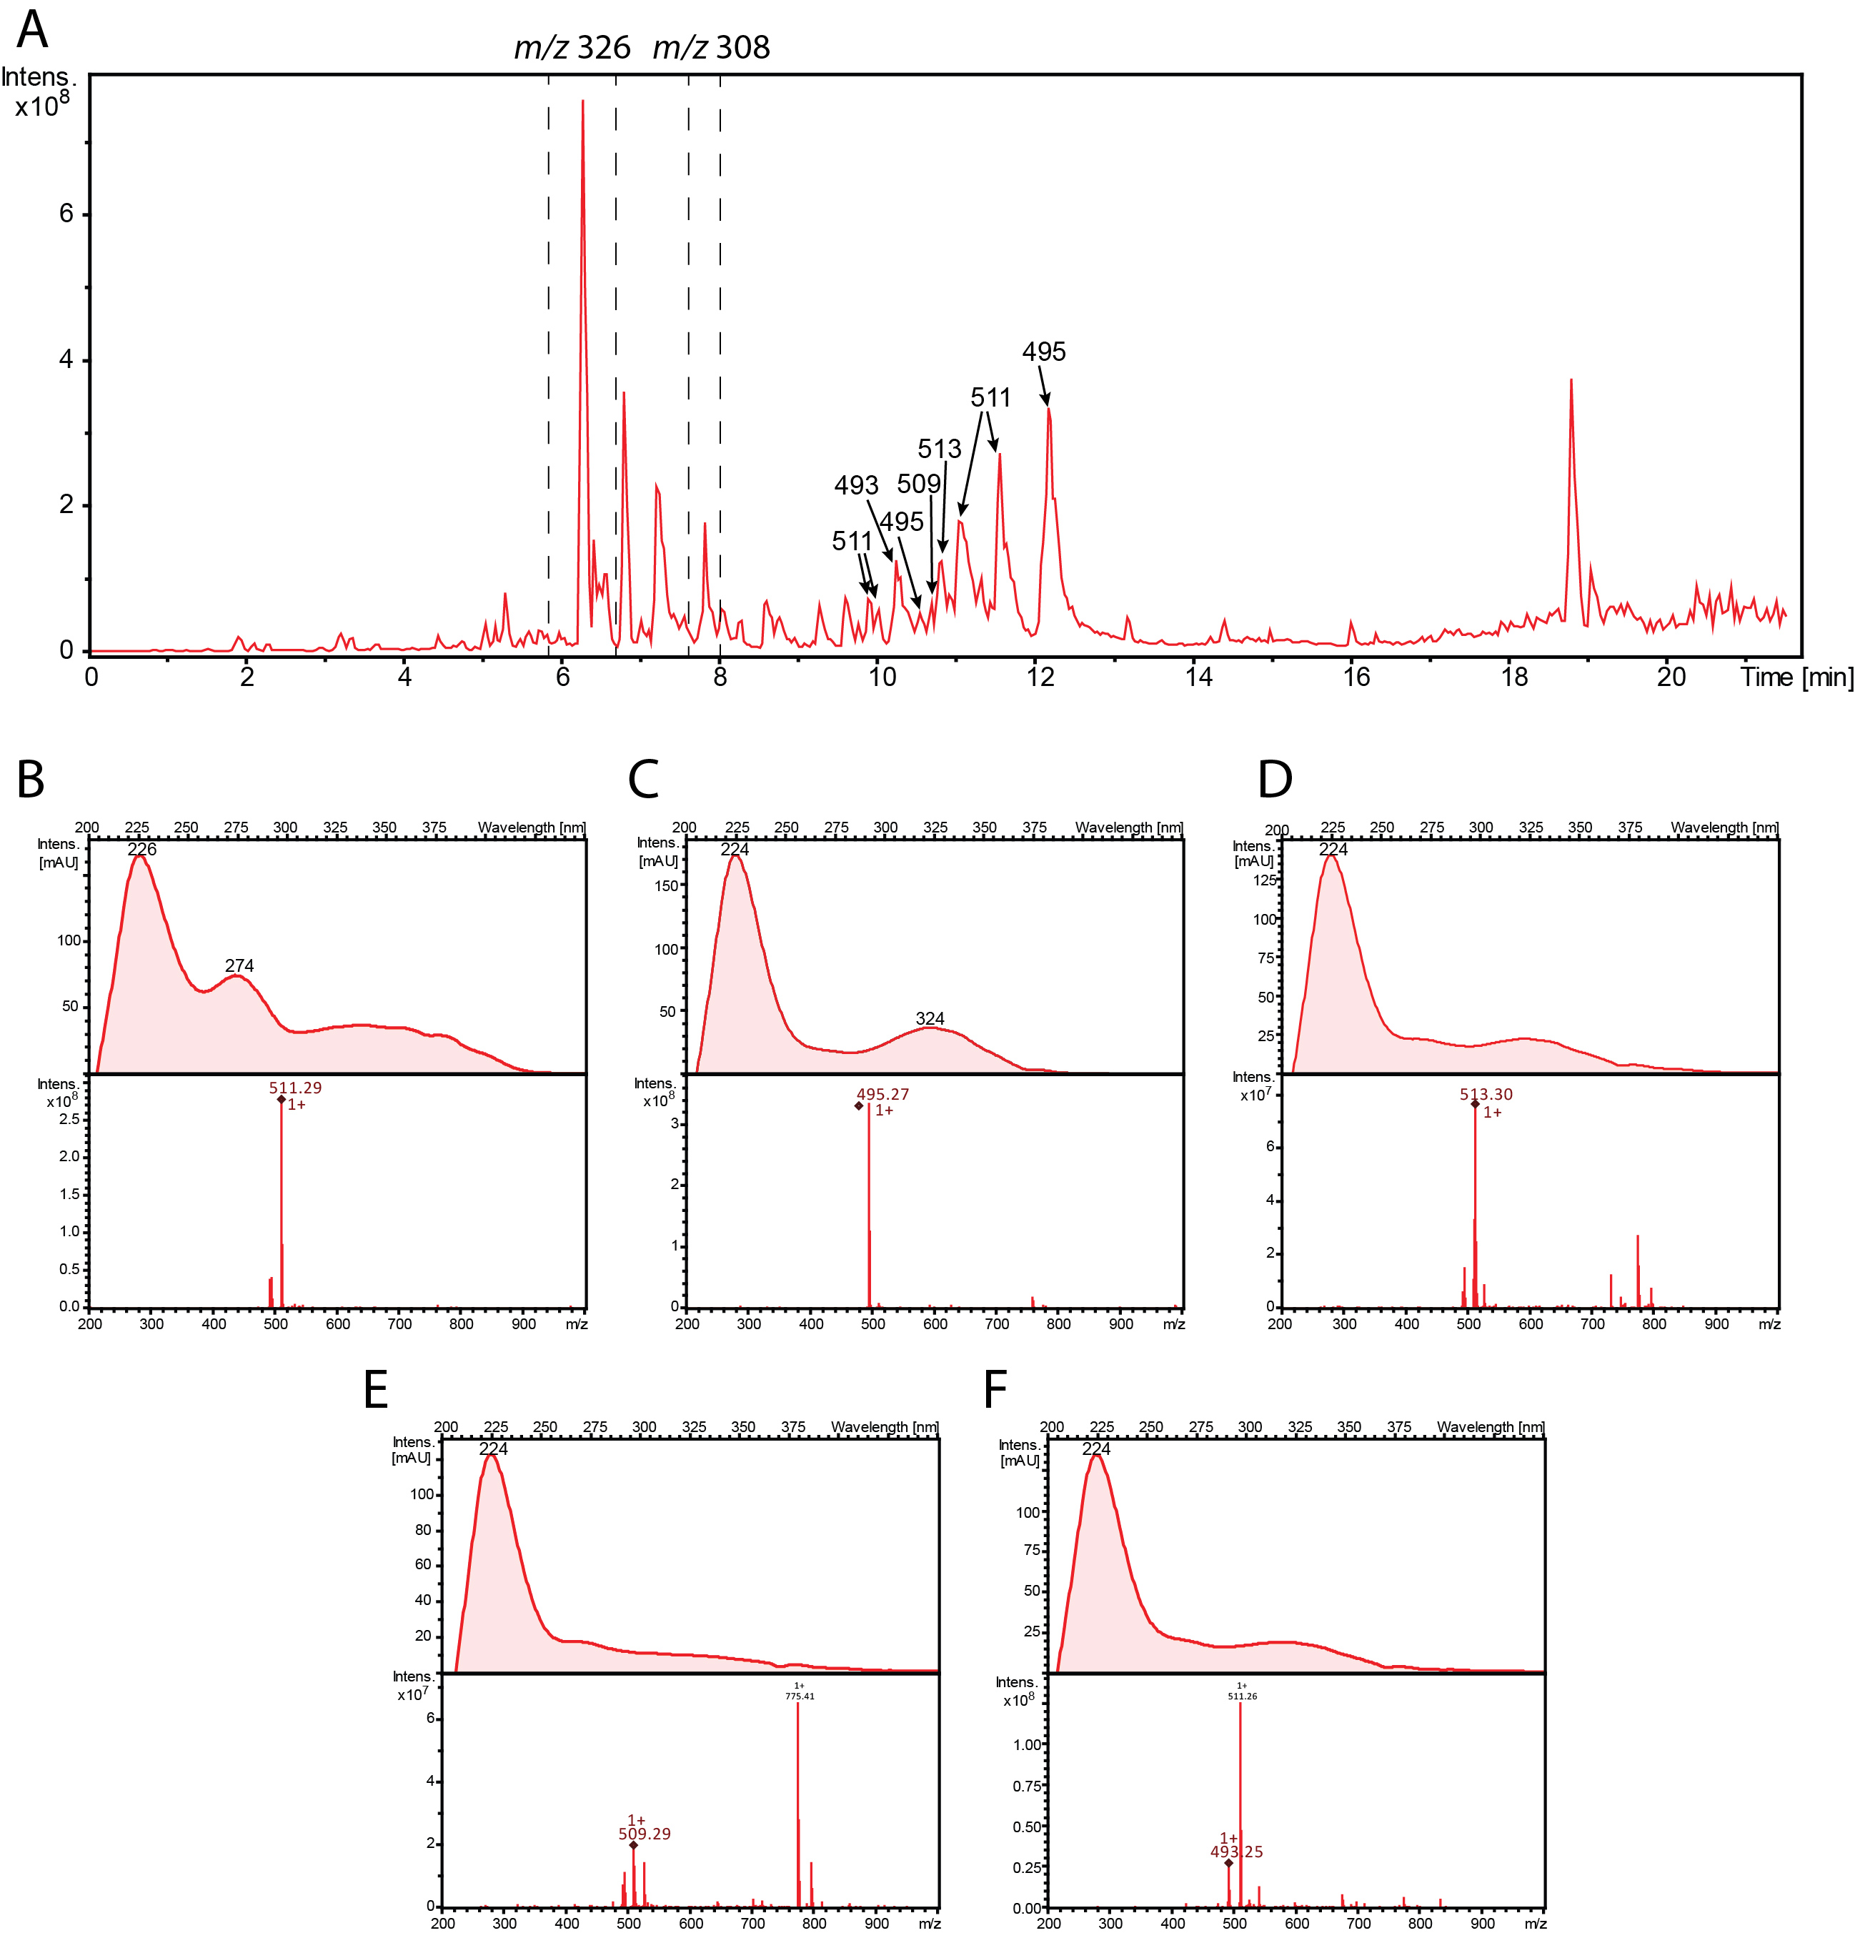
Supplementary figure S4. (A) MS and UV spectra of polycyclic tetramate macrolactams identified in the extract of Streptomycetes sp. IB2014/011-12. (B) alteramide A (9); (C) alteramide B (10); (D) clifednamide A (11); (E) clifednamide B (12); (F) dihydromaltophylin (13) (HSAF).

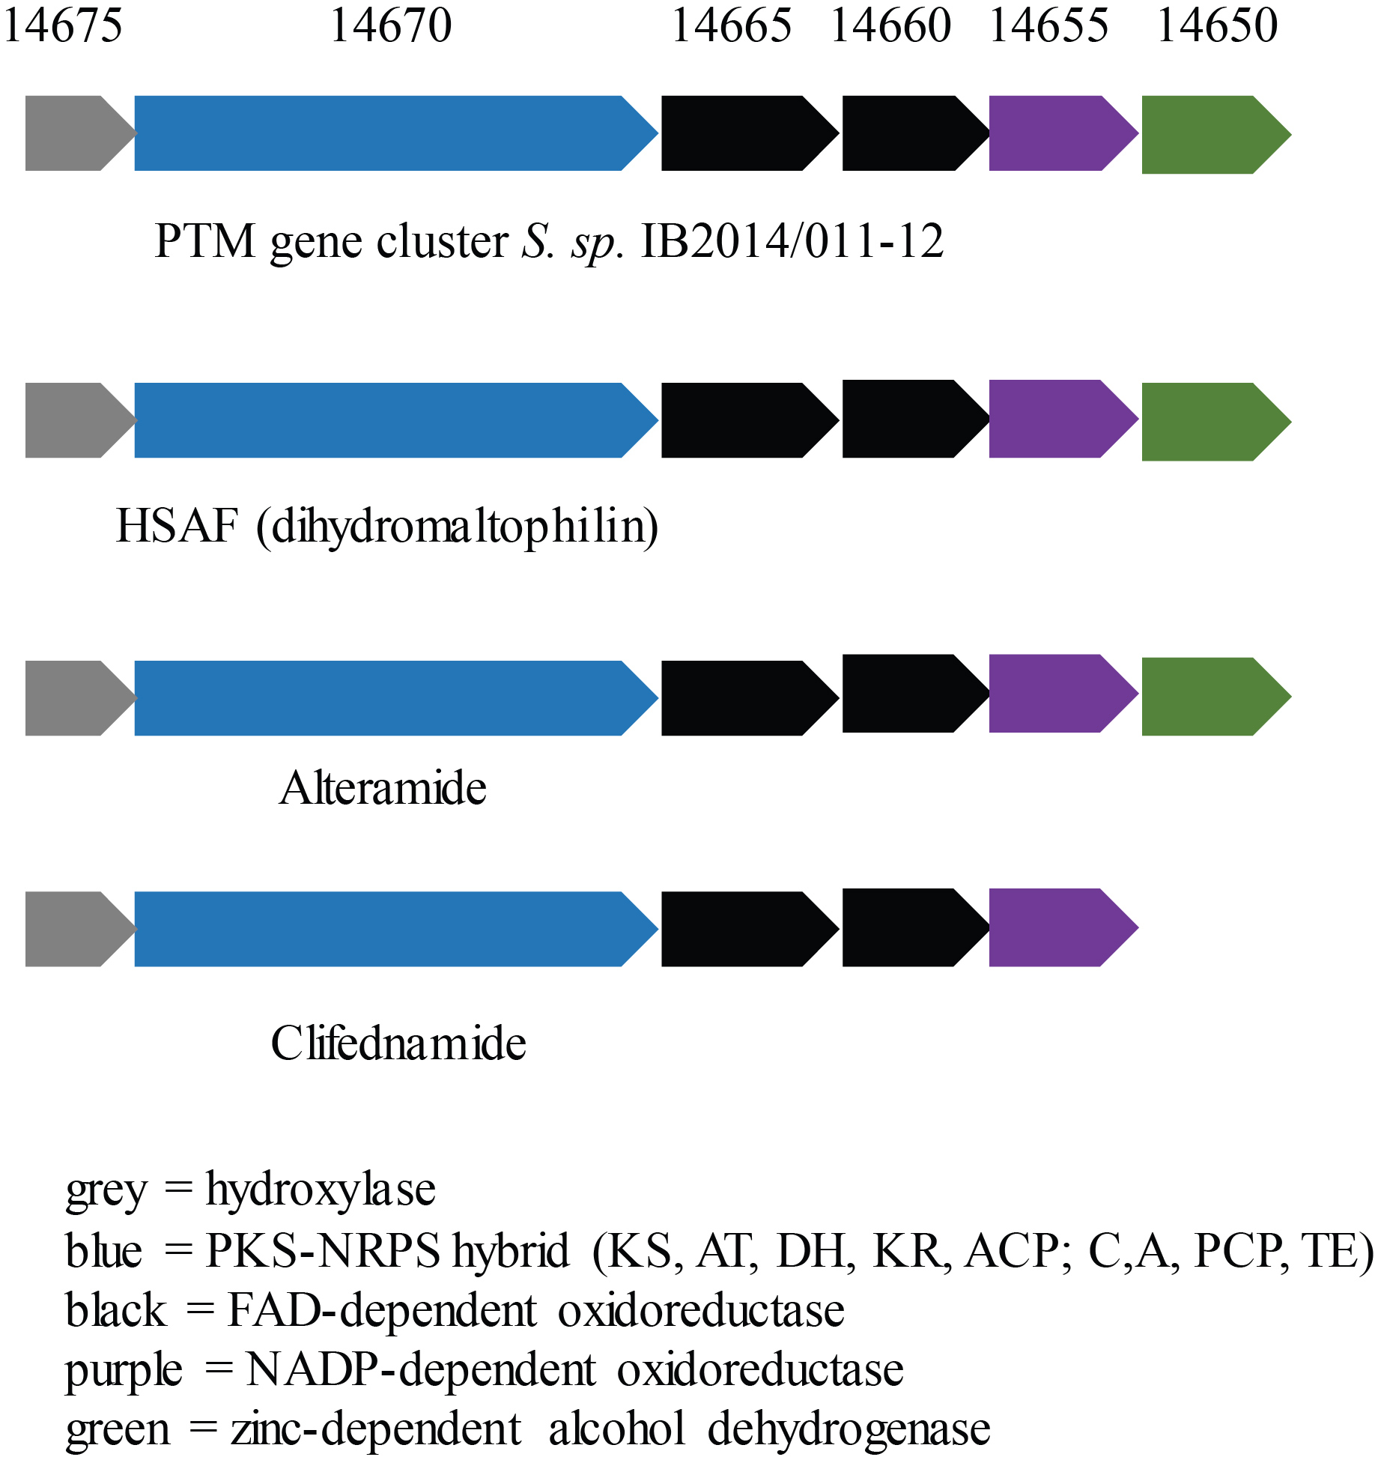
Supplementary figure S5. Genetic organization of gene cluster for PTMs production from the genome of Streptomyces sp. IB2014/011-12 and gene cluster of dihydromaltophylin, alteramide and clifednamide.

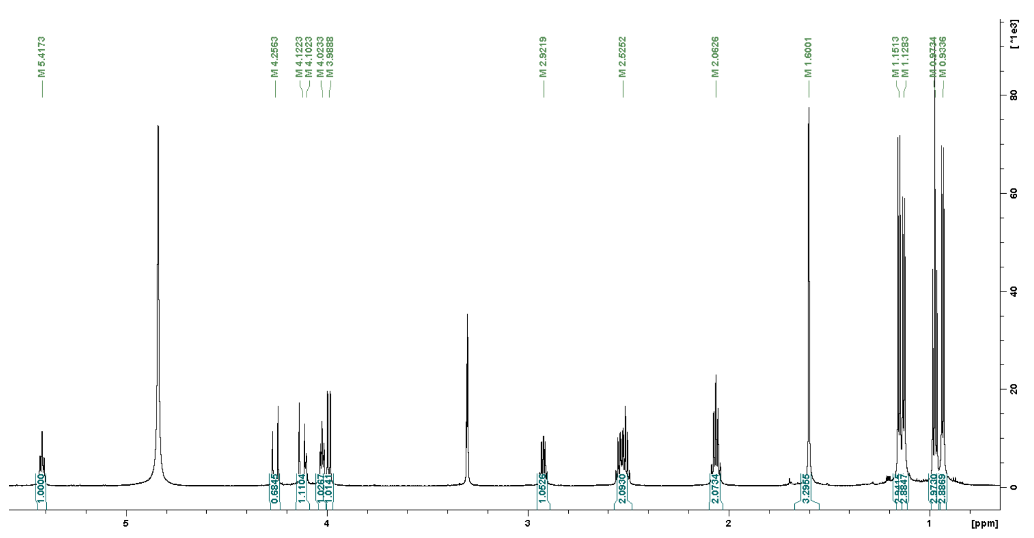

Supplementary figure S6. ¹H NMR-spectra of alpiniamide A in MeOD₄ 500 MHz.
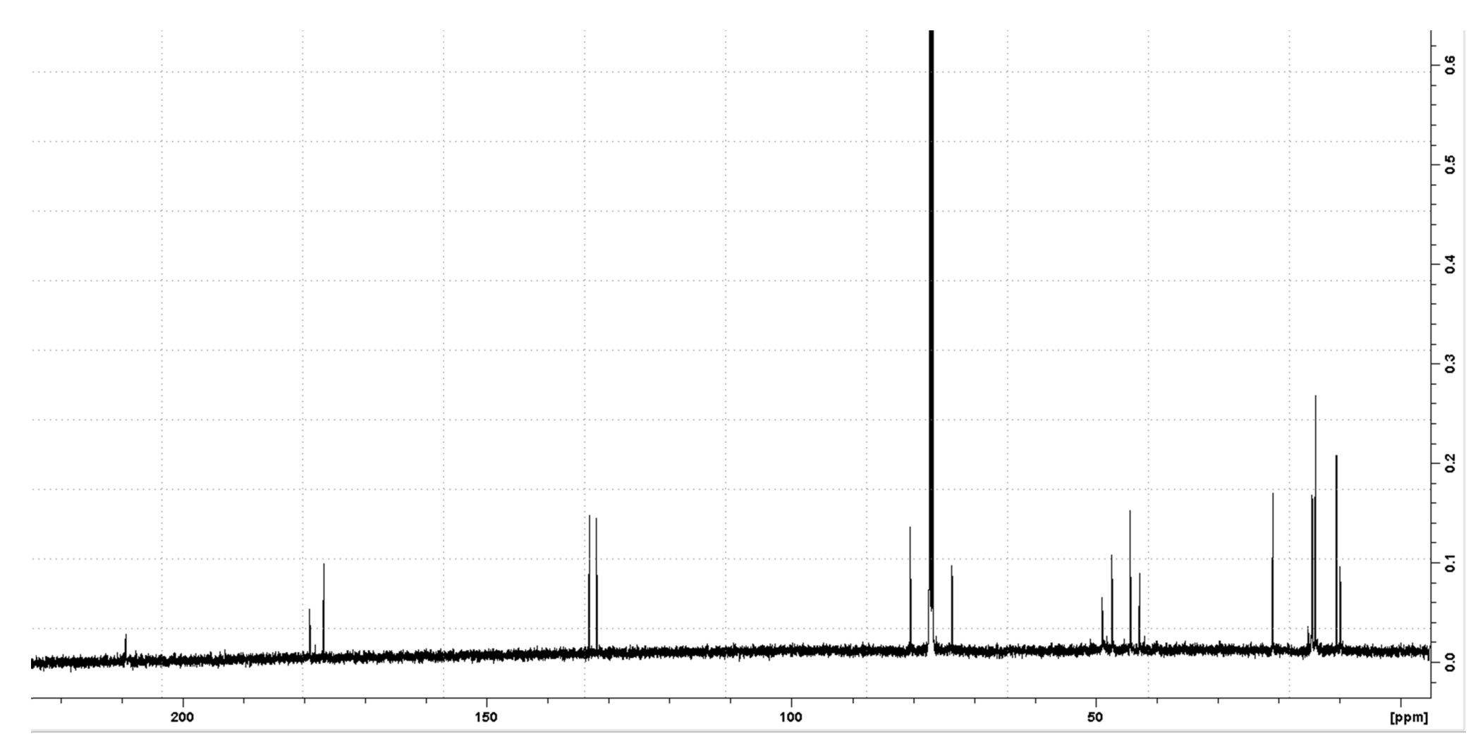

Supplementary figure S7. ¹³C NMR-spectra of alpiniamide A in CDCl₃ 500 MHz.

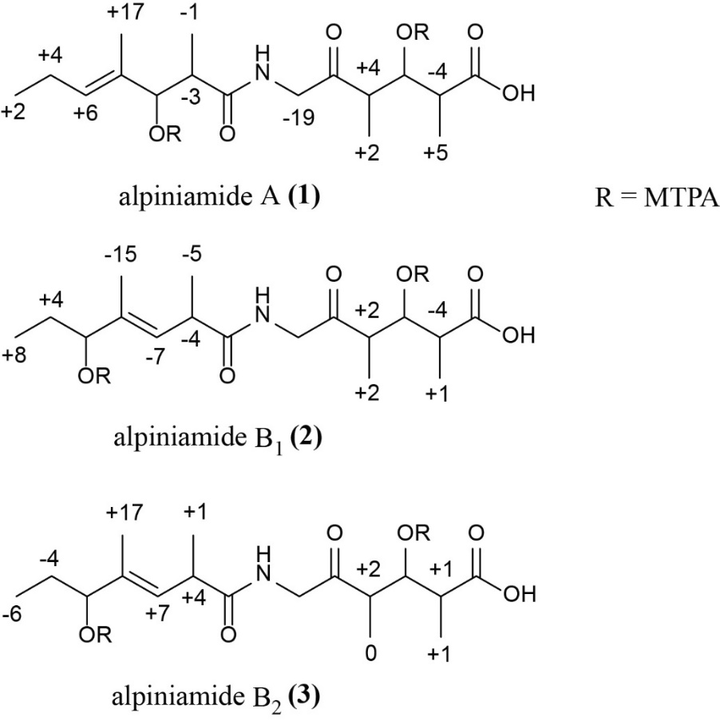
Supplementary figure S8. ∆δ_{(S-R)} values (x10⁻² ppm) of the MTPA esters of 1-3.

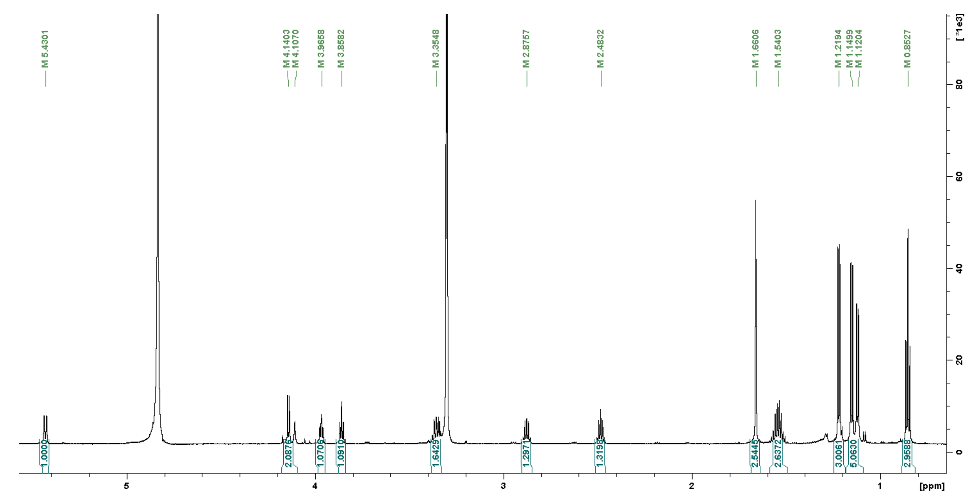

Supplementary figure S9. ¹H NMR-spectra of alpiniamide B₁ in MeOD₄ 500 MHz.
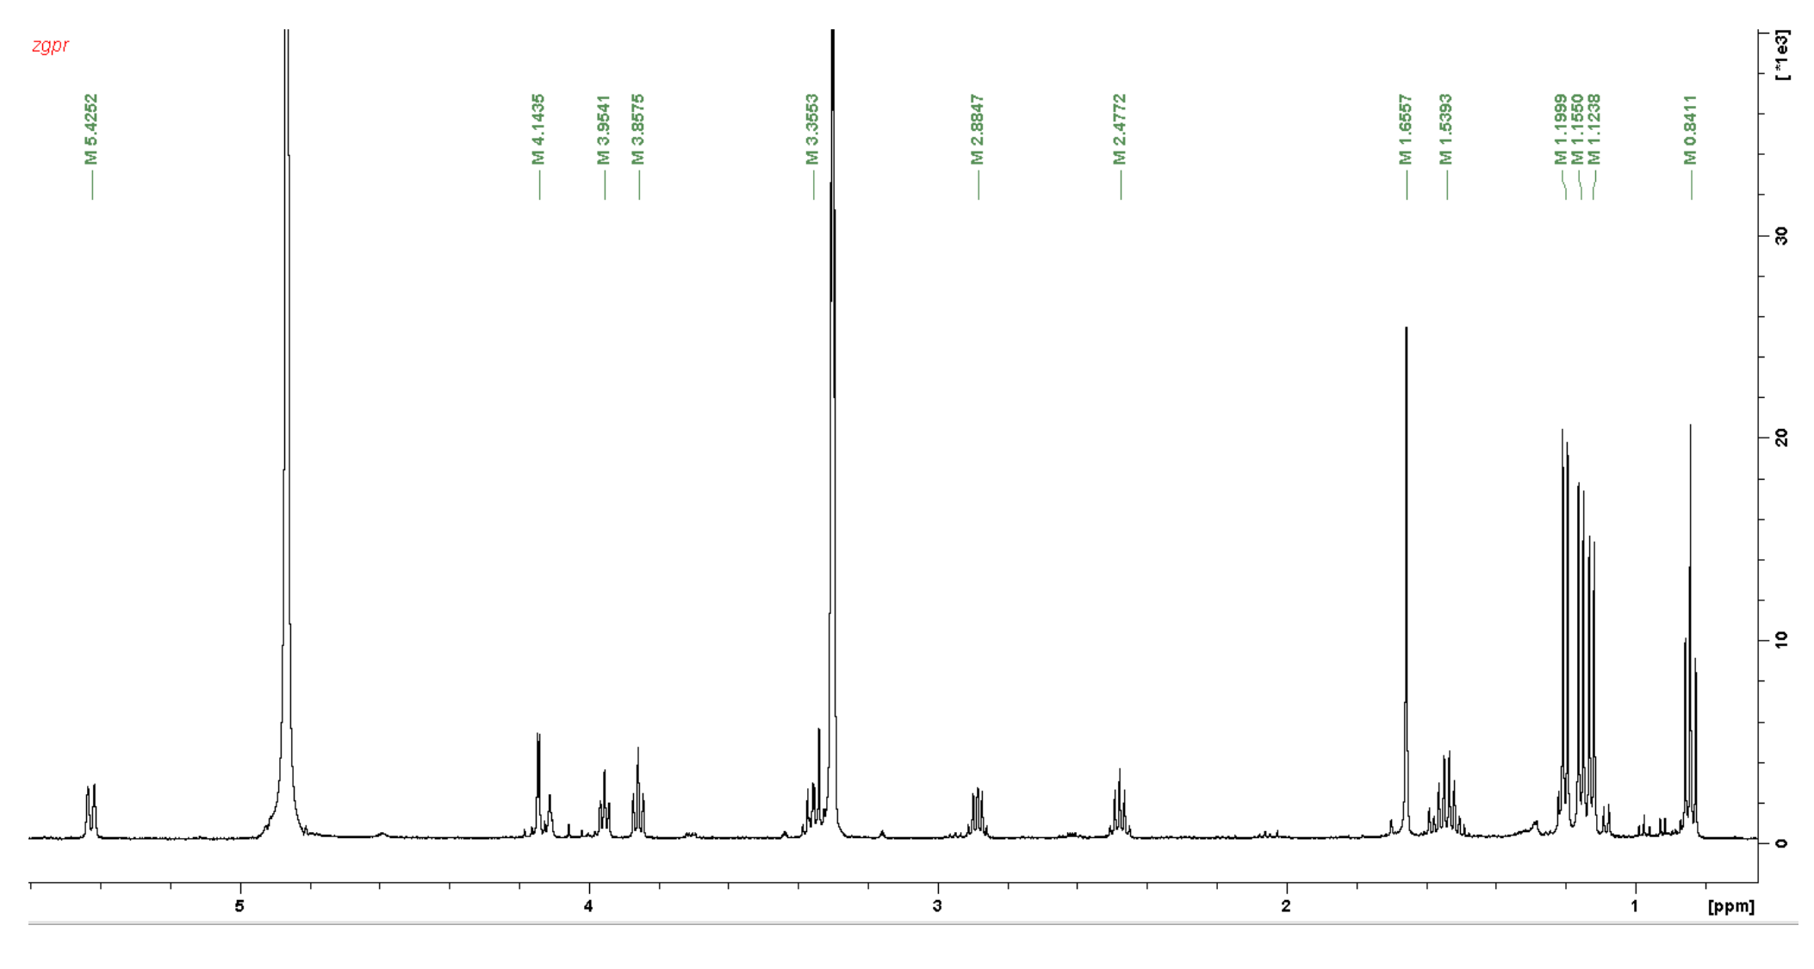
Supplementary figure S10. ¹H NMR-spectra of alpiniamide B₂ in MeOD₄ 500 MHz.
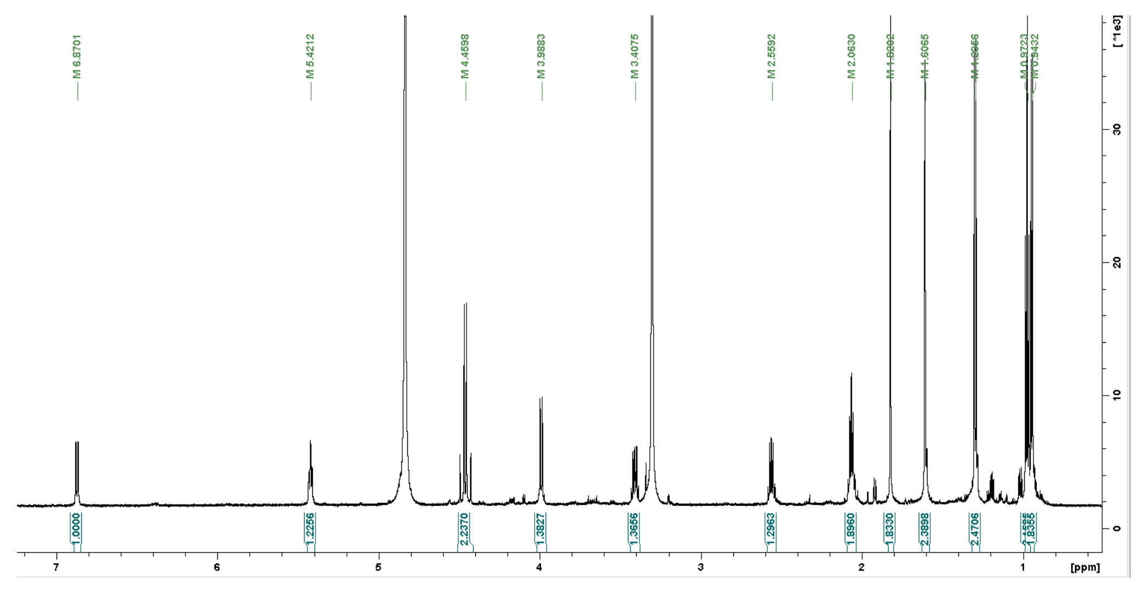

Supplementary figure S11. ¹H NMR-spectra of alpiniamide C in MeOD₄ 500 MHz.

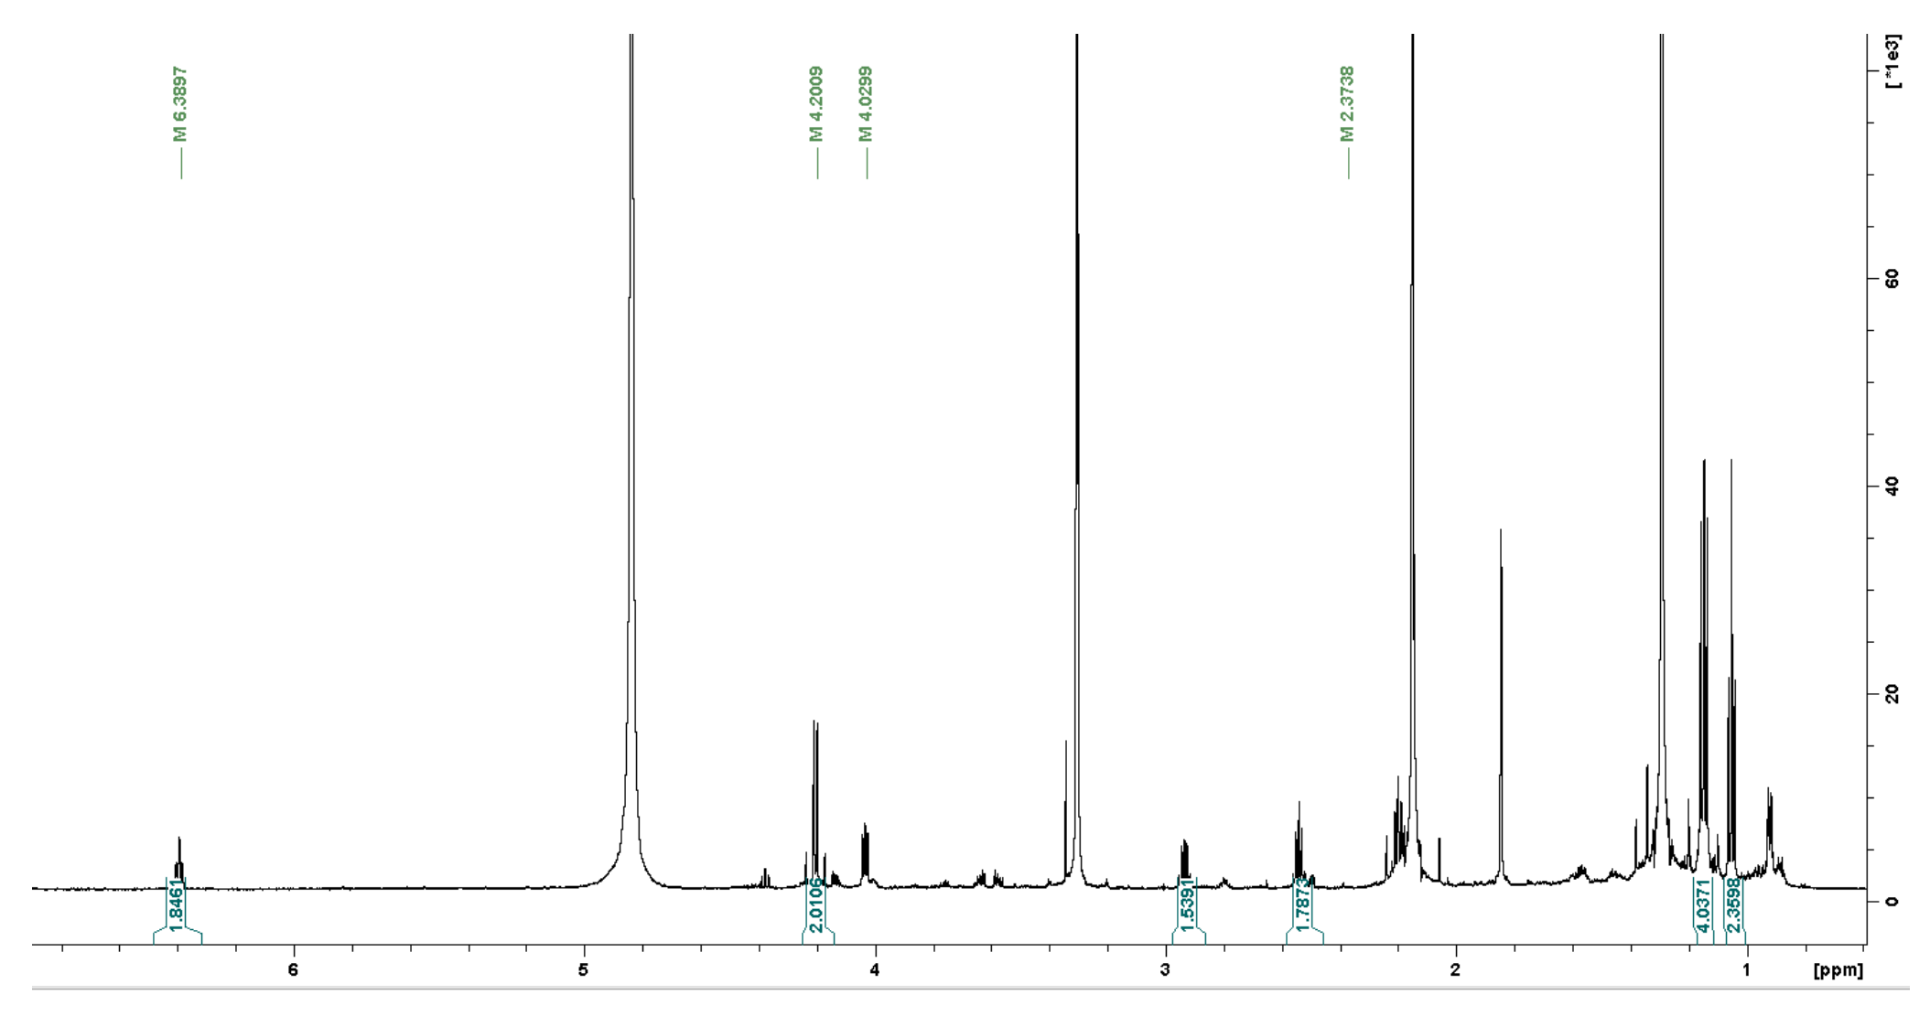

Supplementary figure S12. ¹H NMR-spectra of alpiniamide D in MeOD₄ 500 MHz.

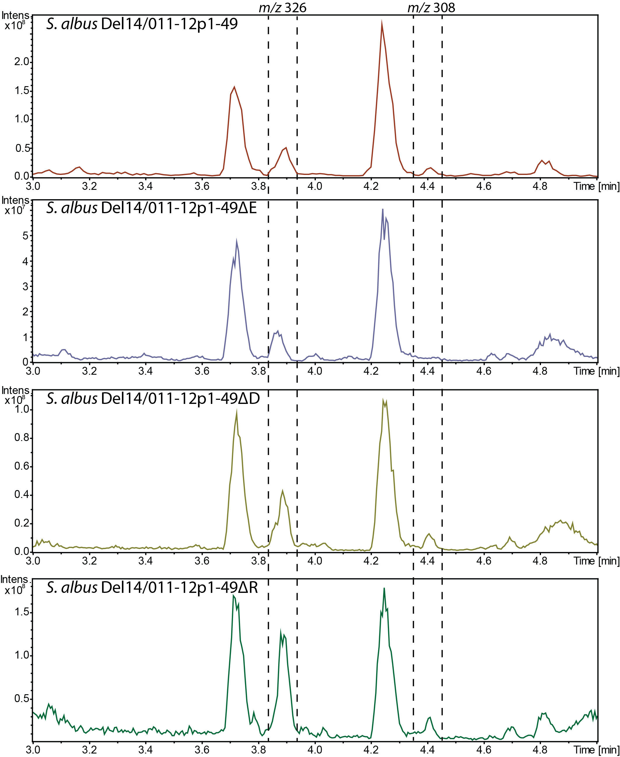

Supplementary figure S13. LC-MS chromatogram of extracts of S. albus Del14 carrying 011-12p1-49 plasmid and it’s variants with the deletion of individual alp genes: S. albus Del14/011-12p1-49∆E – alpE; S. albus Del14/011-12p1-49∆D – alpD; S. albus Del14/011-12p1-49∆R – alpR. Peak that corresponds to alpiniamides are highlighted: m/z 326 [M-H₂O+H]⁺ for alpiniamides A and B, m/z 308 [M-H₂O+H]⁺ for alpiniamide C. In the case of S. albus Del14/011-12p1-49∆E small peak eluting around same RT as alpiniamide A has m/z of 285 [M+H]⁺.

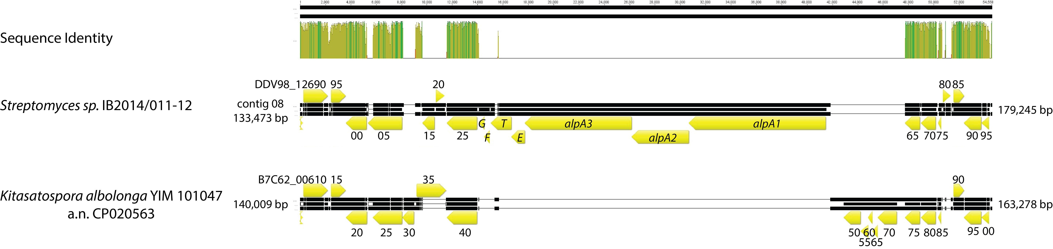

Supplementary figure S14. Alignment of whole genome of Kitasatospora albolonga YIM 101047 (GenBank accession number CP020563) and contig 08 of Streptomyces sp. IB2014/011-12 genome containing alp gene cluster and regions surrounding it. The alignment was performed with Geneious v. 8.1.7 software (Biomatters Ltd., New Zealand) using progressive Mauve algorithm.

10 20 30 40 50 60 70 80
....*....|....*....|....*....|....*....|....*....|....*....|....*....|....*....|
gi 17548863 5391 RPLFLVHEITGLDGYFTQLGAWIDAD-IPVYGLPAVGWG----EPQLRTIEGLAKRLKAAMRAVQPHG---PYRLAGWSF 5462
query 1 RPVFWIHGALAGVESYRTIAERI--D-RPFYGIQARGLLt--eDEPIEGITAMAEHYTEVIRSVQPEG---PYDVGGFCL 72
gi 17989334 1 -------------------MGLLAGAaLVLPSLPAEAKt-----QQAAMPPNATSPHQADVYLLRGFA---DIFSTGIDE 53
gi 730829 1058 QIIFAFPPVLGYG-------LMYQN-----LSSRLPSYKl--cAFDFIEEEDRLDRYADLIQKLQPEG---PLTLFGYSA 1120
gi 19554061 1348 PAVFMFHPAGGS-------SVVYQPL-MRRLPEDVPVYg---vERLEGDLADRAAAYVDDIKKYSDGF---PVVLGGWSF 1413
gi 15610936 1469 VPVFVFHPAGGS-------TVVYEPL-LGRLPADTPMYg---fERVEGSIEERAQQYVPKLIEMQGDG---PYVLVGWSL 1534
gi 2120647 2170 SPLFMFHPSFGSVHCYKTLAMALRDR-HPVKGVVCRALLg--aGREVPEWDDMVAEYAEQLLQEHPEG---VFNLAGWSL 2243
gi 15598523 2077 PPLFLVHPLGGHVLCYLPLVRALPPD-QPVYALQAAGTGq--gSTPLAVLEDIAASYLAAIRRVQPEG---PYYLGGWSF 2150
gi 17546530 1727 RTLVCVHASDGHAAAYRPLAAVLAGT-VQCVALQSPGLEa--gQAPLRSVEAQAACYLAALRAGREAGaqaPWHVLGWSM 1803
gi 17549641 1173 PAVFAIPGVGGLAAAFAPLGTELRRHgIELVAFDSPGWHadrtLPIDARLLAYVQHVVDAIRRRTPHG---PYQLIGHSF 1249
90 100 110 120 130 140 150 160
....*....|....*....|....*....|....*....|....*....|....*....|....*....|....*....|
gi 17548863 5463 GGVLAYEIAIQLIGED-EEVEFLGLLDTR-------QPalvsGGKPKWAAENRPH----HAQLLELCLAYWQ-QRSPGgP 5529
query 73 GGIVAYEVTRRLQAQG-QDVASLTMVDSPdetglakSN----ANGFQSARSAALQvvnsLLWPAGEKDPAALrARLVH-R 146
gi 17989334 54 IGAELQAAGVNAHVQG-HAAWRLVLNRIV-------AD----------------------------QQKNGH-LPVVL-- 94
gi 730829 1121 GCSLAFEAAKKLEEQG-RIVQRIIMVDSY-------KK---------QGVSD--------------LDGRTV-ESDV--- 1165
gi 19554061 1414 GGAVAFEVAHQLVGSD-VEVATVALLDTV-------QPsn-pAPDTAEETRARWT----RYADFAKKTY-GL-DFEVP-F 1477
gi 15610936 1535 GGVLAYACAIGLRRLG-KDVRFVGLIDAV-------RAge-eIPQTKEEIRKRWD----RYAAFAEKTFNVT-IPAIP-Y 1599
gi 2120647 2244 GGNLAMDVAARLEQRG-RQVAFVGWIDAP-------AP---------VRVEAFWN----EIGPTPEAVPNLS-VGEMR-V 2300
gi 15598523 2151 GGFVAYEMARQLRALDpQAVAQLIVLDSI-------TVdr-nHAG--SASDEALL----LFFYWELVWFERS-DKEVEpL 2215
gi 17546530 1804 GAYVAVEMARQLAQAG-ECVAQLLLVDPA-------PQ----EAMRAAARSEYDL----LLSLAPEAVRREL-AEQVGsA 1866
gi 17549641 1250 GARVAFDVALALEEAG--GTVALTMLDAL-------PG------N--DLVDMSRW----RVGQTPRELAGWL-LGAMQ-- 1305
170 180 190 200 210 220 230 240
....*....|....*....|....*....|....*....|....*....|....*....|....*....|....*....|
gi 17548863 5530 ESAKLAGLAGVEDFSALLERCRAQallAPDL-ADVTEPDLW--HVLDRIVAHGDAQANYTVfpmplKLHLFVAAHEQRDD 5606
query 147 DEIADDLDEDAFVL-RLAELAAER---GLAMrPDRTARFVRrnMAIQLAYRLGEHTIRPLP-----RPEAVVctyfrnrr 217
gi 17989334 95 -IGHSLGANAAIYIAEELERRGIA---VDYM-ATFAATGPD--PLPGNVRRVVNFYFKQHG-----WGLPLVPGPR---- 158
gi 730829 1166 EALMNVNRDN---EALNSEAVKHG---LKQK-THAFYSYYV--NLISTGQVKADIDLLTSG--------ADFDMPE---- 1224
gi 19554061 1478 EILDTIGEDG--MLSMMTDFLANTdasEHGL-SAGVLEHQR--ASFVDNRILAKLNFADWAnv--eAPVILFRAERMHDG 1550
gi 15610936 1600 EQLEELDDEG--QVRFVLDAVSQS---GVQI-PAGIIEHQR--TSYLDNRAIDTAQIQPYD-----GHVTLYMADRYHDD 1666
gi 2120647 2301 ELLGVMFPERAEHIERAWSSICSAttdDEQR-WTRMSDWAE--AEIGAEFATLRSEIAQSN-----ELEVSWELKQILDE 2372
gi 15598523 2216 PEGASLEQKLDHIVERAIEAGVLPagtPRAT-VQRLYELFR--ASWQALIGYRPEVSDQDMtllraDGPLPLALKPMHDA 2292
gi 17546530 1867 DAFASLPPARRLAHWRAGLRLAAPs--PADD-DAALERMVA--VLLANVTAMVDYRLPILD-----LPTVALYQASEHPA 1936
gi 17549641 1306 --NGDVPAEPGEDAVASLARLQIYg--DLDV-HDALALVDD--QMLASRRYRPARRLRATR------VQMVYAEHGLIGA 1372
250 260 270 280 290 300
....*....|....*....|....*....|....*....|....*....|....*....|....*..
gi 17548863 5607 EPP---------------PHKRWLGWNAILPDTQlqrivV--PGTHQSMVLE-HAQALGEALSAALHAAAGQPQP 5663
query 218 glflgevepyfqvtgetfsldhvnyrqdwgrempglrlveidaanHmtilndaep-------------------- 272
gi 17989334 159 --------------------FHGHLENRDFSNAK--------DVGHFNIEKQrPLQAEVVRDVLAVVNAD----- 200
gi 730829 1225 ------------------WLASWEEATTGVYRVKr------GFGTHAEMLQG-ETLDRNAEILLEFLNTQTVTVS 1274
gi 19554061 1551 AIElepnyakidQDGGWSGIVNDLEIVQ-------------LNGDHLAVVDE-PEIGTVGAHLSRRIDEISRKN- 1610
gi 15610936 1667 AIMfepryavrqPDGGWGEYVSDLEVVP-------------IGGEHIQAIDE-PIIAKVGEHMSRALGQIEADRT 1727
gi 2120647 2373 RLKamdyprltaKVSLWWAARSTNAIQRs-----------aVERSMAEAIGA-ERVEPVRVLDTRHDKIIDHPEF 2435
gi 15598523 2293 AGThy-----gdPKNGWQHWTSGRLDVId------------VPGDHLVLMKE-PYVETVAAEIAALLEPSTSSER 2349
gi 17546530 1937 GWGd--------VIAPWRDVFPRGIQAEt------------LAGTHWSVVGAeVLGPVLAQRLREGGAAAPATPA 1991
gi 17549641 1373 HAHd-------aIVDSLRAWADTVAVAR-------------LDADHFSMLKA-APALAGHVMAHGRA-------- 1418

Supplementary figure S15. Multiple sequence alignment of TE domain of AlpA2 using the Conserved Domain BLAST with the closest representatives of COG3319 super-family. The proposed active site residues (catalytic triad) are marked with red frames. The catalytic triad is deduced based on structural data for thioeserase domain of surfactin synthetase subunit 3 SrfA-C (730829, highlighted in yellow) (Bruner et al., 2002).

REFERENCES
Barona-Gómez, F., Wong, U., Giannakopulos, A. E., Derrick, P. J., and Challis, G. L. (2004). Identification of a cluster of genes that directs desferrioxamine biosynthesis in Streptomyces coelicolor M145. Journal of the American Chemical Society 126, 16282–16283. doi: 10.1021/ja045774k
Bruner, S. D., Weber, T., Kohli, R. M., Schwarzer, D., Marahiel, M. A., Walsh, C. T., et al. (2002). Structural basis for the cyclization of the lipopeptide antibiotic surfactin by the thioesterase domain SrfTE. Structure (London, England : 1993) 10, 301–310.
Challis, G. L., and Ravel, J. (2000). Coelichelin, a new peptide siderophore encoded by the Streptomyces coelicolor genome: Structure prediction from the sequence of its non-ribosomal peptide synthetase. FEMS Microbiology Letters 187, 111–114. doi: 10.1111/j.1574-6968.2000.tb09145.x
Cook, D., Rimando, A. M., Clemente, T. E., Schröder, J., Dayan, F. E., Nanayakkara, N. P. D., et al. (2010). Alkylresorcinol synthases expressed in Sorghum bicolor root hairs play an essential role in the biosynthesis of the allelopathic benzoquinone sorgoleone. The Plant cell 22, 867–887. doi: 10.1105/tpc.109.072397.
Kersten, R. D., Yang, Y.-L., Xu, Y., Cimermancic, P., Nam, S.-J., Fenical, W., et al. (2011). A mass spectrometry-guided genome mining approach for natural product peptidogenomics. Nature chemical biology 7, 794–802. doi: 10.1038/nchembio.684.
Luo, Y., Huang, H., Liang, J., Wang, M., Lu, L., Shao, Z., et al. (2013). Activation and characterization of a cryptic polycyclic tetramate macrolactam biosynthetic gene cluster. Nature communications 4, 2894. doi: 10.1038/ncomms3894
Pan, J.-J., Solbiati, J. O., Ramamoorthy, G., Hillerich, B. S., Seidel, R. D., Cronan, J. E., et al. (2015). Biosynthesis of Squalene from Farnesyl Diphosphate in Bacteria: Three Steps Catalyzed by Three Enzymes. ACS central science 1, 77–82. doi: 10.1021/acscentsci.5b00115
Schwarz, J., Konjik, V., Jankowitsch, F., Sandhoff, R., and Mack, M. (2016). Identification of the Key Enzyme of Roseoflavin Biosynthesis. Angewandte Chemie (International ed. in English) 55, 6103–6106. doi: 10.1002/anie.201600581
Suzuki, H., Ohnishi, Y., and Horinouchi, S. (2007). GriC and GriD constitute a carboxylic acid reductase involved in grixazone biosynthesis in Streptomyces griseus. J. Antibiot. 60, 380–387. doi: 10.1038/ja.2007.52
Ueda, K., Oinuma, K.-I., Ikeda, G., Hosono, K., Ohnishi, Y., Horinouchi, S., et al. (2002). AmfS, an Extracellular Peptidic Morphogen in Streptomyces griseus. Journal of Bacteriology 184, 1488–1492. doi: 10.1128/JB.184.5.1488–1492.2002
Woo, P. C. Y., Tam, E. W. T., Chong, K. T. K., Cai, J. J., Tung, E. T. K., Ngan, A. H. Y., et al. (2010). High diversity of polyketide synthase genes and the melanin biosynthesis gene cluster in Penicillium marneffei. The FEBS journal 277, 3750–3758. doi: 10.1111/j.1742-4658.2010.07776.x
Zhu, D., Liu, J., Han, R., Shen, G., Long, Q., Wei, X., et al. (2014). Identification and characterization of ectoine biosynthesis genes and heterologous expression of the ectABC gene cluster from Halomonas sp. QHL1, a moderately halophilic bacterium isolated from Qinghai Lake. Journal of microbiology (Seoul, Korea) 52, 139–147. doi: 10.1007/s12275-014-3389-5.

