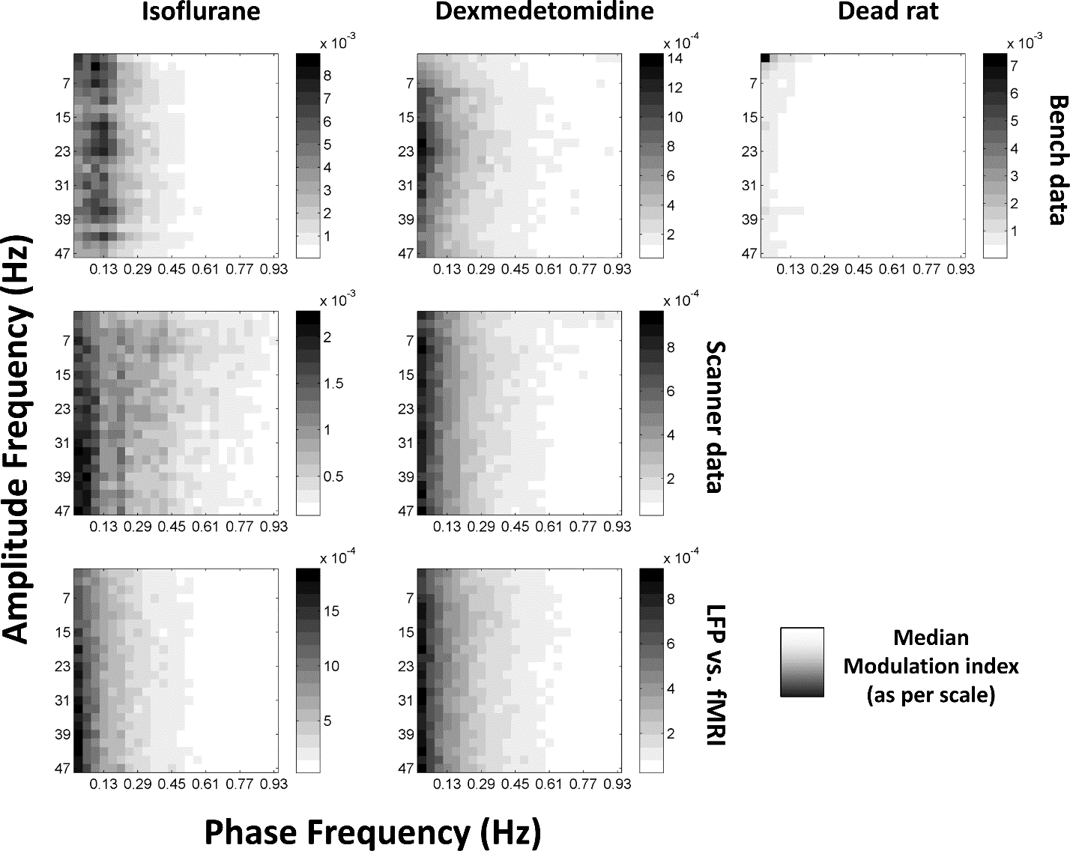

Data sheet 2
Median comodulograms for each condition. Amplitude frequencies are plotted against phase frequencies with darker values representing greater phase-amplitude coupling. Each plot is scaled between minimum and maximum modulation index, with scale shown on the right. Top row represents data recorded outside the fMRI scanner, middle row data inside the scanner during simultaneous imaging. Bottom row is the same as the middle row but has had the phase signal replaced with equivalent simultaneous fMRI data. Left column is isoflurane anesthesia (N=21 for bench, 17 for scanner, times 2 electrodes), middle column is dexmedetomidine (N = 20 for bench, 39 for scanner, times 2 electrodes) anesthesia, right column is following euthanatization of the rat (N = 10 times 2 electrodes, only available outside the fMRI scanner).

