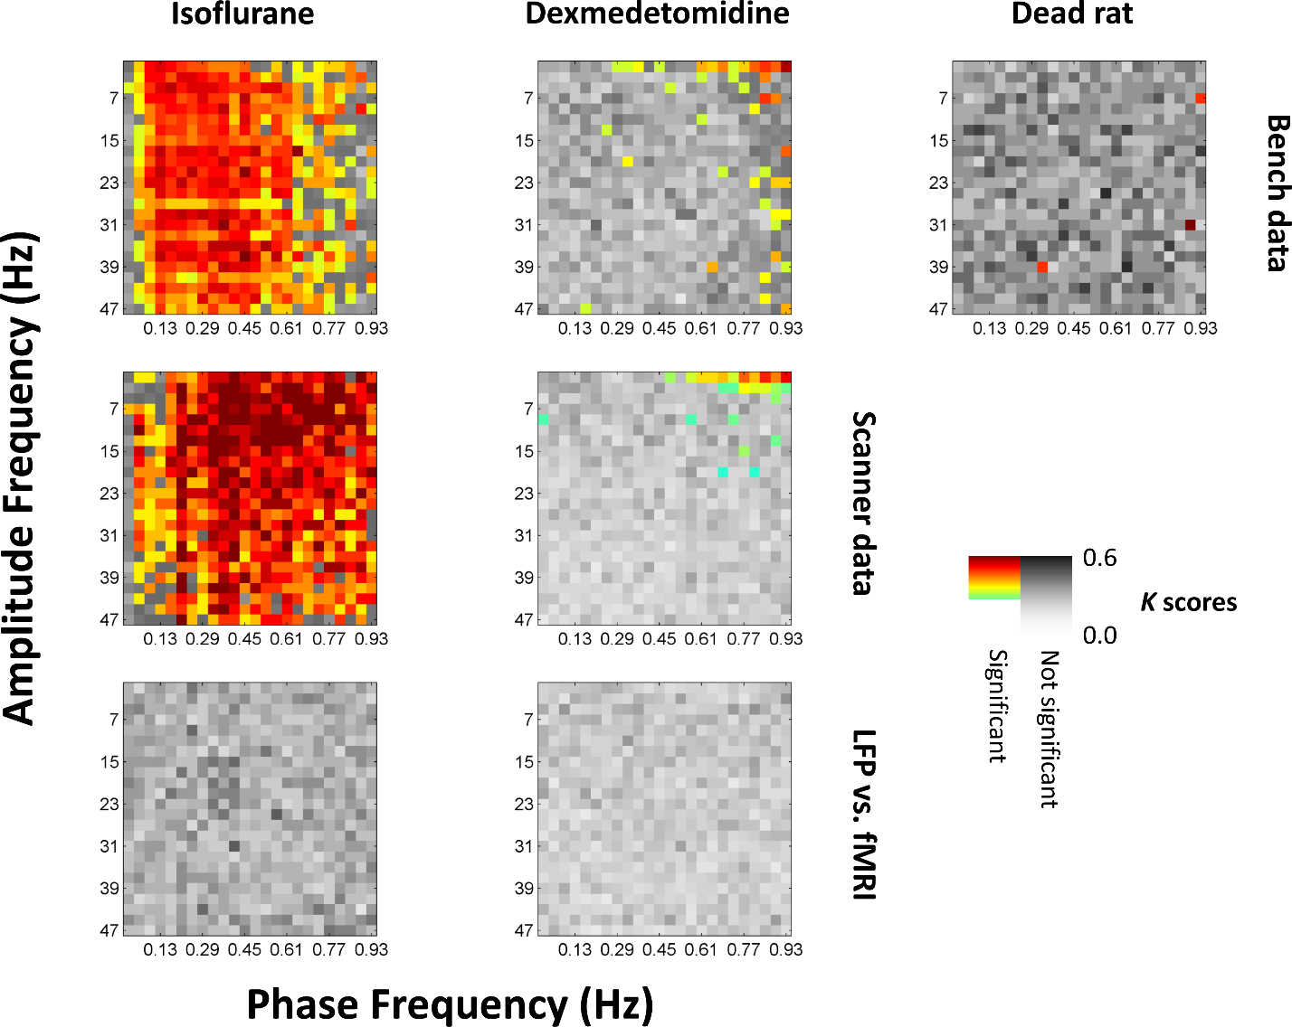

Data sheet 4
Identical to figure 3 in the main text, except a KS test was used to determine significance instead of a t test, and the colors indicate K scores resulting from that test rather than t scores. Results are similar under both types of test.

