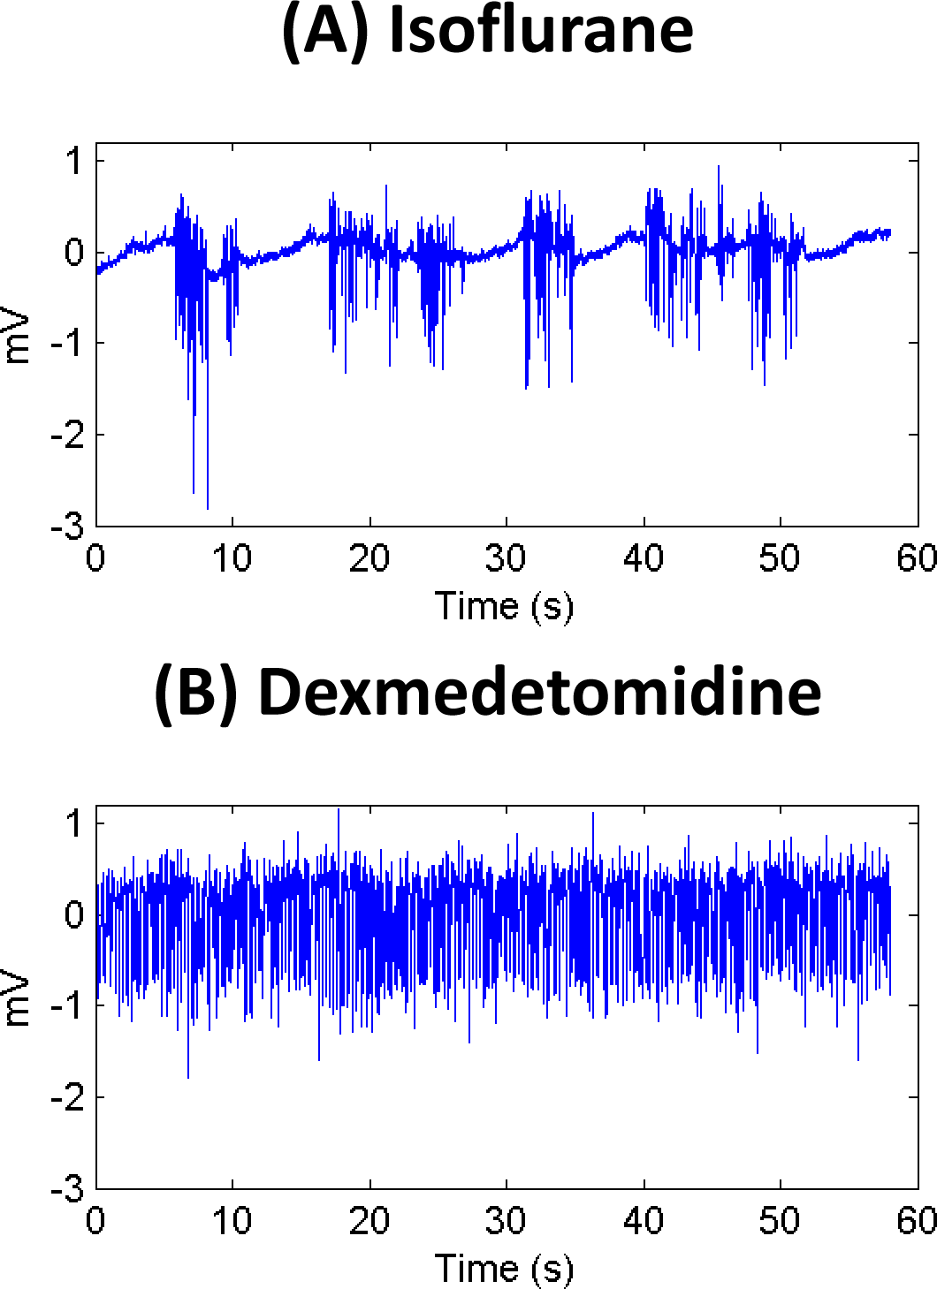

Data sheet 5
Example LFP traces under each anesthetic, (A) isoflurane and (B) dexmedetomidine. Note that activity is fairly constant under dexmedetomidine, while isoflurane alternates between periods of neural suppression and periods of activity. This is referred to as a “burst state.”

