Supplementary Material

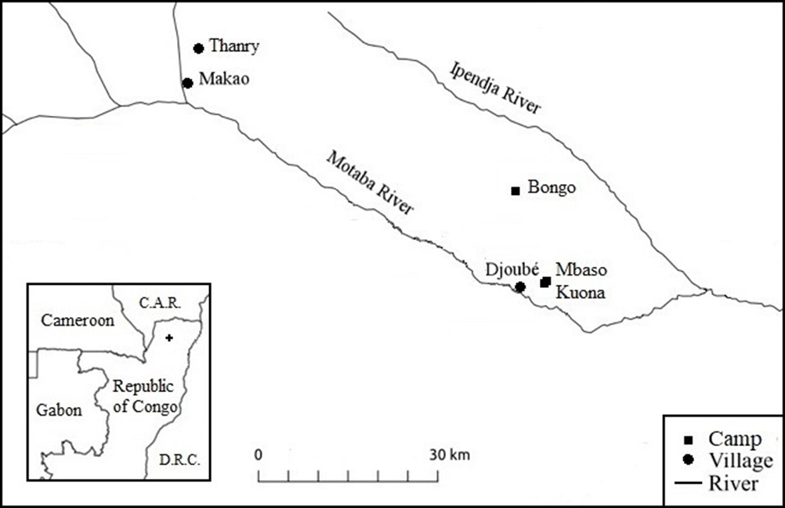
Figure S1: Location of study sites
The research region is located in the Likouala department, in the northern part of the Republic of the Congo (see cross inset). For simplicity, only relevant forest camps (squares) and villages (circles) are indicated. See Jang et al. (2019) for maps with additional forest camps. Data from 2016 were collected in camp Mbaso. From November 2019 until January 2020 the family resided in camp Bongo, after which they moved to camp Kuona, adjacent to camp Mbaso. Kitanishi (1995) collected their data around Makao. This figure is, with permission, adapted from Bombjaková (2018).
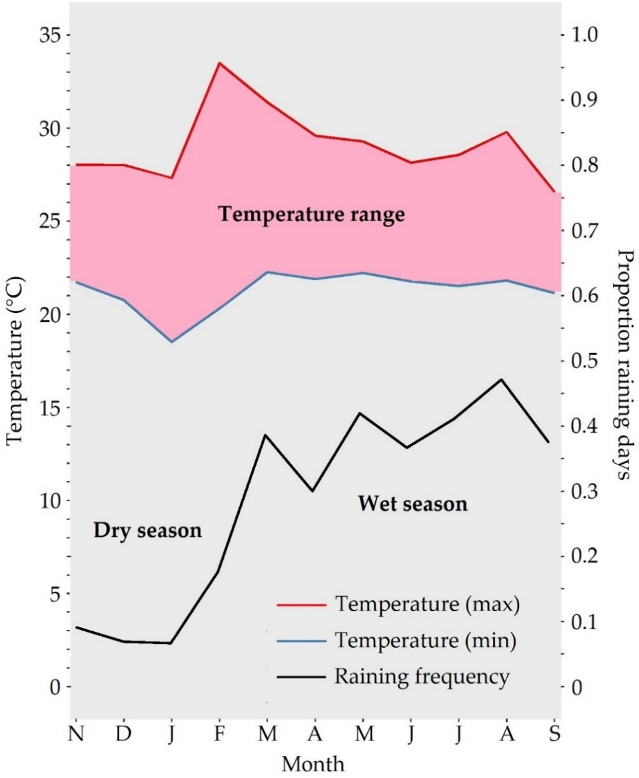
Figure S2: Annual seasonality temperature and raining frequency
Annual seasonality at the research region, with the average maximum (red line) and minimum (blue line) temperature (in °C) together with the proportion of raining days (black line) per month, except for October. The temperature is relatively constant throughout the year (pink area). Based on the raining frequency, the seasons can be roughly divided into a short dry season (onset in November) and a long wet season (onset in March). Temperature and rainfall data were collected over multiple fieldwork periods from 2015 until 2020.

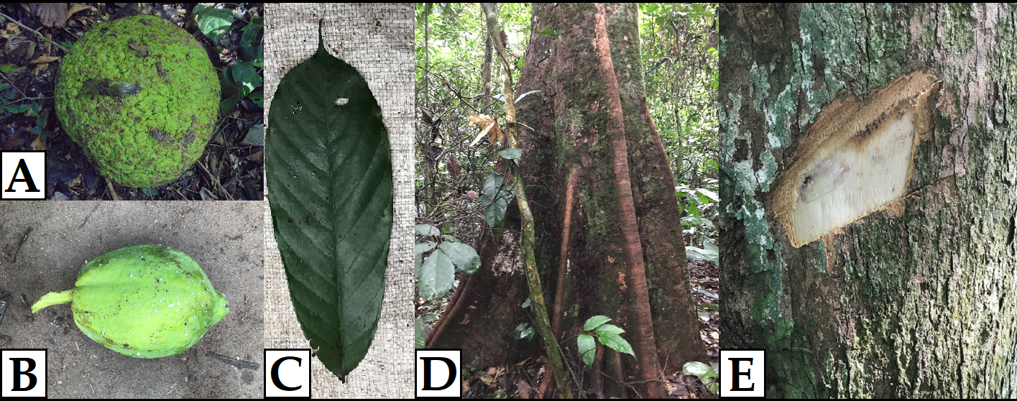
Figure S3: Examples pictures botanical knowledge test
Examples include A) seeds of Treculia africana, B) fruit of Carica papaya, C) leaf of Anonidium mannii, D) trunk of Klainedoxa gabonensis, and E) bark of Irvingia excelsa.
Table S1: Study period
To visualize the variation in the diet composition and foraging activities throughout the year, the study period was divided into five periods, with period I to III corresponding with the wet season and period IV and V with the dry season.
Period | Duration | Observation days | Observation hours
Period I | 17 March 2016 – 19 April 2016 | 11 | 141
Period II | 5 May 2016 – 17 June 2016 | 13 | 162
Period III | 16 July – 25 August 2016 | 15 | 200
Period IV | 29 November 2019 – 12 January 2020 | 10 | 162
Period V | 6 February 2020 – 6 March 2020 | 8 | 132
Total | March 2016 – August 2016, November 2019 – March 2020 | 57 | 798

Table S2: Children participating in the study
The day of observation, estimated age, and gender of the children.
ChildIDª | Observation day  (DD-MM-YYYY) | Estimated age  (on observation day) | Gender^{b}
Child_A | 17-03-2016 | 8.30 | g
Child_B | 19-03-2016 | 12.81 | b
Child_C | 25-03-2016 | 12.32 | g
Child_D | 28-03-2016 | 10.83 | b
Child_E | 31-03-2016 | 10.67 | g
Child_F | 03-04-2016 | 10.10 | b
Child_G | 08-04-2016 | 14.36 | g
Child_H | 11-04-2016 | 10.37 | b
Child_I | 14-04-2016 | 12.13 | g
Child_J | 17-04-2016 | 7.88 | b
Child_K | 19-04-2016 | 6.05 | g
Child_L | 05-05-2016 | 11.19 | b
Child_M | 07-05-2016 | 13.44 | g
Child_N | 10-05-2016 | 8.11 | b
Child_O | 14-05-2016 | 4.45 | b
Child_P | 17-05-2016 | 5.63 | g
Child_Q | 21-05-2016 | 5.89 | b
Child_R | 23-05-2016 | 6.23 | g
Child_S | 25-05-2016 | 5.82 | g
Child_T | 27-05-2016 | 6.99 | g
Child_U | 08-06-2016 | 5.52 | g
Child_V | 11-06-2016 | 5.03 | b
Child_W | 13-06-2016 | 5.79 | g
Child_X | 17-06-2016 | 7.55 | b
Child_A | 16-07-2016 | 8.63 | g
Child_B | 19-07-2016 | 13.14 | b
Child_Q | 25-07-2016 | 6.07 | b
Child_R | 28-07-2016 | 6.41 | g
Child_L | 30-07-2016 | 11.42 | b
Child_N | 02-08-2016 | 8.34 | b
Child_U | 06-08-2016 | 5.68 | g
Child_J | 08-08-2016 | 8.19 | b
Child_E | 11-08-2016 | 11.04 | g
Child_D | 13-08-2016 | 11.21 | b
Child_C | 16-08-2016 | 12.72 | g
Child_V | 18-08-2016 | 5.22 | b
Child_P | 21-08-2016 | 5.89 | g
Child_X | 23-08-2016 | 7.73 | b
Child_H | 25-08-2016 | 10.74 | b
Child_B | 29-11-2019 | 16.51 | b
Child_K | 05-12-2019 | 9.68 | g
Child_Y | 09-12-2019 | 15.36 | b
Child_A | 14-12-2019 | 12.04 | g
Child_V | 18-12-2019 | 8.55 | b
Child_R | 23-12-2019 | 9.82 | g
Child_L | 29-12-2019 | 14.84 | b
Child_U | 04-01-2020 | 9.10 | g
Child_Z | 08-01-2020 | 13.11 | b
Child_M | 12-01-2020 | 17.13 | g
Child_Q | 06-02-2020 | 9.61 | b
Child_S | 12-02-2020 | 9.54 | g
Child_N | 16-02-2020 | 11.88 | b
Child_H | 20-02-2020 | 14.23 | b
Child_E | 23-02-2020 | 14.57 | g
Child_O | 28-02-2020 | 8.25 | b
Child_D | 02-03-2020 | 14.76 | b
Child_AA | 06-03-2020 | 6.10 | g
ª Note that some children were observed more than once
^{b} g: girl, b: boy

Table S3: Complete dietary list
Eating percentages of each food item, indicated with its local name and (scientific) name, together with its food type, habitat, and periodic availability.
Percentage diet (%) | (Scientific) name | Local food name | Food typeª | Food habitat^{b} | Periodic availability^{c}
 |  |  |  |  | I | II | III | IV | V
25.74 | Elaeis guineensis | mbila | F | A | X | X | X | X | X
15.73 | Manihot esculenta | boma | T | A | X | X | X | X | X
8.93 | Dioscoreophyllum cumminsii | mela | T | F | X | X | X | X | X
6.14 | Treculia africana | (bo)pusa^{d} | S | F | X | X | X
4.58 | Carica papaya | papai^{d} | F | A | X | X |  | X | X
3.30 | Musa × paradisiaca | gondo | F | A | X | X | X | X | X
2.85 | Zea mays | mombombo | S | A | X |  | X |  | X
2.73 | Manihot esculenta | jabuka | L | F | X | X | X | X | X
2.28 | Gonimbrasia melanops | kongo | C | F |  |  | X
2.05 | Plukenetia conophora | mokaso | S | F | X |  | X
1.92 | Colocasia esculenta | ika | T | A | X | X | X | X | X
1.82 | Myrianthus arboreus | ediki | F | F | X | X | X
1.63 | Saba comorensis | musuku | S | F | X | X | X |  | X
1.58 | Anonidium mannii | mobe^{d} | F | F |  | X | X
1.54 | Gnetum bucholzianum | koko | L | F | X | X | X |  | X
1.25 | Irvingia excelsa | mofayo^{d} | S | F | X | X | X
1.12 | Honey (Apis mellifera) | bui | H | F | X |  |  |  | X
1.00 | Ipomoea batatas | benze | T | A | X |  |  | X | X
0.92 | Honey (bee spp.) | mopina | H | F | X | X |  | X | X
0.91 | Landolphia foretiana/owariensis | pembe | F | F |  |  | X
0.89 | Cephalophus callipygus | mosome | TA | F | NA
0.83 | Catfish | ngolo | AA | F | NA
0.81 | Imbrasia epimethea | beta | C | F |  |  | X
0.74 | Tuber spp. | yoko^{e} | T | A/F | NA
0.68 | Pancovia laurentii | motende^{d} | F | F | X
0.61 | Chytranthus atroviolaceus/talbotii | matokodi | S | F |  |  | X
0.58 | Fish spp. | swi^{e} | AA | F | NA
0.51 | Irvingia grandifolia | mosombo | S | F |  |  | X
0.41 | Rhynchophorus phoenicis | essoko | C | F |  |  | X
0.39 | Philantomba monticola | mboloko | TA | F | NA
0.39 | Elaeis guineensis | mondika | S | A |  |  |  | X | X
0.35 | Imbrasia obscura | gekene | C | F |  |  | X
0.35 | Unknown fruit sp.1 | mongako | F | F | X | X | X
0.30 | Honey (stingless bee) | koma | H | F |  |  |  |  | X
0.27 | Dioscorea burkilliana | ngangi | T | F | X | X |  | X | X
0.27 | Pseudopachystela lastoursvillensis | mosambela | F | F | X
0.26 | Termites | musuka | Te | F | NA
0.26 | Oreochromis niloticus | bundu | AA | F | NA
0.25 | Polypterus spp. | mokonga | AA | F | NA
0.22 | Dioscorea semperflorens | ekule | T | F | X | X | X | X | X
0.22 | Unknown tuber sp.1 | bodiaka | T | F | X | X | X
0.20 | Unknown fish sp.1 | embolo | AA | F | NA
0.19 | Insects | nyamanyama | I | F | NA
0.17 | Unknown fish sp.3 | motombi | AA | F | NA
0.15 | Soil | sopo | So | F | NA
0.15 | Unknown fish sp.2 | mokenge | AA | F | NA
0.13 | Termitomyces striatus | mabota | M | F |  |  | X |  | X
0.11 | Atherurus africanus | gomba | TA | F | NA
0.08 | Dioscorea schimperiana | essouma | T | F | X |  |  |  | X
0.07 | Clitandra cymulosa | elebe | F | F |  |  | X
0.07 | Cola urceolata | ngaingai | F | F |  | X | X
0.05 | Trichoscypha abut | entoya^{d} | F | F | X | X | X
0.04 | Chrysophyllum lacourtianum | bamboo | F | F |  | X
0.04 | Unknown fruit sp.2 | mongangili | F | F | X
0.03 | Grewia oligoneura | woko | F | F | X
0.03 | Citrus sinensis | malala | F | A |  |  | X
0.02 | Chytranthus gilletii | esekelente^{d} | F | F |  |  | X | X
< 0.01 | Shrimp | mongkasa | AA | F | NA
0.88 | Rice, biscuit, fufu, beignet | village food | O | V | NA
ª F: Fruit, T: Tuber, S: Seed, L: Leaf, C: Caterpillar, AA: Aquatic animal, H: Honey, TA: Terrestrial animal, Te: Termite, I: Insect, So: Soil, M: Mushroom, O: Other
^{b} A: Agricultural, F: Forest, V: Village
^{c} X indicates that the food item was assumed to be available during the observation period described in Table 1, based on the data of the children and women. The availability of terrestrial animals (TA), aquatic animals (AA), termites (Te), insects (I), soil (So), other food (O), and yoko are not indicated since availability was less clear
^{d} Plant species included in the botanical knowledge test (Table A2)
^{e} The local names yoko and swi are used for a variety of tubers and fish, respectively

Table S4: Gradient program for carbohydrate analyses
For carbohydrate measurements with the high-performance anion-exchange chromatography system ICS-5000 (Thermo Fisher Scientific, Dreieich, Germany), a gradient of Eluent A (12 mM NaOH) and B (150 mM NaOH) was used. The total measuring time was 35 minutes.
Time  (min) | Eluent A  (12 mM NaOH) | Eluent B  (150 mM NaOH)
0 | 100 | 0
12 | 100 | 0
12,1 | 0 | 100
25 | 0 | 100
25,1 | 100 | 0
35 | 100 | 0

Table S5: Sugar and sweetness levels of foraging-related plant species
Indicated are the sweetness levels of 15 plant species that were eaten by the BaYaka children. These sweetness levels were calculated by multiplying the concentrations (in mg per g fresh material) of glucose, fructose, and sucrose with 1.00, 6.55, and 7.76, respectively, and subsequently summing these concentrations.
Scientific name | Local food name | Food typeª | Glucose | Fructose | Sucrose | Sugar | Sweetness
Landolphia foretiana/owariensis | pembe | F | 69.36 | 51.16 | 10.67 | 131.19 | 487.26
Saba comorensis | musuku | F | 58.68 | 52.15 | 4.97 | 115.8 | 438.83
Anonidium mannii | mobe | F | 32.99 | 38.87 | 3.07 | 74.94 | 311.46
Trichoscypha abut | entoya | F | 25.57 | 49.04 | 0 | 74.61 | 346.77
Carica papaya | papai | F | 17.15 | 17.64 | 2.93 | 37.72 | 155.45
Syncepalum brevipes | mosambela | F | 14.67 | 14.67 | 2.49 | 31.83 | 130.11
Pancovia laurentii | motende | F | 5.81 | 6.44 | 2.53 | 14.77 | 67.56
Musa × paradisiaca | gondo | F | 3.63 | 5.47 | 5.35 | 14.45 | 80.96
Myrianthus arboreus | ediki | F | 4.82 | 9.35 | 0 | 14.17 | 66.05
Chytranthus gilletii | esekelente | F | 0 | 4.09 | 0 | 4.09 | 26.79
Elaeis guineensis | mbila | F | 0.24 | 0.38 | 0.12 | 0.74 | 3.67
Chytranthus atroviolaceus/talbotii | matokodi | S | 1.06 | 1.66 | 7.55 | 10.26 | 70.45
Treculia africana | (bo)pusa | S | 0.3 | 0.44 | 8.63 | 9.37 | 70.1
Irvingia excelsa | mofayo | S | 0.22 | 0.25 | 7.63 | 8.1 | 61.08
Plukenetia conophora | mokaso | S | 0.12 | 0.19 | 3.12 | 3.42 | 25.52
ª F: Fruit, S: Seed

Table S6: Foraging-related plant species in botanical knowledge test
The local name of the 12 plant species included in the botanical knowledge test with their scientific name and corresponding plant family, as well as the part that is eaten.
Scientific name | Local name | Plant family | Part eatenª
Klainedoxa gabonensis | bokoko | Irvingiaceae | S
Eribroma oblongum | emboyo | Malvaceae | S
Trichoscypha abut | entoya | Anacardiaceae | F
Chytranthus gilletii | esekelente | Sapindaceae | F
Anonidium mannii | mobe | Annonaceae | F
Irvingia wombolu | mobolu | Irvingiaceae | S
Irvingia excelsa | mofayo | Irvingiaceae | S
Panda oleosa | mokana | Pandaceae | S
Chrysophyllum boukokoense | mondonge | Sapotaceae | F
Pancovia laurentii | motende | Sapindaceae | F
Carica papaya | papai | Caricaceae | F
Treculia africana | (bo)pusa | Moraceae | S
ª F: Fruit, S: Seed

Table S7: Model overview
The five GLMMs that were performed. The fixed effects were the same for models F_{col} and F_{eat}, as was the case for models T_{col} and T_{eat}. These four models additionally had the same offset term and random effects.
Model | Response variable | Fixed effects | Offset term | Random effects
F_{col}ª: Fruit/seed species collecting probability | Collected (binary) | - Estimated age  - Gender (boy/girl)  - Weighted average number of boys and men in group  - Sweetness  - Habitat (forest/agriculture)  - Food type (fruit/seed) | - Log observation  time (in h) | - Observation  day  - Child  - Food  species
F_{eat}ª: Fruit/seed species  eating probability | Eaten  (binary)
T_{col}^{b}: Tuber species collecting probability | Collected (binary) | - Estimated age  - Gender (boy/girl)  - Weighted average number of girls and women in group  - Habitat (forest/agriculture)
T_{eat}^{b}: Tuber species eating probability | Eaten  (binary)
B_{know}^{c}: Botanical knowledge of foraging-related plant species | Correct answer (binary) | - Estimated age  - Gender (boy/girl)  - Part shown (fruit/seed,  leaf, trunk, bark) | NA | - Sample  - Child  - Plant  species
ª N_{total}=364, N_{observation day}=57, N_{child}=27, N_{food species}=15
^{b} N_{total}=250, N_{observation day}=57, N_{child}=27, N_{food species}=8
^{c} N_{total}=1020, N_{sample}=300, N_{child}=17, N_{plant species}=12
Table S8: Percentage of forest fruits and tubers
Shown are the percentages of time spent eating on and foraging for fruits and tubers. These fruits and tubers include both forest and agricultural foods, of which the percentage of forest fruits (based on percentage total fruits) and of forest tubers (based on percentage total tubers) are shown. Forest tubers consist mostly of D. cumminsii, as indicated with the percentage within brackets.
 | Fruits |  |  |  | Tubers
 | Eating |  | Foraging |  | Eating |  | Foraging
 | Total (%) | Forest  (%) | Total (%) | Forest (%) | Total (%) | Forest  (%) | Total (%) | Forest  (%)
Total | 39.6 | 15.0 | 15.8 | 43.3 | 29.1 | 34.2 (31.5) | 40.5 | 89.4 (85.8)
Period I | 44.7 | 13.3 | 26.9 | 36.2 | 28.7 | 26.6 (17.4) | 29.0 | 87.1 (81.4)
Period II | 30.8 | 9.8 | 24.3 | 53.2 | 32.6 | 39.1 (38.4) | 11.3 | 15.1 (15.1)
Period III | 46.0 | 25.0 | 22.3 | 77.7 | 18.9 | 9.4 (9.4) | 11.4 | 48.9 (48.9)
Period IV | 25.7 | 0 | 8.7 | 0 | 58.5 | 83.2 (80.6) | 82.2 | 99.8 (97.0)
Period V | 42.0 | 0 | 9.3 | 0 | 28.6 | 5.4 (2.0) | 19.1 | 5.0 (0.4)

Table S9: Sensitivity definition availability – three days before and after
Food items were assumed to be available one week before and one week after they were observed to be foraged and/or eaten, based on data of children and women. Assuming that they were available only three days before and after they were observed to be foraged and/or eaten yielded similar results, as is shown in model F²_{col} and F²_{eat} (N=286) and in model T²_{col} and T²_{eat} (N=190). The estimates are shown together with the standard errors (SE), lower and upper 95% confidence interval (CI_{lower} and CI_{upper}), likelihood ratio tests results (χ², df, P-value), and the minimum and maximum estimates based on the model stability analyses (min and max). Significant results (P<0.05) are indicated in bold.
Term | Estimate |  | SE | CI_{lower} | CI_{upper} | χ² | df | P | min | max
Model F²_{col} |  | Effect on collecting probability fruit/seed species
Intercept |  | -4.223 | 0.649 | -30.964 | -3.159 | - | - | - | -4.678 | -3.824
Ageª |  | 0.035 | 0.287 | -1.618 | 3.609 | 0.015 | 1 | 0.902 | -0.142 | 0.180
Gender^{b} |  | -0.165 | 0.662 | -8.486 | 3.130 | 0.062 | 1 | 0.803 | -0.661 | 0.351
Nr of boys and menª |  | 0.534 | 0.389 | -0.319 | 8.825 | 1.888 | 1 | 0.169 | 0.279 | 0.916
Sweetnessª |  | 0.327 | 0.282 | -1.055 | 5.416 | 1.378 | 1 | 0.240 | 0.143 | 0.550
Habitat^{b} |  | -0.289 | 0.829 | -6.182 | 3.355 | 0.118 | 1 | 0.731 | -2.235 | 1.014
Food type^{b} |  | -0.713 | 0.806 | -9.448 | 1.763 | 0.826 | 1 | 0.364 | -1.691 | -0.210
Model F²_{eat} |  | Effect on eating probability fruit/seed species
Intercept |  | -2.901 | 0.542 | -4.749 | -1.632 | - | - | - | -3.149 | -2.621
Ageª |  | -0.149 | 0.212 | -0.766 | 0.367 | 3.065 | 1 | 0.080 | -0.235 | -0.011
Gender^{b} |  | -0.588 | 0.496 | -2.088 | 0.446 | 1.393 | 1 | 0.238 | -0.957 | -0.270
Nr of boys and menª |  | 0.542 | 0.249 | 0.013 | 1.559 | 4.692 | 1 | 0.030 | 0.403 | 0.778
Sweetnessª |  | -0.146 | 0.270 | -1.159 | 0.634 | 0.286 | 1 | 0.593 | -0.433 | 0.022
Habitat^{b} |  | 2.255 | 0.828 | 0.644 | 5.398 | 6.765 | 1 | 0.009 | 1.137 | 3.177
Food type^{b} |  | 0.611 | 0.714 | -1.005 | 3.076 | 0.697 | 1 | 0.404 | 0.078 | 0.848
Model T²_{col}^{c} |  | Effect on collecting probability tuber species
Intercept |  | -3.558 | 0.795 | -18.679 | -2.217 | - | - | - | -28.654 | -3.197
Ageª |  | 0.654 | 0.417 | -0.117 | 1.674 | 2.856 | 1 | 0.091 | 0.256 | 1.307
Gender^{b} |  | -2.886 | 1.094 | -10.688 | -1.106 | 6.056 | 1 | 0.014 | -3.791 | -2.279
Nr of girls and womenª |  | 0.033 | 0.406 | -1.080 | 1.502 | 0.007 | 1 | 0.936 | -0.171 | 0.192
Habitat^{b} |  | -0.430 | 0.887 | -3.680 | 1.730 | 0.224 | 1 | 0.636 | -0.904 | 8.855
Model T²_{eat} |  | Effect on eating probability tuber species
Intercept |  | -3.696 | 0.790 | -5.960 | -2.118 | - | - | - | -4.329 | -3.470
Ageª |  | 0.070 | 0.202 | -0.381 | 0.581 | 0.118 | 1 | 0.731 | -0.066 | 0.166
Gender^{b} |  | 0.190 | 0.472 | -0.835 | 1.637 | 0.158 | 1 | 0.691 | -0.004 | 0.539
Nr of girls and womenª |  | 0.315 | 0.248 | -0.231 | 1.035 | 1.647 | 1 | 0.199 | 0.157 | 0.546
Habitat^{b} |  | 2.398 | 1.245 | -0.153 | 6.373 | 3.320 | 1 | 0.068 | 0.465 | 3.512
- Model F²_{col}: Full-null model comparison: χ²=6.097, df=6, P=0.412; marginal R²: 0.053, conditional R²: 0.276
- Model F²_{eat}: Full-null model comparison: χ²=14.354, df=6, P=0.026; marginal R²: 0.194, conditional R²: 0.420
- Model T²_{col}: Full-null model comparison: χ²=16.161, df=4, P=0.003; marginal R²: 0.216, conditional R²: 0.544
- Model T²_{eat}: Full-null model comparison: χ²=5.206, df=4, P=0.267; marginal R²: 0.181, conditional R²: 0.513
ª Z-transformed; mean ± SD of original variables age, number of boys and men, sweetness, and number of girls and women were 9.737 ± 3.321, 2.788 ± 1.924, 156.137 ± 158.820, and 3.887 ± 2.42, respectively
^{b} The variables gender, habitat, and food type were dummy coded with girl, forest, and fruit as reference, respectively
^{c} The random effect structure of model T²_{col} had to be simplified compared to model T_{col} and T³_{col} due to convergence issues, leaving the random slopes of age within child and habitat within observation day

Table S10: Sensitivity definition availability – periodic availability
Food items were assumed to be available one week before and one week after they were observed to be foraged and/or eaten, based on data of children and women. Assuming that they were available during the whole period (Table 1; Table A3) yielded similar results, as is shown in model F³_{col} and F³_{eat} (N=478) and in model T³_{col} and T³_{eat} (N=342). The estimates are shown together with the standard errors (SE), lower and upper 95% confidence interval (CI_{lower} and CI_{upper}), likelihood ratio tests results (χ², df, P-value), and the minimum and maximum estimates based on the model stability analyses (min and max). Significant results (P<0.05) are indicated in bold.
Term | Estimate | SE | CI_{lower} | CI_{upper} | χ² | df | P | min | max
Model F³_{col} | Effect on collecting probability fruit/seed species
Intercept | -5.040 | 0.629 | -13.399 | -4.157 | - | - | - | -5.467 | -4.563
Ageª | -0.044 | 0.286 | -1.016 | 0.746 | 0.147 | 1 | 0.701 | -0.229 | 0.051
Gender^{b} | -0.307 | 0.612 | -2.490 | 1.102 | 0.257 | 1 | 0.612 | -0.715 | 0.193
Nr of boys and menª | 0.526 | 0.349 | -0.183 | 2.000 | 2.413 | 1 | 0.120 | 0.303 | 0.853
Sweetnessª | 0.195 | 0.321 | -0.919 | 1.162 | 0.360 | 1 | 0.549 | -0.051 | 0.442
Habitat^{b} | 0.502 | 0.916 | -1.848 | 3.469 | 0.387 | 1 | 0.534 | -1.230 | 1.766
Food type^{b} | -0.594 | 0.789 | -5.232 | 1.220 | 0.560 | 1 | 0.454 | -1.240 | -0.117
Model F³_{eat} | Effect on eating probability fruit/seed species
Intercept | -4.202 | 0.434 | -5.506 | -3.590 | - | - | - | -4.532 | -3.871
Ageª | -0.254 | 0.233 | -0.837 | 0.212 | 1.151 | 1 | 0.283 | -0.367 | -0.153
Gender^{b} | -0.157 | 0.414 | -1.099 | 0.719 | 0.137 | 1 | 0.711 | -0.586 | 0.282
Nr of boys and menª | 0.424 | 0.193 | 0.052 | 0.949 | 4.535 | 1 | 0.033 | 0.243 | 0.633
Sweetnessª | -0.258 | 0.221 | -0.951 | 0.199 | 1.317 | 1 | 0.251 | -0.386 | -0.135
Habitat^{b} | 2.277 | 0.595 | 1.223 | 4.036 | 11.585 | 1 | 0.001 | 1.560 | 2.914
Food type^{b} | 0.446 | 0.510 | -0.657 | 1.592 | 0.769 | 1 | 0.381 | 0.103 | 0.680
Model T³_{col} | Effect on collecting probability tuber species
Intercept | -4.807 | 0.691 | -29.313 | -3.732 | - | - | - | -5.625 | -4.474
Ageª | 0.154 | 0.908 | -0.558 | 1.253 | 0.849 | 1 | 0.357 | 0.075 | 0.537
Gender^{b} | 0.312 | 0.324 | -6.456 | -0.775 | 10.809 | 1 | 0.001 | -2.524 | -1.866
Nr of girls and womenª | -2.154 | 0.679 | -1.357 | 0.608 | 0.023 | 1 | 0.879 | -0.168 | 0.101
Habitat^{b} | -0.043 | 0.280 | -2.622 | 2.127 | 0.029 | 1 | 0.865 | -0.160 | 0.932
Model T³_{eat} | Effect on eating probability tuber species
Intercept | -4.699 | 0.675 | -6.307 | -3.492 | - | - | - | -5.442 | -4.481
Ageª | -0.151 | 0.152 | -0.475 | 0.167 | 0.959 | 1 | 0.328 | -0.307 | -0.037
Gender^{b} | 0.188 | 0.367 | -0.481 | 0.962 | 0.253 | 1 | 0.615 | 0.008 | 0.330
Nr of girls and womenª | 0.120 | 0.181 | -0.213 | 0.504 | 0.426 | 1 | 0.514 | 0.047 | 0.218
Habitat^{b} | 1.682 | 1.024 | -0.253 | 3.885 | 2.383 | 1 | 0.123 | 0.372 | 2.373
- Model F³_{col}: Full-null model comparison: χ²=5.623, df=6, P=0.467; marginal R²: 0.034, conditional R²: 0.180
- Model F³_{eat}: Full-null model comparison: χ²=20.802, df=6, P=0.002; marginal R²: 0.191, conditional R²: 0.329
- Model T³_{col}: Full-null model comparison: χ²=12.133, df=4, P=0.016; marginal R²: 0.077, conditional R²: 0.218
- Model T³_{eat}: Full-null model comparison: χ²=3.524, df=4, P=0.474; marginal R²: 0.095, conditional R²: 0.339
ª Z-transformed; mean ± SD of original variables age, number of boys and men, sweetness, and number of girls and women were 9.737 ± 3.321, 2.788 ± 1.924, 156.137 ± 158.820, and 3.887 ± 2.42, respectively
^{b} The variables gender, habitat, and food type were dummy coded with girl, forest, and fruit as reference, respectively

